Hiver Blonde Beer fruit loaf
30/12/2025 by Christian Gott
Uncategorised

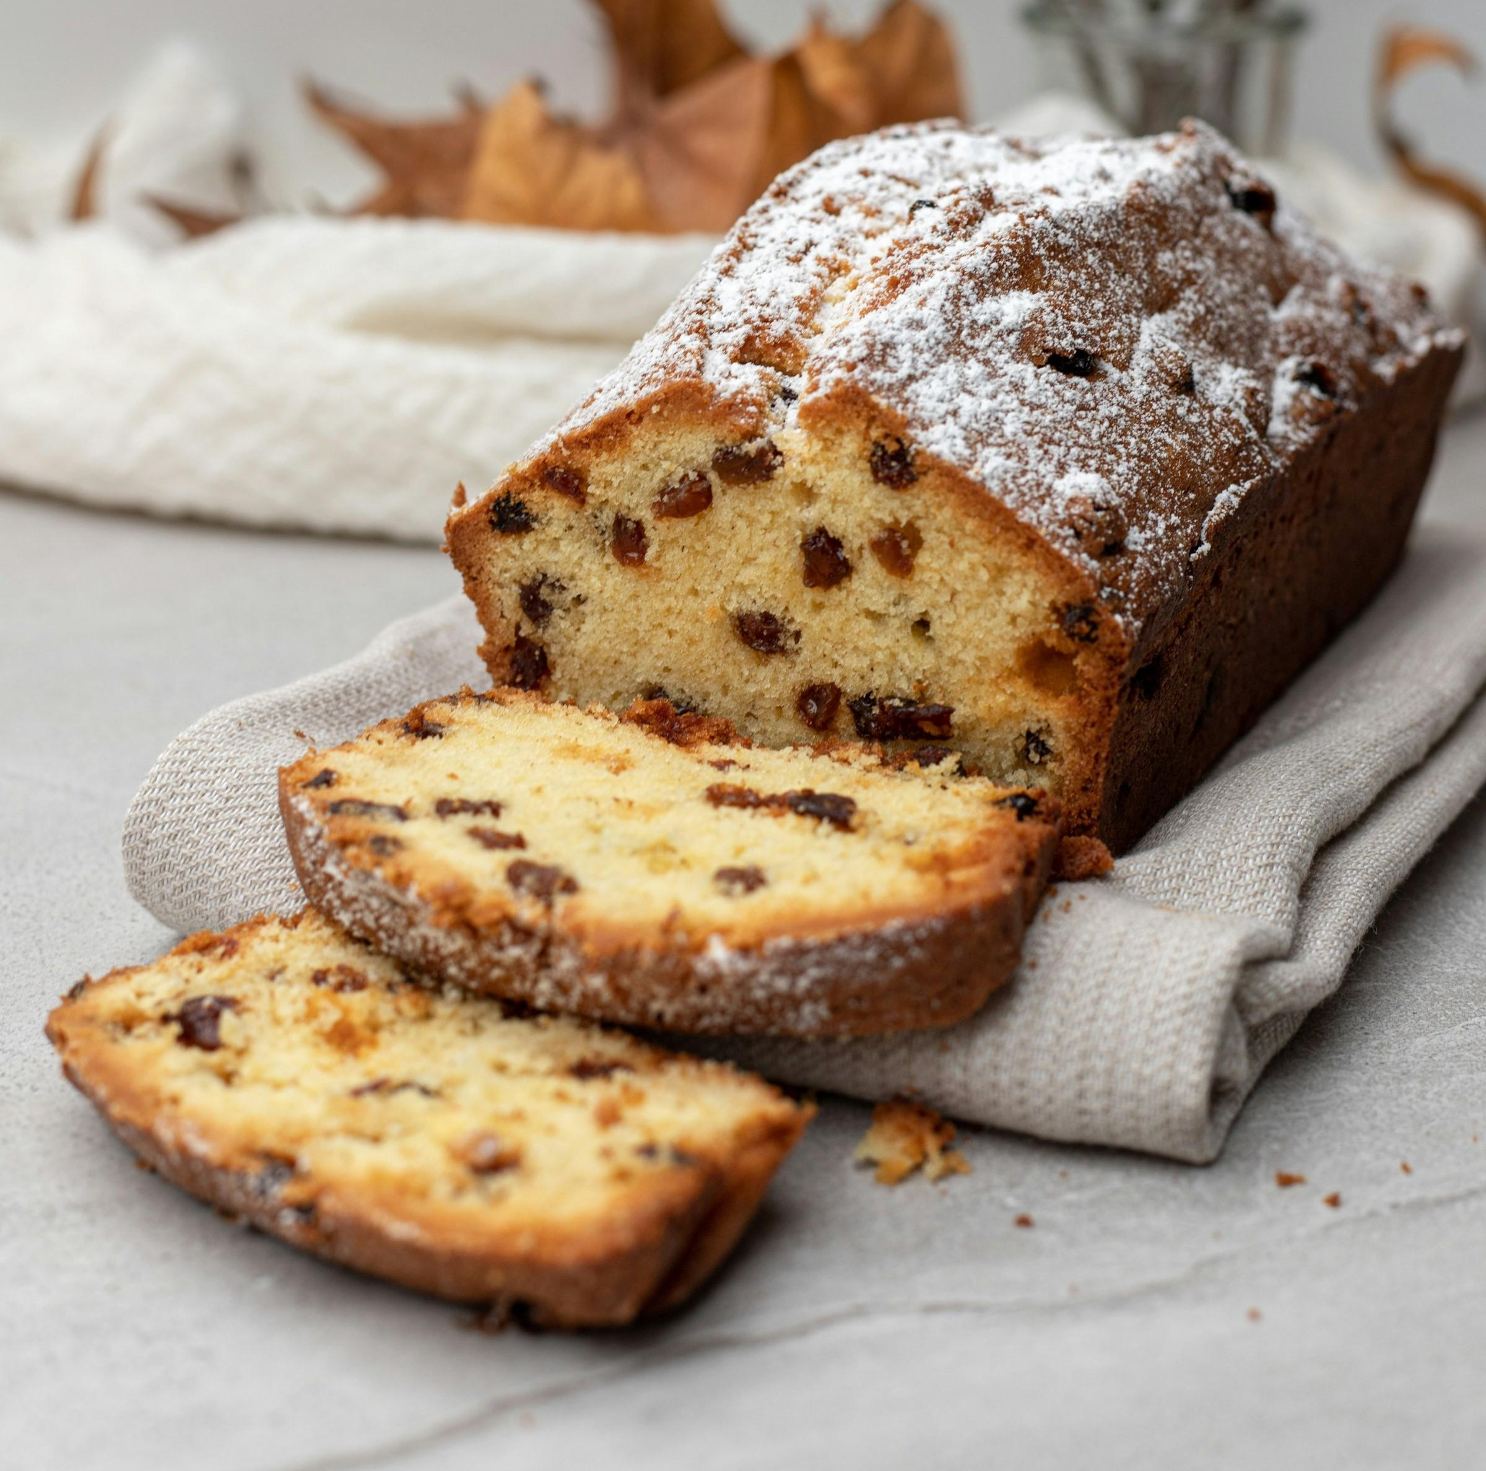

For my last recipe of the year, I thought it would be good to have something suitable for the festive season. Now I will be the first person to admit I am not a natural baker. My hands are too hot to make pastry and most of my 20-odd years in kitchens was spent preparing and cooking meat and fish. There is something special about Christmas however that gets me inspired making biscuits, mince pies and cakes. It is a little late to think about a traditional, iced, fruit cake, but there other options to grace your table. Today’s beer fruit loaf recipe is my lighter version of a classic Irish barmbrack or brack. This is a traditional enriched yeast dough speckled with dried fruit. It was originally made with barm or the froth left over in the brewing process as an alternative to yeast or bicarbonate of soda. Barmbrack is used for a popular fortune-telling game at Halloween and is often baked and eaten on New Year’s Eve to ward off poverty and starvation. My recipe is simpler than making a yeast-based dough and uses Hiver Blonde Beer (4.5 per cent ABV). Hiver Blonde Beer is brewed on the Bermondsey beer mile, close to the Maltby Street food market. Honey is an integral ingredient and the natural sugars are fermented leaving just the flavour and aromas. Hiver uses a lager yeast and UK-grown Cascade hops for clean flavours and a hint of citrus to complement the honey notes. This innovative brew has won a World Beer Challenge gold medal and adds a delicious honey note to the finished recipe. Before I get to the recipe I would like to wish all readers a merry Christmas and happy new year and add my voice to those of my colleagues and encourage you to support your pub not just at this special time, but all year round. Hiver Blonde Beer fruit loaf 225g self-raising flour 125g golden caster sugar 150g sultanas or raisins 75g glace cherries, diced, washed and dried 330ml Hiver Blonde Beer 1 large free-range egg 2tsp baking powder Half tsp mixed spice Icing sugar to decorate Place the sultanas or raisins in a bowl and pour over enough beer to cover. Cling film the bowl and allow to soak overnight. Preheat your oven to 325F/160C/Gas Mark 3 and grease and line a 900g loaf tin with baking parchment. Drain the sultanas or raisins and reserve the liquid. Sieve the flour, baking powder and spice into a bowl and add the sugar. Make a well in the middle and add the egg. Using a wooden spoon mix together, you may need to add a little of the reserved beer you have soaked the fruit in to make a wet dough. Then stir through the fruit and diced cherries until everything is thoroughly combined. At this point it is traditional to add a ring which is baked in the loaf. Whoever finds the ring in their slice is said to be married within a year. I’m not sure what happens if someone finds it if they are already married. Carefully spoon the dough into the lined loaf tin and place in the oven on the middle shelf and bake for one hour. Remove from the oven and allow to cool slightly before removing from the loaf tin and place on a wire rack. When thoroughly cool wrap in cling film and leave for a couple of days. Then unwrap, liberally sprinkle with icing sugar and serve, cut into thick slices.

