Chairman’s end of year message
29/12/2025 by Ash Corbett-Collins
Campaign

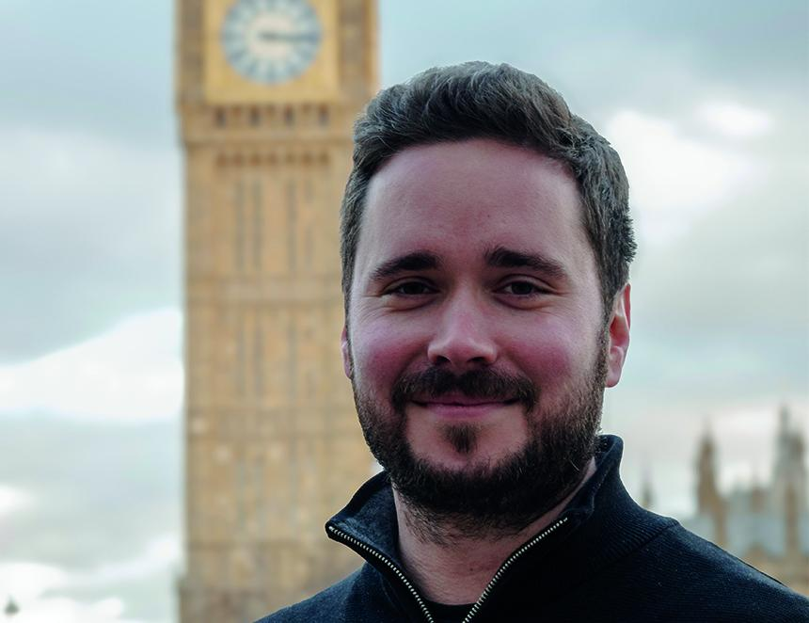

As we rapidly approach 2026, I wanted to round up what we at CAMRA have been doing in 2025, and the campaigning challenges that we have ahead for next year. I’ll start with the moment freshest in our minds – the Autumn Budget. I’m appalled by the chancellor’s Budget joke of a business rates system for pubs in England. As things stand, these “reforms” will actually increase many publicans’ bills, since the current 40 per cent rate relief is being scrapped at the same time as rateable values are increasing for many pubs. This means the average pub’s business rates bill will be £1,500 more next year, £4,500 higher in 2027/28 and a whopping £7,000 more in 2028/29. The chancellor has left publicans with just two very costly options: either increase the prices you pay to cover the cost or shut their doors for good. It’s a sneaky attempt to rinse the industry and us, the customers, dry. We need a U-turn, before communities are ripped apart by inevitable pub closures. We can’t let that happen. And we won’t stop campaigning until the chancellor rethinks this outrageous betrayal and delivers her promise of a permanently lower business rates system. And the same problem is coming down the tracks in Wales, Scotland and Northern Ireland too as governments there prepare their budgets for 2026/27. We are keeping up the pressure on parliamentarians, ministers and political parties in those nations to avoid a repeat of the business rates bombshell that is facing pubs in England. 2026 sees vital elections taking place in Scotland and Wales. This is a great opportunity for us to get our campaigns heard loud and clear by those parties and people who will end up forming the next Scottish and Welsh governments. In those countries, CAMRA is campaigning for: fairer business rates for pubs in Scotland and Wales

better protections for pubs in the planning systems in Scotland and Wales

an end to bonkers plans for a ban on all alcohol advertising and sponsorship in Scotland

a rethink on a Wales-specific deposit return scheme for cans and bottles, which risks independent breweries choosing to stop selling to Welsh pubs and bottle shops. In Northern Ireland, we are campaigning to end the restrictive licensing practices that make opening a new pub often impossible. Because there are a fixed number of alcohol licences, any prospective publican needs to obtain one from an existing business that is closing. And, even if they can find a licence to buy, the going rate is usually more than £100,000, which is far too expensive for someone wanting to open a new pub. The system also leads to global breweries using restrictive tie agreements to dominate taps in pubs, meaning the beer scene is reduced to the same few brands such as Harp, Rockshore and Guinness with quality local and independent beers only available in a handful of pubs across the six counties. A new independent academic study commissioned by government ministers has given us the evidence that we need to push politicians for fundamental reforms. We are more determined than ever to deliver improvements so that we can halt pub closures, make it easier for new pubs to open and give Northern Ireland’s independent producers fair access to all pubs so that customers can get distinctive and locally-produced beer and cider that many of us in the rest of the UK are used to enjoying. These campaigns across England, Northern Ireland, Wales and Scotland are what CAMRA was founded for: fighting for choice and quality, and making it harder for a few big brewing businesses to monopolise taps on the bar, ending the dominance of a few big brewing businesses and a stale selection of the same old macro beers in pubs. Looking at the way publicans and independent brewers have been treated in all parts of the UK this year makes me angry. Angry that the government hasn’t listened to our considered campaigning, angry that global brewers continue to screw over consumers with misleading advertising, and angry that independent brewers continue to suffer at the hands of pub companies and global “brewing” giants. And if you’re angry too, now is the time to get more involved in CAMRA. Whether that’s looking at our volunteering opportunities, getting out to one of your branch events, taking part in our annual policy consultation or even standing for election to the National Executive. Alongside our Members’ Weekend, including AGM and Conference, taking place in St Albans in April, we’ll be electing new members to our National Executive. And just like last year, I want to see a strong field of contenders for the spots available on the board. If you like a challenge, and you’ve got a strategic approach and fresh ideas, please consider standing. It’s no secret that we’ve had a challenging year as a Campaign. In September, I wrote to you to explain our financial situation, and the immediate action that we took to get us back on track. We took the difficult decision to cancel our long running Great British Beer Festival and Great British Beer Festival Winter, made the winter 2025 edition of BEER Magazine completely digital, and moved our national committee and working group meetings entirely online. Alongside that, we completed a tough, but necessary, staff restructure and set a budget for the coming year that includes a modest and realistic surplus. These aren’t decisions that we’ve taken lightly, but they’re what’s right for us as a Campaign. We took these decisions to ensure that CAMRA can continue to support the vital hard work of you, our volunteers, to keep campaigning. That includes organising beer festivals to showcase the best of independent cask beer, publishing local magazines to spread our campaigning message, and meeting with your MPs and councillors to make the case to them to support pubs and beer. While 2025 was a difficult year, I want to make sure that you and other volunteers nationwide feel empowered to campaign in the ways you know will be most effective and encouraged to try new ideas that better promote CAMRA. There’s always support and funding for volunteers to try out new things if you speak to your regional director. We’ve also launched our newest member benefit, designed to drive footfall at your festivals, which is free entry for members to the festivals that we run. The first two festivals that will offer this are Exeter Festival of Beer and Salisbury Winterfest. If you’re in the area, make sure to take advantage of free entry. And this offer will be available throughout the year at all CAMRA-organised festivals, which you can find listed on our website. Our renewed focus, our determination to try new things, and our organisational changes all contribute to our next big milestone; a new Strategic Plan for the coming years. That will be brought to you, the membership, as part of Members’ Weekend in April, and it will set us clear, streamlined goals to focus on. I want 2026 to be a year of loud and proud campaigning. After a year of internal challenges and bitter disappointment in government across the UK, we need to take our determination and anger from this year and come out fighting for our pubs and independent brewers in the next. Finally, we know pubs are in for a tough time this year. Alcohol duties are increasing across the board from February, which will likely mean price increases passed on from brewers, to pub companies, at the bar. Business rates bills are increasing for pubs from April. Let’s make sure we’re showing publicans, where we can, that they have CAMRA’s full support. In a few short days it’ll be January, the most challenging month for the trade. Pubs will be open and ready to welcome you with your favourite pint of cask beer or real cider and perry, or low and no options. Please take advantage of it and continue as you mean to go on throughout the year. Cheers, Ash Corbett-Collins CAMRA chairman

