Seasons greetings from What's Brewing
24/12/2025 by Timothy Hampson
Campaign

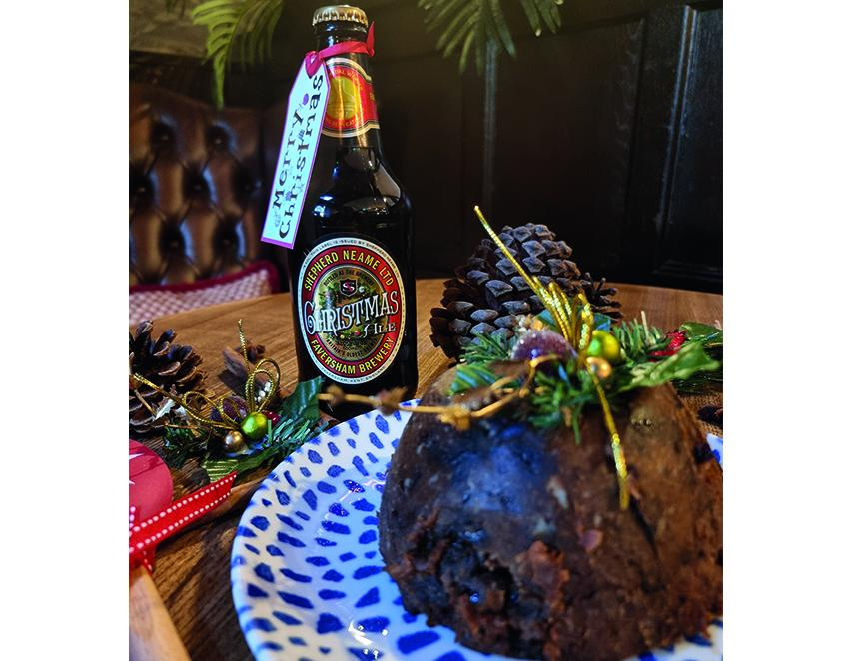

Seasons greetings to all What’s Brewing readers. The editorial team plans to take a few days off over the festive period, however, if you want to continue reading about CAMRA and its campaigns then you will find much to keep you interested on the Campaign’s website. The website is designed to get you to the pubs and pints you want, with the people you like, quicker and easier than ever before. As a member, it's all included in your annual fee. What's Brewing’s regular news service will resume on 6 January.

