Historic pub reopens
24/12/2025 by Laura Hadland
Industry

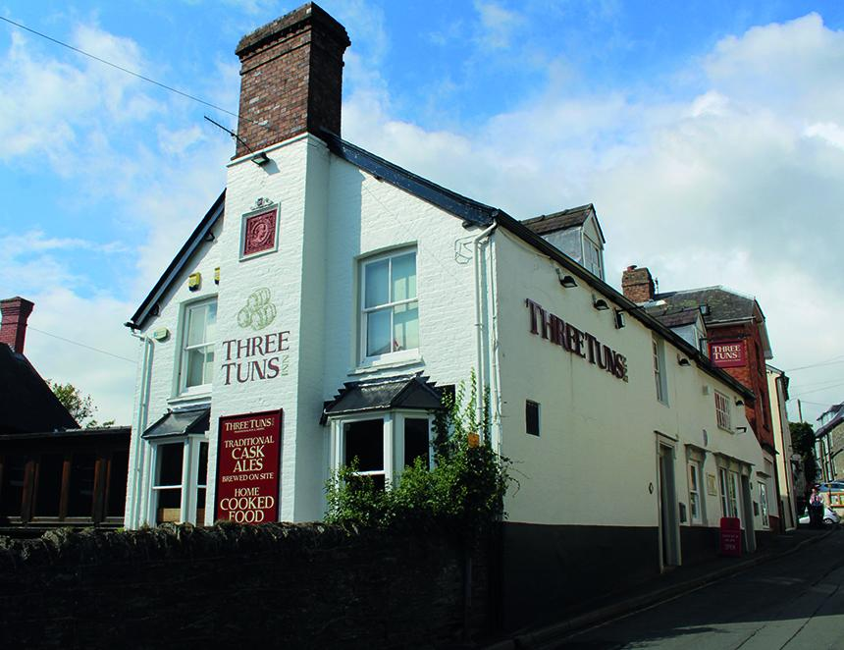

After its shock closure in July 2025, the Three Tuns Inn in Bishop’s Castle has delighted residents and tourists alike by reopening its doors in time for Christmas. The Shropshire pub, owned by Heineken’s Star Pubs, welcomed customers back in September. It is being managed by a local hospitality business The Shed, which is working with Star Pubs on a number of sites. The same team is also responsible for relaunching the Olde Bull Ring Tavern in Ludlow, another significant heritage building, in the last week after being closed for around four months. The journey is not yet over for the Three Tuns Inn though. Star Pubs is still advertising for an investment tenancy agreement on its website. The refurbishment the building so desperately needs will start “once an operator has been appointed, ideally in 2026” a spokesperson from Star Pubs said. “But this is dependent upon a number of different factors including any required planning permissions.” The inn made the news in July 2023 when Three Tuns brewery beers were briefly taken off the bar. The two businesses had gone their separate ways in 2003 under different ownership, but as they are physically linked most customers expected to see Three Tuns beer on the bar. The Star Pubs spokesperson refused to say whether those beers had a guaranteed place on the lines under the new arrangements: “There is a range of good quality national and local cask ales, beers and other drink options for customers. The current operator is able to source from independent breweries across the UK.” A selection of Three Tuns brewery beers has been available at the pub since The Shed revived the business. Shrewsbury and West Shropshire CAMRA public affairs officer Norrie Porter said: “Having the Three Tuns Inn back in the heart of Bishop’s Castle, and serving beers from the local brewery, is truly wonderful. A special pub in its own right, the Tuns is a cornerstone of both the community and the local tourist scene. The permanent loss of another pub would have been a major blow to the town and it is great to know that Star Pubs is committed to the pub’s future and ready to invest in it.”

