Catford club picks Portobello
22/12/2025 by Timothy Hampson
Industry

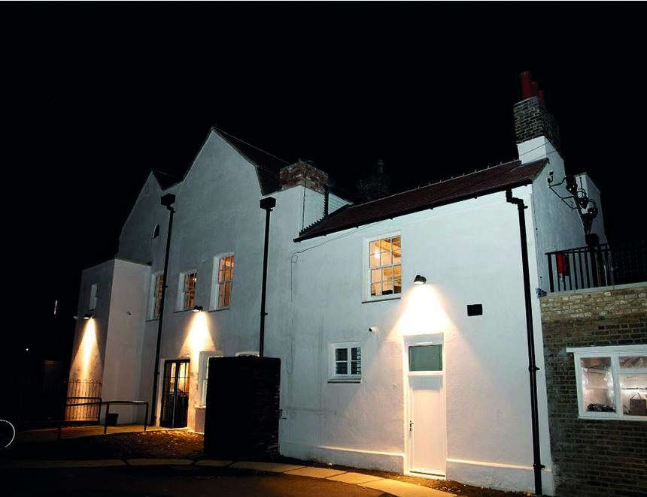

Portobello Brewing has been selected to supply the newly restored Catford House, which reopened in November. Formerly the Catford Constitutional Club, the restored pub and garden in South East London was renovated by community organisation Greenwich Co-operative Development Agency (GCDA) and has opened as a community-led venue inside Catford’s oldest building. Portobello founder Rob Jenkins said: “We are thrilled to be able to support the Catford House and contribute to the local community, which have been such a large part of our own success since launching in 2012. “From being involved in setting up the bar, to pouring the first pint and training the staff, our team has been on hand to support The Catford House and this remarkable transformation.” The process of choosing a brewery began 15 months ago, where GCDA approached 10 different brewers to tender for the restoration project. Portobello was selected after being shortlisted and following a taste test of its range of beers. Jenkins said: “As a community project it was important for us to be able to offer something more than just quality beers. “We are a team of vast experience, including cellar service and health and safety, which we were able to provide pre-opening and support the GCDA in pushing the project over the line. In all my 38 years in the industry, I have not seen a similar transformation from what was a shell, to a wonderful destination with a unique history. It has been a real honour to be part of this.” The Catford House restoration project was part of the Catford Town Centre Framework supported by the mayor of London’s Good Growth Fund. Parts of the original Georgian hall date back to the 1700s. Portobello is part of Sunrise Beverages, an independent UK brewing group that owns several beer brands including Efes, Orion, St Peter’s brewery, Gipsy Hill, and Curious brewery. Image: Leon Thompson, Astor Photography

