Guinness back brewing in London
21/12/2025 by Roger Protz
Industry

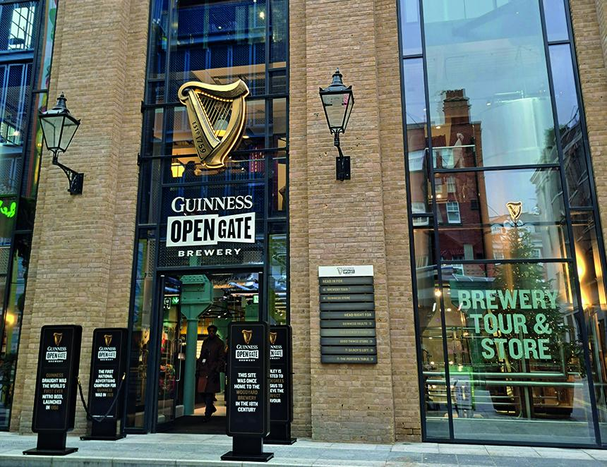

Guinness has brought brewing back to the heart of London with its much-heralded Open Gate visitor centre in Covent Garden. The centre is based on the site of the Combe brewery, one of the capital’s leading porter producers in the 18th and 19th centuries. The Guinness centre in London will boost sales of the Irish stout that have overtaken global lager brands to become the biggest-selling beer in the UK. One in 10 pints of beer sold in London is now Guinness Stout and sales nationally have grown by 30 per cent in recent years. Open Gate occupies 50,000 square feet, including a covered courtyard for outdoor drinking, and has cost Guinness owner Diageo £73m plus created 150 jobs. At the heart of the centre is a brewery that can produce 20,000 barrels a year. Draught Guinness will continue to be brewed in Dublin and exported to the UK while Open Gate brews beers for visitors, including a London porter. Visitors who take the brewery tour are given an illustrated history of the origins of porter and stout in London in the 18th century. Exports to Ireland encouraged Arthur Guinness to switch from ale to porter brewing and his company became the biggest brewery in the world before the rise of global lager. Visitors are then taken on a tour of the brewhouse, which can make lager as well as ale and porter, before sampling a range of beers in the tasting room. The brewery is based on the European system of mash vessel, a lauter tun where the sweet wort or malt extract is filtered and a kettle where both American and English hops are used. Fermentation takes place in cylindro-conical vessels. The beers include Lager (4.9 per cent: matured for a month), IPA (4.4 per cent), Pale Ale (5.2 per cent) and Porter (4.7 per cent). Porter is brewed in the Irish manner with a proportion of unmalted roasted barley. It’s not an original recipe, as it’s brewed with American hops. It has a rich aroma and palate of coffee, chocolate and molasses, with a bitter-sweet finish. Following the tasting, visitors are taken to the bar where they are encouraged to try their hands at pouring perfect pints of the black stuff. Hollie Stephenson is in charge of brewing and has transferred from an Open Gate site in Baltimore to London. There’s also an Open Gate in Chicago and all three centres follow on the success of the Guinness Storehouse in Dublin, which is now the most-visited tourist attraction in the republic. The major disappointment in London is the absence of any cask-conditioned beers and I was told there are no plans to produce any. It’s not the Guinness style, I was told, though a spokesman added: “Never say never.” I would urge fellow visitors to encourage Hollie Stephenson to make a cask porter, good though the keg version is. As well as the brewery, Open Gate has two restaurants and several bars. Just a few days after opening, the centre was packed and is clearly going to be a major success. It’s very much a commercial centre and visitors have to make their way through a vast area packed with Guinness merchandise to access the brewery and the tours. Brewery tours cost £30. Old Brewer’s Yard dates from 1722 as the Woodyard brewery on Castle Street. It’s thought the name comes from the on-site cooperage where wooden casks were made. The brewery was bought by Combe in 1787, which moved the plant to Neal Street in 1759. It became the fifth biggest porter brewer in London, producing 130,000 barrels a year. Combe had cellars throughout London where it stored butts of porter. Combe was bought by the London brewer Watney in 1898 and it formed the major group Watney Combe Reid. Watney closed the Combe plant in 1905. Guinness Open Gate brewery, Old Brewer’s Yard, off Long Acre and Neal Street, London WC2. Two to three minutes’ walk from Covent Garden Underground Station.

