Community pub ownership bulletin - December
19/12/2025 by Paul Ainsworth
Campaign

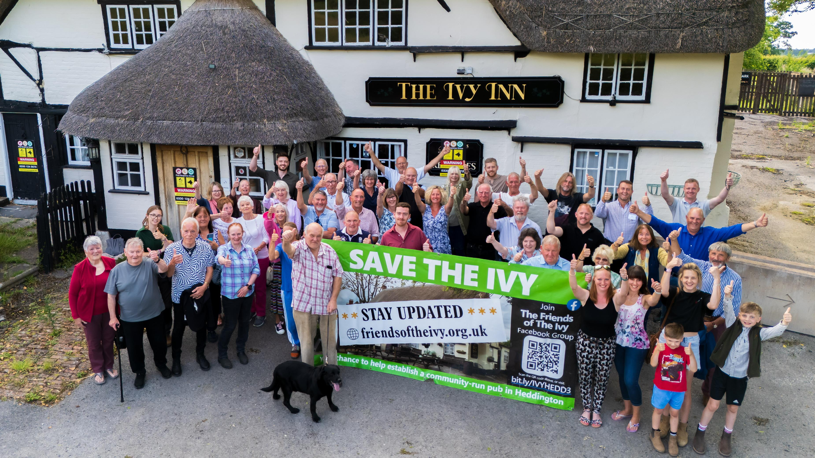

Since August’s bulletin, the number of community-owned pubs (COPs) has increased slightly from 223 to 227. Those not owned but run by the community are up one at 29. This slowdown is no doubt connected to the demise of the Community Ownership Fund. However, the number of active campaigns has gone up from 78 to 90 so enthusiasm for community ownership is plentiful. CAMRA supports the community-ownership model and is keen to help those interested in going down this route. The community pubs webpage of CAMRA’s website contains advice and guidance as well as regularly updated information about existing and planned projects. Community Right to Buy The government’s intention to bring in a Community Right to Buy was reported in the August bulletin, which aims to give community groups first refusal on the purchase of Assets of Community Value that are put up for sale. If a deal cannot be agreed, an independent valuer will set the price based on market value. Also, the moratorium period will be extended from six to 12 months and ACV nominating groups will have a right of appeal against council refusal decisions. The enabling legislation is currently in the House of Lords and should become law next spring. While this is a very positive development, its effectiveness will be severely compromised by the absence of supporting funding. The Community Ownership Fund, which over the past five years enabled many community purchases to go ahead, was wound up by the government last year and has not been directly replaced. Instead, a Pride in Place programme has been announced which will deliver up to £5bn over the next decade to around 240 deprived neighbourhoods across the UK. The areas concerned will be ones disadvantaged by both high deprivation levels and weak social infrastructure. One objective is to invest in “community spaces”, which could include pubs, while another is to revitalise high streets, including helping “small businesses thrive”. However, the reality is that these new funds are unlikely to result in many, if any, pubs coming into community ownership. There is no mention of pubs in the Pride in Place strategy document. Campaign news Ivy, Heddington, Wiltshire Wadworth brewery put the pub up for sale and the Community Benefit Society, Friends of the Ivy (above), was set up to buy it for the community. Its community share offer was launched in September and raised £400,000 in just six weeks – enough to both purchase the pub and carry out essential refurbishment. The offer was extended until 12 December, aiming to raise a further £200,000 to fund comprehensive, high-quality renovations and working capital. Hullabaloo, Shipley, West Yorkshire This bar and music venue is no longer run by a community group. It has, however, been leased to a licensee who has reopened it as Reconnection Shipley. Bayford Inn, Bayford, Somerset The former 17th-century coaching inn reopened in November. A refurbishment of the kitchen is still to come though the manager hopes to attract pop-up food providers. Ship Inn, Portloe, Cornwall The Ship Inn reopened in December after a “mammoth community effort” by the Save Our Ship (SOS) group which raised £400,000 to purchase it from St Austell brewery in September. George, Wickham Market, Suffolk This village pub burned down 12 years ago. After fighting off developer plans to redevelop the site, campaigners raised more than £2m to rebuild the pub which reopened in the summer. The George has been fully modernised but also retains much of the character from the original building. A first-floor activity room puts on events and classes. Golden Lion, Ashton Hayes, Cheshire Shut since 2013, a community group was formed in 2016 to save this historic pub. The campaign involved huge struggles with an uncooperative owner who wished to convert the pub into private housing. Sheer persistence won the day and a purchase was agreed in 2024. Following a full-scale renovation, the Golden Lion’s doors opened again in August. Elm Tree, Langton Herring, Dorset The pub’s closure in 2023 was a major blow to the village and its community, and Friends of the Elm Tree was formed to save it. The owner put the ACV-listed premises on the market giving the group just six months to raise the asking price of £650,000. After a mammoth fundraising effort, the purchase was secured in May, and the Elm Tree reopened in July. Black Lion, Skelton-on-Ure, North Yorkshire Owner Admiral Taverns closed the pub in 2016 and put it up for sale. A fundraising effort (including a 5,000-leaflet drop) raised more than £230,000 which, topped up with a Community Ownership Fund grant, enabled the purchase of the pub and a full renovation, most of the latter by volunteers. The pub opened its doors again in November. Crown Inn, Newcastle on Clun, Shropshire Closed in 2023, the 17th-century pub came back to life in November. Now owned by the parish council on behalf of the community, the Crown Inn has been renovated and extended. A grant from the now-defunct Community Ownership Fund made a major contribution. Fox, Ryton, Shropshire The Fox reopened on 19 December, initially just for drinks but a full food offering is planned for late January. The pub had been closed since 2022 but was purchased and renovated by a community group. Documentary series Three short community pub films have been commissioned by CAMRA, celebrating people who banded together to save their local. The first episode, More Than A Pub, focusses on the Antwerp Arms, London. The Travellers Rest, North Yorkshire is the star of the show in the second film, Where Community Grows, with the finale, A Pint of Love, starring Yr Heliwr, North Wales. If you have information about community ownership developments in your area, particularly new campaigns, send updates to info@communitypubs.camra.org.uk If your pub has closed or is under threat, CAMRA’s website has in-depth guides and resources, including those about community pub ownership, to help save your local here. Pictured: Ivy Inn, Heddington by Jamie Padfield, JMP photography

