Sussex brewery set to double in size
18/12/2025 by Timothy Hampson
Industry

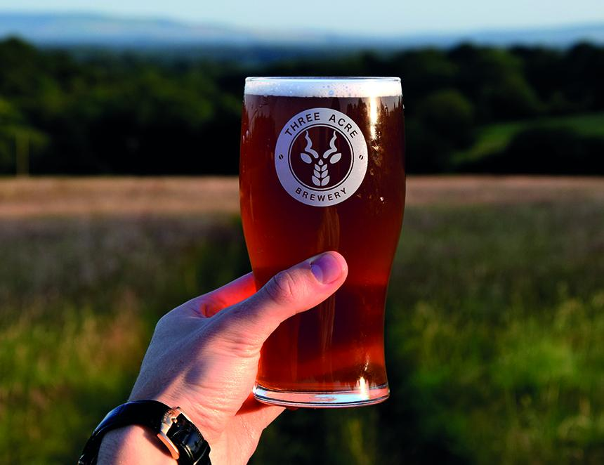

A Sussex brewery started by three school friends is set to double in size to cope with increasing demand for its beer as work begins on the expansion. Three Acre brewery, based at Blackboys near Uckfield, is taking over the neighbouring premises which had been used for the past few years by another independent brewer. “The expansion will see us more than double our floor space,” said director Chester Broad. “This is huge news for us, giving us the room to grow output significantly over the mid and long-term, making much-increased brewing and fermentation capacity possible over time, while making the working day more efficient and enjoyable for our team, and enabling new meeting spaces for us, our customers and our investors.” The change will also bring increased cold storage space, a move welcomed by brewing director Jamie Newton. “This expansion will not only accommodate greater volumes of our own beers, but also the combined output of our fledgling wholesale arm Sussex Beer Trader.” The diversification has seen Three Acre buying and selling other local breweries' beers, as well as their own since it was launched in July.

