Pub bosses call for urgent rates relief to stop closures
17/12/2025 by Timothy Hampson
Industry

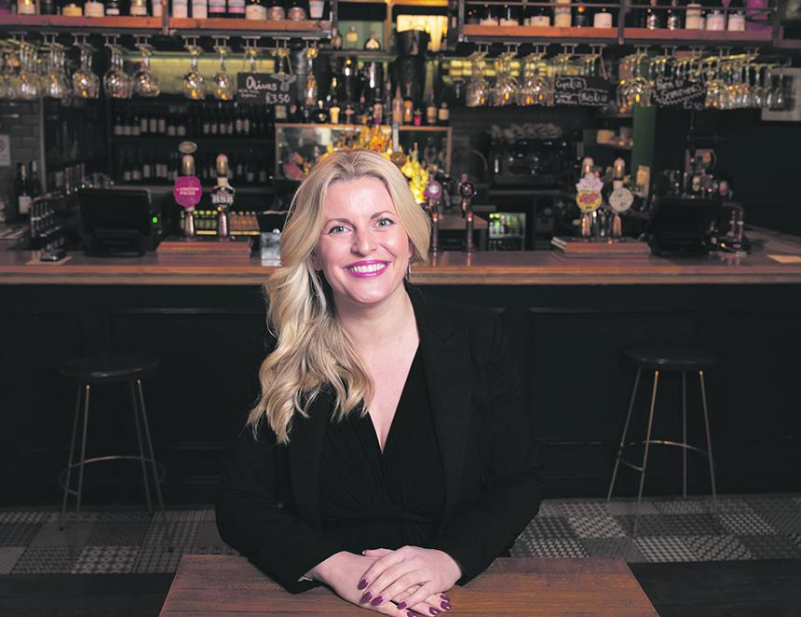

Following an emergency summit of pub chiefs, the British Beer and Pub Association (BBPA) has issued an urgent call for government to introduce a 30 per cent pub-specific business rates relief to prevent widespread closures and protect approximately 15,000 jobs. The demand came as the BBPA revealed the stark reality facing the sector and urged government to work with the sector to ensure pubs could survive. Around 4,800 of the smallest pubs will now be hit with a business rates bill for the first time, pushing many to the brink. For the average community pub, which will be hit by a 30 per cent increase in rateable value (RV) and the loss of the vital 40 per cent relief, this revaluation means a 63 per cent rise in bills, roughly £6,000 more each year. Some pubs have seen their RVs double or even triple. Meanwhile, distribution warehouses often used by online giants face increases of just 7 per cent. The summit, which followed a strongly worded letter to the chancellor where the sector said it felt misled, has led to the BBPA calling for a 30 per cent pub-specific relief applied to final bills from 1 April 2026. Without this additional relief, the BBPA said that amount in tax could threaten the equivalent of 15,000 jobs. The BBPA said the government’s plans to soften the new rates with transitional relief will not counter the devastating impact. The leading trade association said the sector’s total bill will mean a further £150 million by 2028/29 even after transitional support, an increase of 32 per cent. The calls follow the BBPA saying the claims that the Budget permanently lowered rates for pubs were misleading. It said the minor 5p tweak to multipliers does nothing to fix the long-standing imbalance: pubs continue to massively overpay relative to their turnover. With costs mounting and margins tightening, closures will only intensify, the BBPA said, stripping communities of essential social hubs and wiping out thousands of jobs. While the ratings methodology for pubs urgently needs reviewing, leaders at the summit were clear the situation is so drastic that immediate action is required. In a letter to government they said this move would require minimal changes to the current package, build on clear precedent from previous targeted reliefs, recognise the unique economic and social role pubs play and provide immediate reassurance to thousands of operators. BBPA chief executive Emma McClarkin (above) said: “This Budget left publicans petrified and many fearing there is no way they can survive these sky-high bill increases or keep their home. The situation is so grave that it requires immediate action as the very existence of thousands of pubs is at stake. “Without urgent intervention, communities will lose their pubs at an alarming rate and take with them livelihoods and jobs. A 30 per cent pub-specific relief is the simplest, fairest and fastest way to protect Britain’s locals and we want to work with government so we can ensure the sector survives.”

