Small is beautiful for festive Sheps
16/12/2025 by Timothy Hampson
Industry

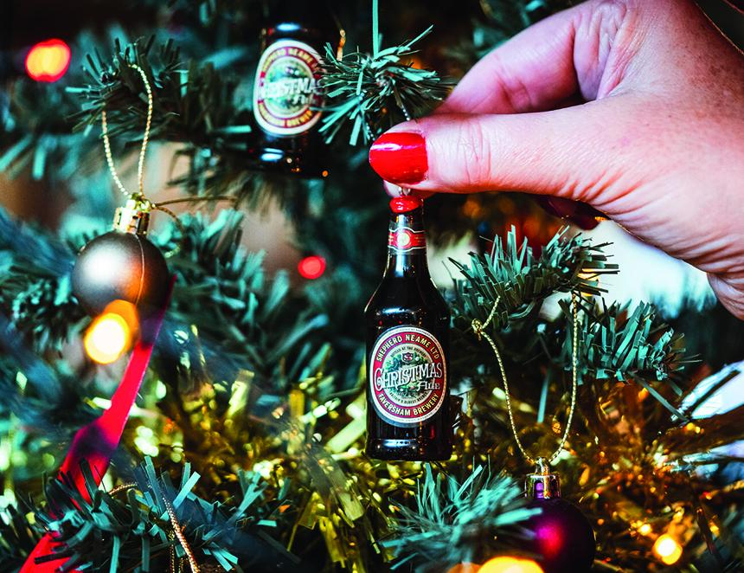

Shepherd Neame is pulling out all the festive stops to ensure it’s a season to celebrate in its pubs and hotels, and also at home. Festive favourite Christmas Ale (5 per cent ABV) has returned, and is now available at selected pubs across Kent, London and the South East. The full-bodied beer, boasts notes of mulled fruits and spices, combines pale and crystal malts with Target and Challenger hops for bitterness, and adds Goldings for aroma. It is available on draught and in bottles (7 per cent) now, as well as on sale online and in Shepherd Neame’s brewery shop in Faversham, Kent. For firm fans of Christmas Ale, limited-edition miniature bottle tree decorations (above) are also on sale now in the brewery shop, at £3.95. The 8cm-high decoration is an exact replica of its big brother bottled version, down to the full ingredients list on its back. Shepherd Neame’s director of marketing and communications Kathryn Tye said: “We unveiled our Christmas Ale decorations last year to hang on trees across our pub estate – and in customers’ homes too – and they proved a huge hit. So we thought we would bring them back for another year and they are already selling fast.”

