CAMRA Pub Heritage Group update – December
11/12/2025 by Tom Chapman
Campaign

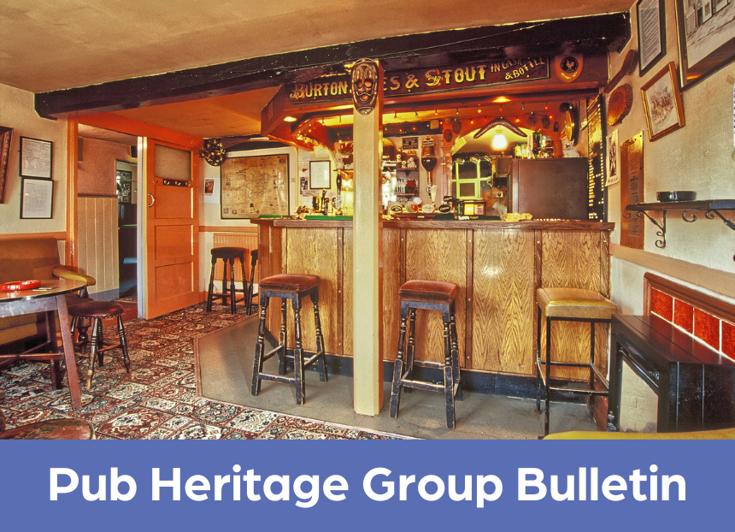

CAMRA’s Pub Heritage Group shares news and updates about pubs with historically significant interiors across the UK. For further news see the Pub Heritage Group webpage here. Three Star heritage pubs Crown and Anchor, Llanidloes, Mid-Wales Closed since October 2022, the pub was sold in October and is hoped to reopen by Christmas with no drastic changes planned. Dating back to the 17th century, the Crown and Anchor (above) is a fine example of an unspoilt, traditional town pub which retains a multi-room layout. Prior to the sale it had been in the same family ownership for more than 100 years and was known affectionately as Ruby’s, after landlady Ruby Holmes who ran the pub for 50 years from 1965 until she retired in 2018.
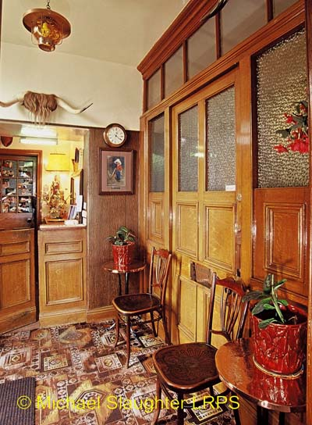
Star Inn, Netherton, Northumberland (above) The Netherton and Biddlestone Parish Council has disappointingly declined the opportunity of making an Asset of Community Value (ACV) application for the Star. Having worked hard to secure the pub’s statutory listing, CAMRA is now considering the next steps needed to help safeguard this rare national treasure. The Pub Heritage Group would like to hear from anyone who would be interested in rallying to the cause of giving the Star a future as a pub.
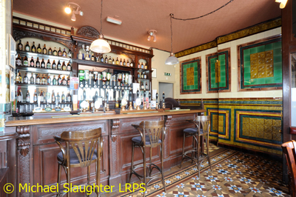
Bulls Head, Telford, Shropshire (above) The Bulls Head reopened on 31 October after owner Inglenook Inns undertook a refurbishment of the pub’s previously modernised rooms. The Grade-II listed pub was built in 1838 and is included on the inventory at Three Star status, primarily for the front bar with its spectacular floor-to-ceiling tiling, which was installed around 1904. Two Star heritage pubs
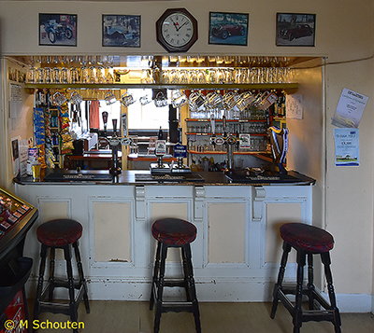
Lamb and Fountain, Somerset, Frome (above) The Lamb and Fountain is up for sale with an asking price of £650,000. The sale comes with the condition that “it is not for the faint of heart and not to be used as a tourist attraction”, which the Pub Heritage Group hopes to mean that only a buyer sympathetic to its unique character will be considered. The Lamb and Fountain is a wonderfully old-fashioned pub that has operated at least since 1753, with the building itself dating back to the 16th century. It has a multi-room interior with a surviving Victorian bar and has remained unchanged since the 1960s. As well as the pub it also has a large barn to the side which used to be a brewhouse and maltings. Find more information about the sale here.
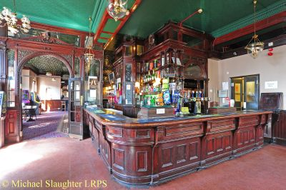
Cauliflower (553 London), Ilford, Greater London (above) The Cauliflower, a large and imposing gin palace built in 1900 at the height of the pub-building boom, reopened on 7 November having been rebranded as 553 London. It closed in 2018 following a fire and has reopened as a Mediterranean restaurant on the ground floor with a lounge and bar on the first. While the surviving Victorian features including the large servery, ornate stillion and publican’s office have been retained, the contemporary refurbishment has led to the character of the Cauliflower being fundamentally altered. The Pub Heritage Group is assuming casual drinking without the requirement to order food will be restricted to the first-floor bar only. Find more information about the pub’s reopening and refurbishment on the Ilford Recorder website here.
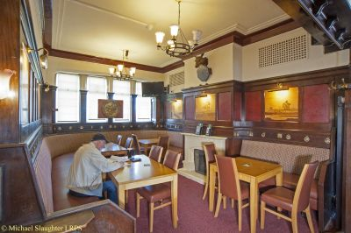
Ramsden Arms, Blackpool, Lancashire (above) After being closed for refurbishment by owner Star Pubs, as reported in August, the Ramsden Arms reopened 24 November with no changes to the interior. The pub was built in 1939 for Ramsden’s Brewers in mock-Tudor style. One Star heritage pubs
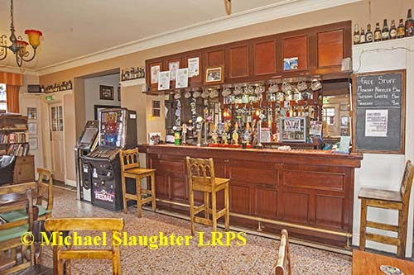
Plough Inn, Nottingham, Nottinghamshire (above) Built in 1920, the Plough Inn has been included on the inventory at One Star status. It retains a two-room layout with a central servery, a surviving glazed screen for the off sales, terrazzo flooring, fixed seating and original fenestration. The bar fittings are modern. Sadly, the Plough closed on 22 October with its future uncertain. It is not statutorily listed but is registered as an ACV. The Pub Heritage Group would welcome any further updates.
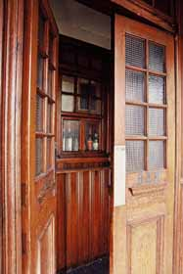
Harbour Bar, Kirkcaldy, Fife (above) The Harbour Bar closed in July as owner John Stanley is focussing on developing the onsite microbrewery. The pub will still open for music events but is unlikely to operate on a regular basis until 2027. The site became a pub in 1924 and is one of the few now left with a separate jug bar – a tiny off-sales with two hatches. Find more information about the closure on the Fife Today website here.
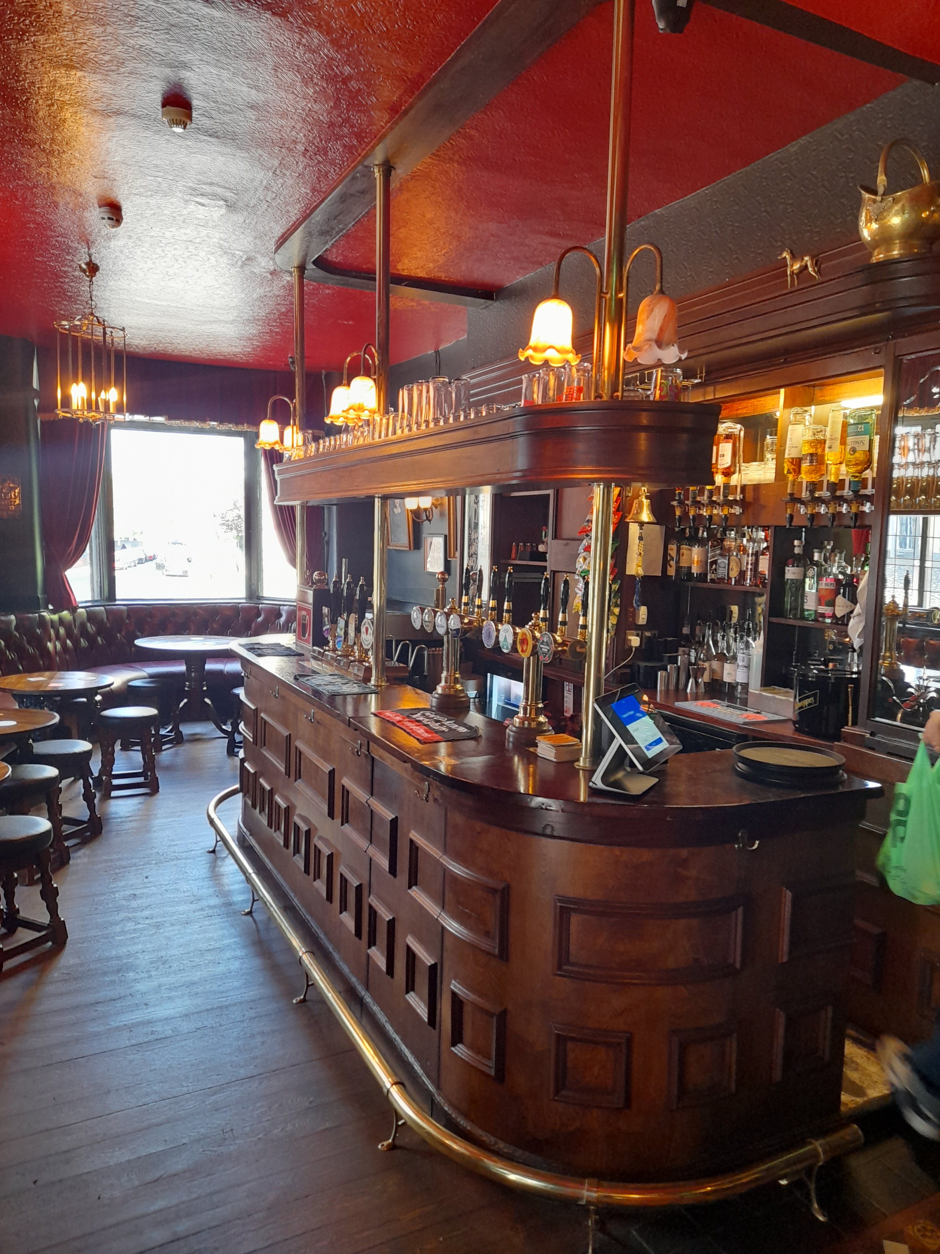
Highland Laddie, Leeds, West Yorkshire (above) The Highland Laddie, which reopened in April has claimed the number one spot in the Good Food Guide’s 100 Best Pubs in Britain. The pub is run by Sam Pullen and Nicole Deighton and offers high-quality food while maintaining a traditional pub atmosphere. Find out more about the win on BBC News here.
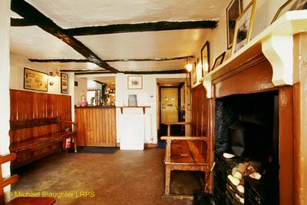
Old Point House, Angle, West Wales (above) An early 18th-century pub on a headland between East Angle Bay and Milford Haven, the Old Point Inn closed in November. It is not due to reopen until summer 2026 with the owner looking for a tenant. It has a tiny, unspoilt snug with two old settles which, until the 1980s, was the only pub room. Find out more about the closure on the Western Telegraph site here. Hanbury, Islington, Greater London North The Hanbury was rebuilt in 1937 by Charrington’s brewery and, despite being opened up, retains some inter-war features such as bar counters and fielded panelling. However, due to the illuminated bar backs having been dissected and moved, the Hanbury has been removed from the inventory. Other news The Victorian Society The Victorian Society, founded in 1958 by John Betjeman and Nikolaus Pevsner, campaigns for the conservation of the UK’s Victorian and Edwardian architecture and has a shared interest in supporting significant, surviving heritage pubs. It is currently looking for nominations for the top 10 endangered buildings 2026. Former Pub Heritage Group member, the late Geoff Brandwood, was chairman of the Victorian Society from 2001-07. Sign up to their newsletter here. The Twentieth Century Society The Twentieth Century Society campaigns to safeguard the heritage of architecture from 1914 onwards, which includes many of the pubs on the National Inventory. Each year it publishes a Risk List, highlighting outstanding 20th and 21st century buildings that are at risk of demolition, dereliction or neglect. Sign up to its newsletter here. John Young Memorial Award Robert Thomas of Remarkable Pubs has been awarded the John Young Memorial Award by CAMRA’s London branches. Remarkable Pubs has been responsible for refurbishing a number of National Inventory pubs in the capital: Boleyn Tavern, East Ham (Pub Design Award 2022 Community Local category winner), Salisbury, Harringay; Prince George, Hackney; Shaftesbury Tavern, Holloway; and Shakespeare, Stoke Newington. Read more about the win on the Ham and High site here. Heritage Talk Dave Pickersgill of the Pub Heritage Group is giving a talk about the Retford Brewery Company and associated social history at the Worksop Library on Wednesday 21 January. Tickets are £3 and can be booked here. London’s Real Heritage Pubs With Christmas just around the corner, the most recent Pub Heritage Group book, London’s Real Heritage Pubs is available to order here. If you have any news on heritage pubs, send to: info@pubheritage.camra.org.uk Feel free to forward this bulletin to friends interested in visiting pubs like these. If you wish to receive the bulletins direct, sign up by sending an email to bulletin@pubheritage.camra.org.uk with the word “subscribe” as the subject, or “unsubscribe” if you wish to stop receiving bulletins. Photos by Michael Slaughter and Michael Schouten

