Brewery helps injured rugby veteran
09/12/2025 by Timothy Hampson
Industry

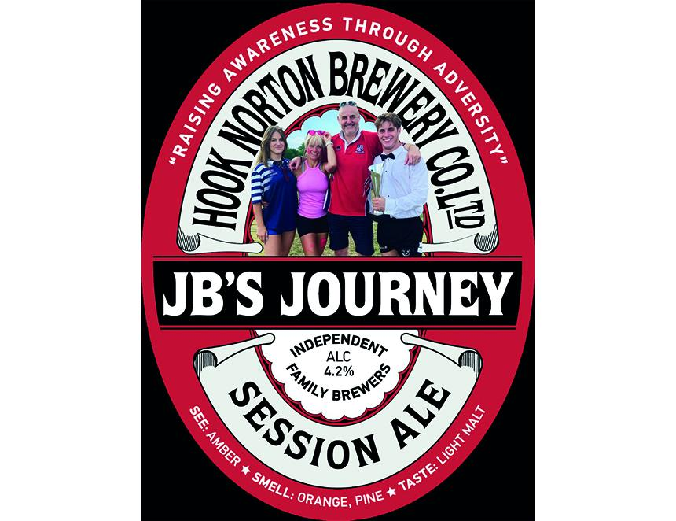

Hook Norton brewery has unveiled a special beer, JB’s Journey (4.2 per cent ABV), created to raise awareness of the former Banbury Rugby Club captain and coach John Baker, who was injured last year. John “JB” Baker sustained a serious spinal injury while playing in a Vets game. He had two major operations and spent a considerable time at the John Radcliffe Hospital following the incident. Baker’s contributions to Banbury Rugby Club included serving as the first XV captain, coaching the second team, and head coaching the Colts for four seasons. John’s wife Tina, daughter Georgina, and close family friend Paul Jackson joined brewer Robin Underwood at Hook Norton to take part in the brewing process. Together, they spent the day crafting JB’s Journey, a beer dedicated to supporting John and his family during his ongoing recovery. JB’s Journey will make its debut on the bar at Banbury Rugby Club and will also be available in selected local pubs. All proceeds from the beer will go to the JB Foundation. Hook Norton’s Mark Graham said: “I played with John and worked with Tina, so this is very personal to me, and being able to help the family means a lot. Beer and rugby clearly go very well together, and as a brewery we are proud to support the club and all that they do.”

