First festival turns clock back
04/12/2025 by WB Reporter
Campaign

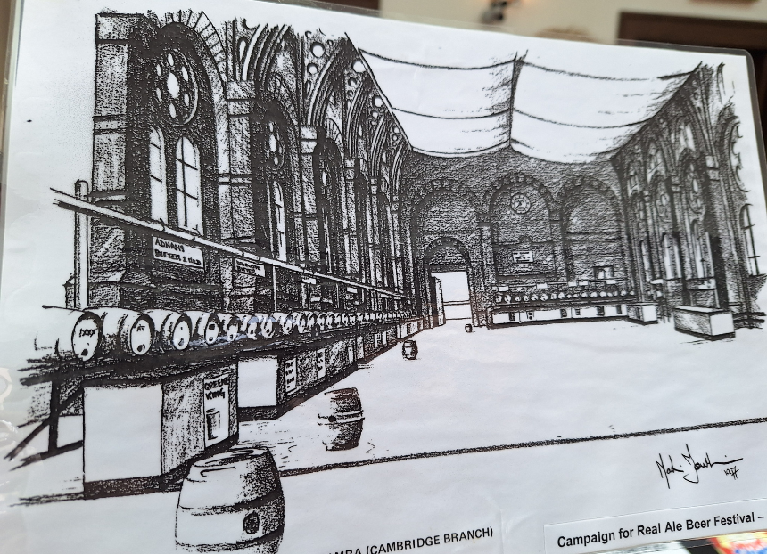

Cambridge CAMRA branch is reviving its link with the city’s Corn Exchange when its winter beer celebration returns to the venue which held the Campaign’s first festival. CAMRA was founded in 1971 and its Cambridge branch in 1973. The possibility of organising the first CAMRA festival was proposed by Peter Pearse sometime before the 15 January 1974 meeting. At the meeting, held in the Panton Arms, Panton Street, Peter reported the plan for a festival was ongoing, would feature as part of the annual Cambridge Festival celebration and it had received support from both the event’s committee and CAMRA’s National Executive. Members were warned the festival “had to be successful”. This was significant as the committee had tried to organise a beer festival in 1973 which had enjoyed little success. Members were told “both qualified and semi-skilled staff were required” to volunteer if the festival was to be a success. In March 1974 Peter, the first CAMRA beer festival organiser, reported detailed proposals for the festival had been rejected by the Cambridge Festival Committee on two grounds: the financial commitment, which the Cambridge Festival committee refused to take even part responsibility, and the lack of a venue. It was agreed the Cambridge branch would take on the full financial commitment and it would seek suggestions for a suitable venue. The latter proved to be a great stumbling block and it was not until May 1974, two months before the festival was to take place, that Cambridge Corn Exchange (pictured) was found and the event saved. The first CAMRA festival ran from 24-27 July. It featured brews from 12 breweries plus one German beer. More than half the beer was sold on the first day. New stock was found and the festival went on to further success. The four-day event attracted 5,000 visitors. This began a partnership between the Corn Exchange and Cambridge branch, which saw it host an annual beer festival until the venue closed for refurbishment in 1982 and returned when it reopened in 1987. By 1991 the festival had outgrown the site and 1992 saw it under canvas as it moved to the Cambridge City football ground, and in subsequent years, on to Jesus Green, Cambridge. The first CAMRA Cambridge Winter Festival, and the forerunner to the 2025 event was called the Cambridge Festival of Ale and Cakes. It took place in Coleridge Community College and was held in January 1986. This year, fittingly, the Cambridge Winter Beer Festival is returning to the Corn Exchange, helping celebrate its 150th anniversary. While it is a winter festival and features seasonal and dark beers, there will be a balance of styles and tastes for everyone. Examples of beer from three of the breweries – Adnams, Batemans and Greene King – featured in the 1974 list can be found. The festival runs from 10-13 December. For more details see cambridgebeerfestival.com/event/cambridge-winter-beer-festival-2025

