Swan Crowdfunder hits right note
03/12/2025 by Timothy Hampson
Pub

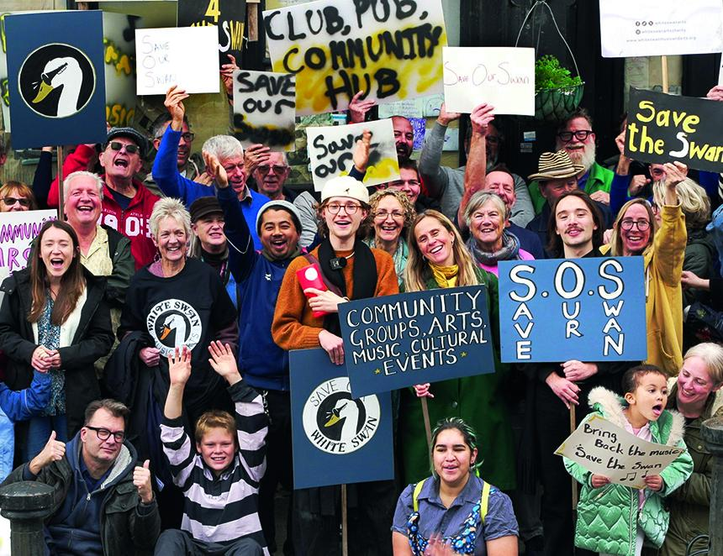

A new charity aims to raise a £360,000 deposit via a Crowdfunder campaign to buy the White Swan pub and live music venue in Charlton Village, South East London. The White Swan Music and Arts (WSMA) campaigners ultimately aim to raise enough money to buy the pub outright and refurbish the Victorian two-storey building. WSMA said bringing the building into community ownership means profits can be ploughed back into young musicians. The Crowdfunder campaign to raise an initial deposit includes rewards like an intimate gig with Glenn Tilbrook lead singer of Squeeze and VIP access to local musicians or the chance to own a personalised, one-of-a-kind tankard made by local ceramicist Fiona Veacock. This campaign is bringing together local artists, musicians, Charlton Athletic supporters and everyone in the wider community to create a new future for this derelict building. WSMA aims to create a multipurpose community arts space above the pub, including digital content creation spaces and a stage to support young artists experiencing their first performances in a pub setting. The campaign is backed by Glenn Tilbrook from Squeeze: “Over 50 years ago, the first gig that myself and Jools Holland got was playing in the Morden Arms in Greenwich. “We soon had a residency there and started getting gigs in other pubs, gradually. It was great fun and helped us to find ourselves. “Places like this are vital for young musicians to learn their craft, playing to friends and neighbours. I hope that the White Swan will be able to host another generation of musicians soon.” WSMA chair Suzanne Hunt said: “The White Swan has been closed now for five years. To me, it’s more than just a pub – it's where my family celebrated landmark anniversaries or simply where we could gather for Sunday lunch. “Our plan is to restore the pub and live music venue, but also do more by investing any profits to enable young people access to the arts and provide a space for our wider community. The White Swan should be where you walk up to the bar as a stranger but walk out as a friend.” The Crowdfunder page and video are now live here.

