Cockermouth brewing doubles up
01/12/2025 by Timothy Hampson
Industry

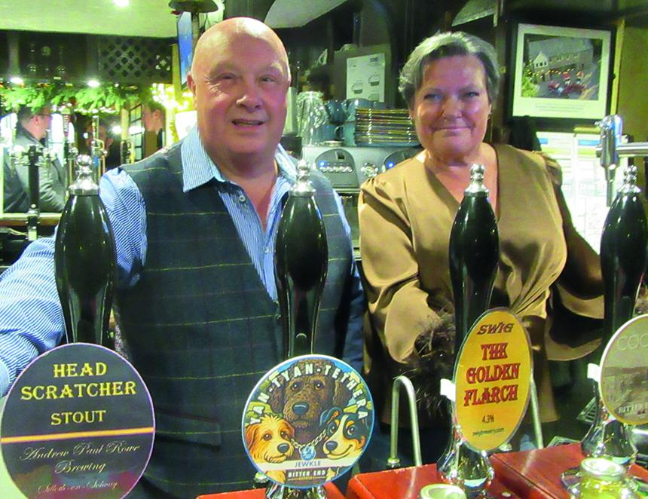

Cockermouth is celebrating going from no breweries to two in just a year. Earlier this year brewing returned to the Jennings site, closed in 2022 by Carlsberg Britvic, now it has been joined by the Bitter End pub. The pub in Kirkgate launched its own beers on in November. Mark Cockbain and his wife Jackie (pictured) bought the pub in spring 2020 and has gained a reputation for good food and cask beers from independent breweries. Under its previous owner the pub had operated its own brewery in the 1990s, but production ceased around 2000 and the space mothballed. In June 2020, Mark Cockbain bought and installed replacement equipment but difficulties with the electric supply delayed the start of brewing. However, having undertaken a brewing course in Sunderland, Mark Cockbain finally started producing in September. The results were unveiled at a packed event on 21 November. Two Bitter End beers were on offer, Cocker Gold, at 4.4 per cent ABV, and Yan Tan Tethera, a dark beer at 4.7 per cent. West Cumbria CAMRA member Len Wainwright said: “Both beers were excellent. “Also on offer were two beers from the newly established Swig brewery in Frizington. Golden Flarch, at 4.3 per cent and Lady Lush, at 4.8 per cent, plus Head Scratcher stout at 3.9 per cent from another new independent brewery at Siloth. “It was good to see Mark supporting other local newly started breweries besides his own. Mark will be brewing 500 litres at a time with the next beers due mid-December. Mark eventually intends to get a licence so that he can sell his beers to other independent pubs.”

