CAMRA wins big at guild awards
28/11/2025 by WB Reporter
Campaign

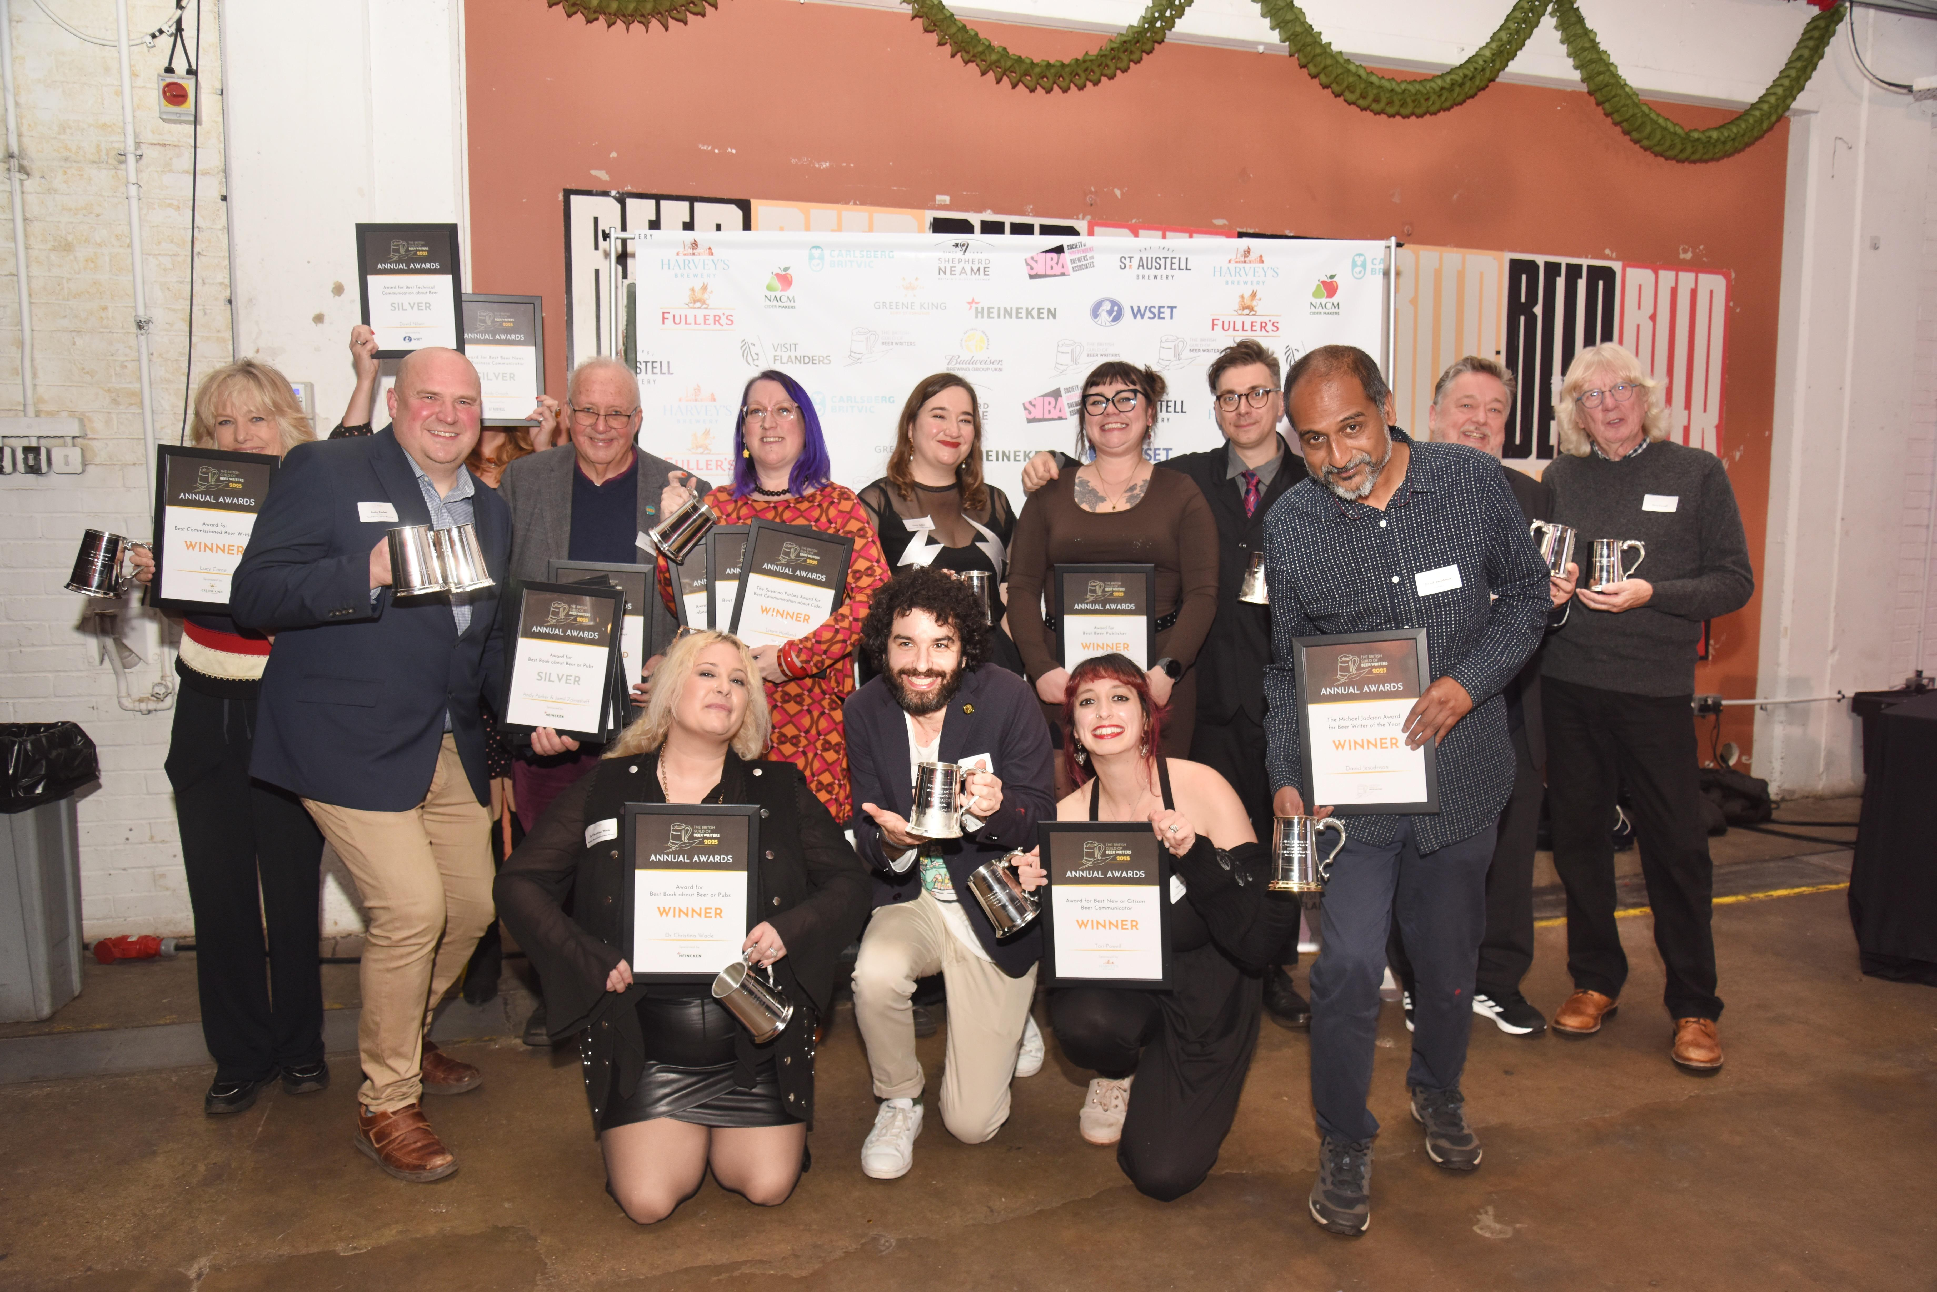

Books published by CAMRA, What’s Brewing columns and Learn and Discover content were recognised at the British Guild of Beer Writers’ annual awards. Tasting Notes: The Art and Science of Pairing Beer with Music by Pete Brown won gold in the Best Technical Communication about Beer category. Tasting Notes blends music, beer and science to show how sound changes flavour, transforming the reader’s appreciation of both beer and music. Pete Brown uses popular science to explain how our senses work, how we appreciate flavour, sound, and the world around us. The engaging book uncovers how our senses interact in ways we don’t even realise and proves how you can change the way your beer tastes by simply listening to your favourite tunes. The Modern Homebrewer by Andy Parker and Jamil Zainasheff took home silver in the Best Book about Beer or Pubs category. The book is a hands-on, practical guide to the most modern and up-to-date home brewing ingredients, equipment, and processes. Written by two award-winning homebrewing experts turned professional brewers, The Modern Homebrewer will equip both novices and the most experienced brewers with the skills they need to produce professional quality beer at home. Laura Hadland claimed two awards for her What’s Brewing columns. Her article, Trigger warning: sexual violence and rape won silver in the Best Short-Form Beer Writing category. Taking part in an International Women’s Collaboration Brew Day event, Laura calls out sexual discrimination and abuse in a powerful, hard-hitting piece. Laura’s Alcohol free: situation normal? was highly commended in the Best Communication about No and Low Alcohol Beer category. Following the first low-and-no bar at the Great British Beer Festival, Laura explores the changing attitudes of drinkers and pubgoers. Gabe Cook, the Ciderologist, won silver in the Best Communication about Cider category with his Learn and Discover video World of Cider: Asturias. Exploring one of the world’s oldest cider cultures, Gabe learns more about the history of cider in Asturias as he meets cider makers across the region and as he visits some of Asturias’ many cider bars. Rachel Hendry also took silver with her Learn and Discover article, Cask: A social perception, in the Best Communication about Diversity in Beer category. The eye-opening piece, illustrated by David Bailey, investigates into how cask beer is perceived and whether its perception is holding the drink back, plus cask’s history and its place in pubs. The British Guild of Beer Writers was formed in 1988 to help spread the word about beer, brewing and pubs. With close to 300 individual and more than 60 corporate members, its mission is “to improve the standards of beer writing and improve the public knowledge of beer and pubs”. Pictured: 2025 award winners (Photo: Cath Harries)

