New survey’s key role in fight for fairness
28/11/2025 by Timothy Hampson
Industry

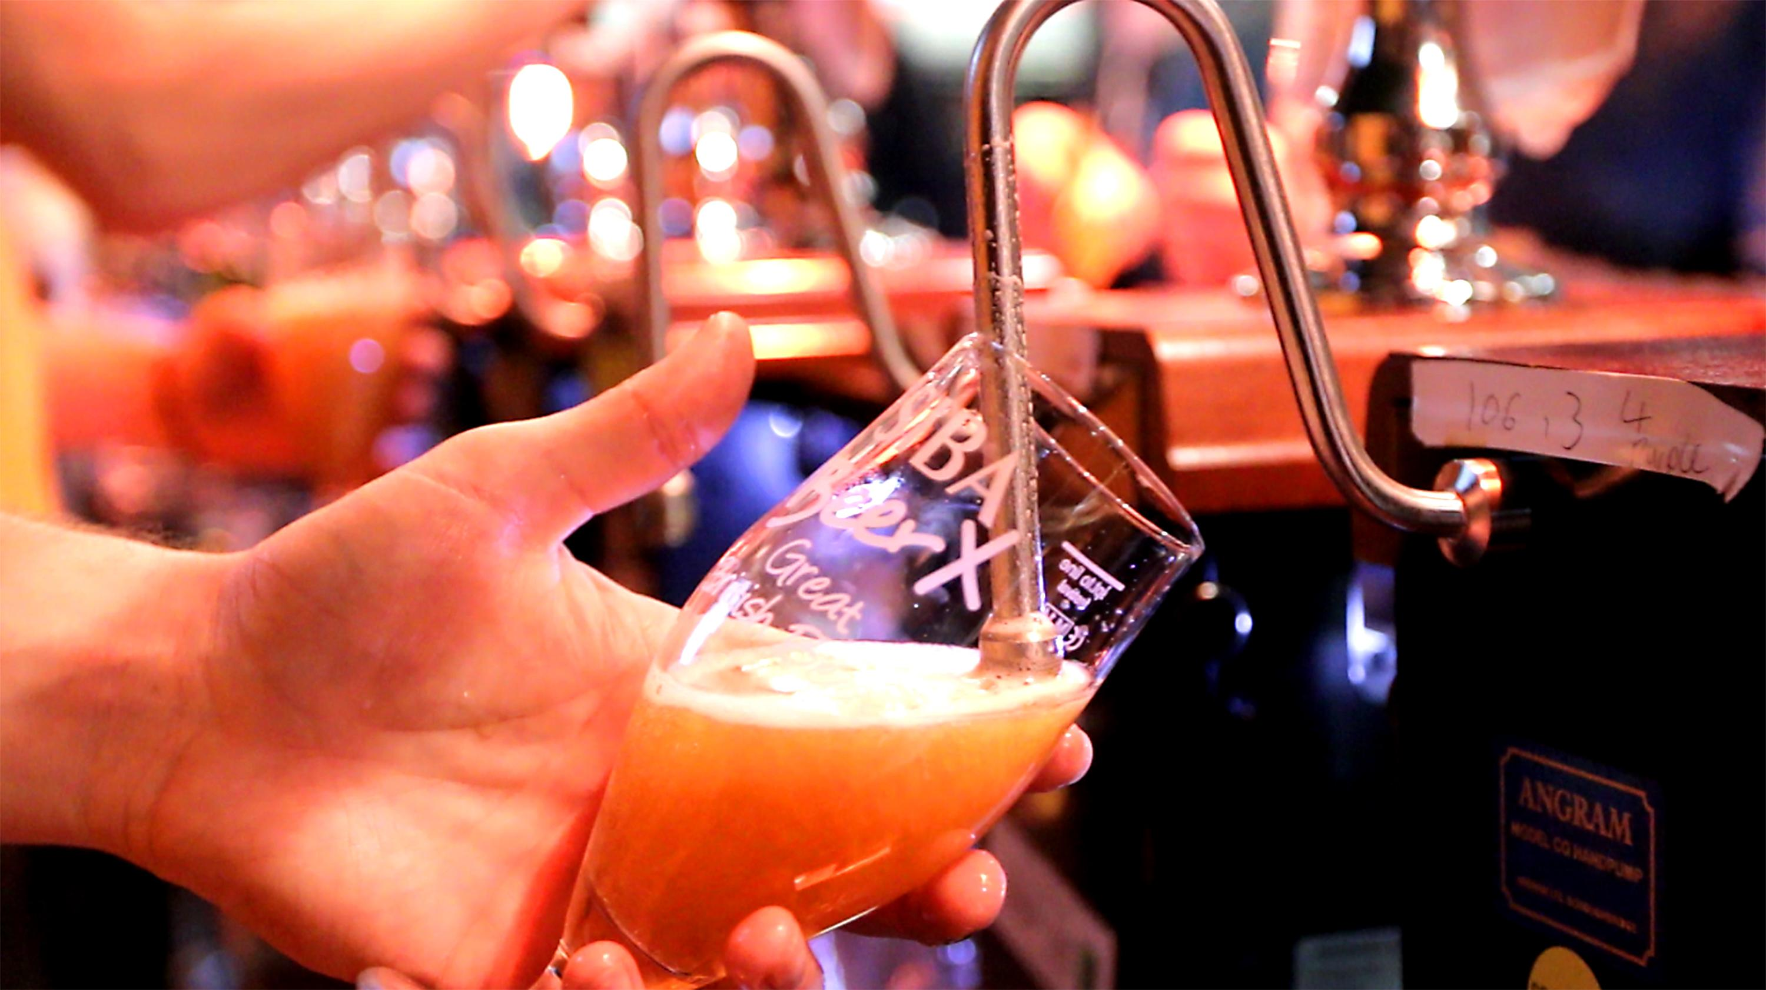

The Society of Independent Brewers (SIBA) has launched its 2026 industry survey as part of its campaign to “fight for fairness” within the sector. The survey plans to use data from breweries across the UK to provide the evidence to improve conditions for independent brewers. The survey is a call to action for independent brewers, inviting them to share their experiences, challenges, and successes. The information will help SIBA identify key factors facing the industry, from access to market and taxation, to the impact of supply chain disruptions and shifting consumer preferences. By highlighting the realities of independent brewing in 2026, SIBA intends to use the findings to inform its discussions with government, regulators, and the wider public. The fight for fairness campaign is at the heart of SIBA’s mission. Independent brewers continue to face significant challenges, including market access, rising operational costs, and regulatory pressures. The campaign seeks to ensure that the voices of smaller breweries are heard and that they receive equal treatment compared to larger, multinational producers. The 2026 survey will provide fresh data and concrete examples to strengthen SIBA’s advocacy and support for the sector. This year SIBA has also worked with Women on Tap (CIC) to improve the data gathered on female ownership and leadership in brewing. Women On Tap founder Rachel Auty said: “We’ve been delighted to work with SIBA for the 2026 survey to make what we feel is an important addition. In the question about the people working in the business, we've now added owner/director/CEO so we can track the gender splits at the most senior level of breweries and other beer organisations. “We see this as a key indicator of change – it tells us who is leading and steering the industry, and how that might be changing – and it’s data that hasn’t existed before. It will be valuable for Women On Tap to have access to this data, but also for the wider industry to have this snapshot.” For more information or to participate in the survey go to: siba.co.uk

