Dark days ahead for pubs following Budget
26/11/2025 by WB Reporter
Campaign

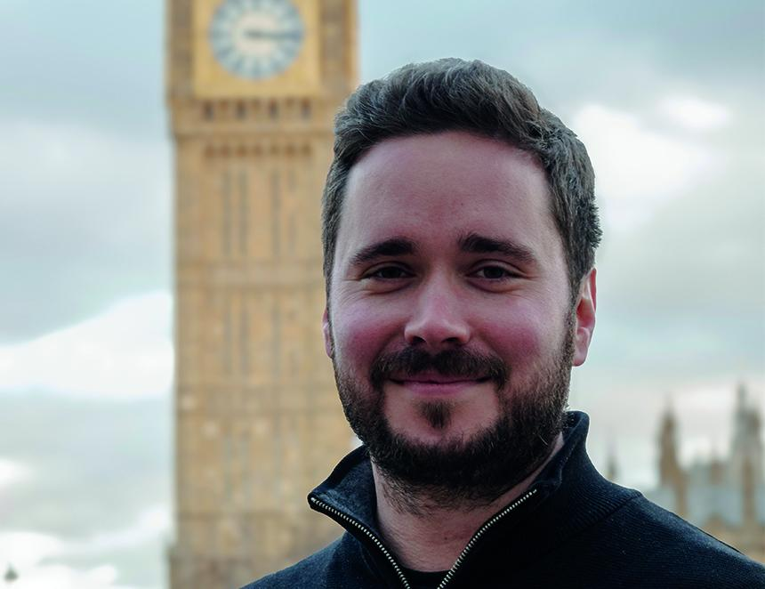

Following the Budget statement CAMRA chairman Ash Corbett-Collins (above) said: “This is a dark day for UK drinkers, pubs and breweries. Instead of offering a bold package to save and support the UK's pubs, the chancellor has chosen not to help with VAT, energy bills or employer National Insurance contributions. Pubs and breweries can contribute to economic growth but only with proper support from the government on sky-high costs which are making it impossible for many pubs to survive and thrive. “The decision to introduce permanently lower business rates for hospitality businesses in England from next May is a positive step and is long overdue. The Treasury has stated that all retail, leisure and hospitality businesses will pay lower rates bills than they do at the moment, even with the 40 per cent discount on business rates bills ending next year. This is encouraging, but pubs will want to know just how much they will be paying to be able to plan and to know how much this decision will help them at a time when other costs continue to rise. “We are bitterly disappointed that alcohol duty has been hiked today. Instead of delivering a substantial cut in tax breweries pay on their beer going to be sold in pubs, the chancellor has made the damaging choice to hike alcohol duties, including on draught beer and cider. As well as a cut in VAT and help with energy costs and employer National Insurance contributions, Rachel Reeves should have taken action to recognise the benefits of drinking in community locals by slashing tax specifically on pints in pubs by up to 50 per cent to help them compete with cheap supermarket alcohol. This extra hike in taxes on drinking in the pub can only risk more pubs and breweries being lost to the communities they serve. “Pubgoers and pub licensees will be shocked that the only mention of supporting pubs in the chancellor’s statement was re-announcing some tinkering around the edges of the licensing system in England and Wales. This just doesn’t cut it. Hundreds of pubs have closed this year and thousands more are at risk because of this Budget where no support has been given on VAT, energy bills, alcohol duty or employer National Insurance contributions.”

