Rocking Rudolph returns with new look
26/11/2025 by Timothy Hampson
Industry

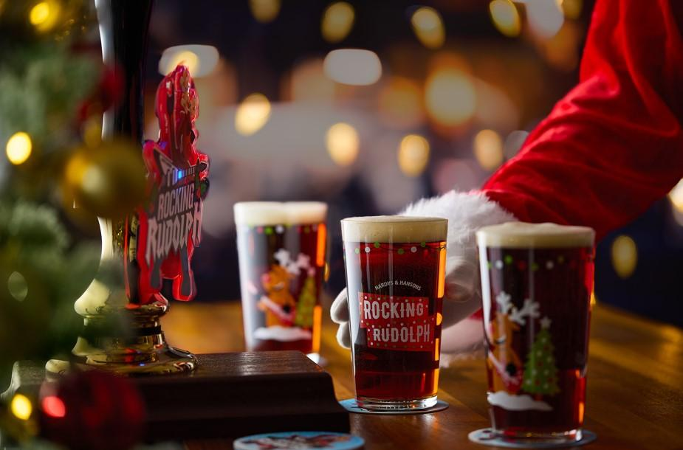

Greene King is embracing winter with the return of three of its seasonal cask beers. Leading the line-up is Rocking Rudolph (above), back with its full-bodied flavour and rich malty notes. The 4.2 per cent ABV beer has a refreshed festive badge, featuring Rudolph’s lights and extra Christmas spirit to draw attention to the pump handles this November and December. As part of the company’s partnership with Macmillan Cancer Support, 5p (plus VAT) from every pint of the Christmas beer sold will be donated to the charity. Fireside, 4.5 per cent ABV returns until the end of December. The grapefruit and lemon citrus flavours are balanced by the black malt that adds a subtle dryness to the beer. Rounding off the cask trio is Abbot Reserve, 6.5 per cent ABV. Known for its rich fruitcake notes and full-bodied depth, Abbot Reserve is ideal for those seeking a deep, rich flavour. The beer will be in pubs for December and January. Brand manager Amina Ali said: “Our winter cask range is all about bringing celebration, rich flavours and a sense of occasion to venues. “Rocking Rudolph is a firm festive favourite, and this year’s refreshed badge adds even more theatre to the bar. “With Fireside and Abbot Reserve also returning, we’re offering a trio of seasonal ales that cater to all those winter moments.”

