All roads lead to Beerex
25/11/2025 by Timothy Hampson
Campaign

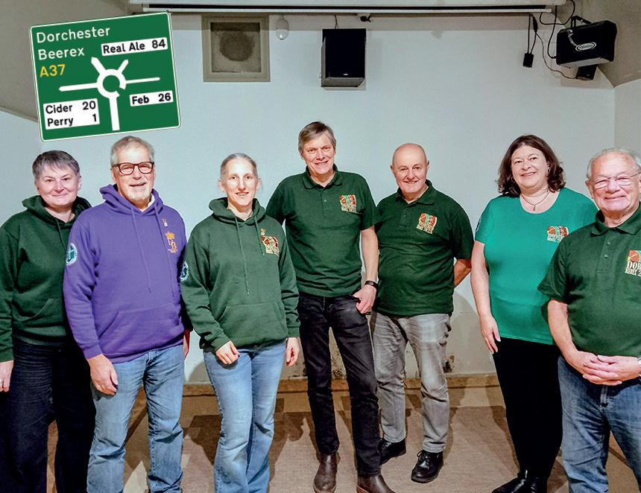

West Dorset branch’s Beerex will be returning to Dorchester’s Corn Exchange 6-7 February next year. Cerne Abbas brewery will be continuing as the main sponsor and will have a selection of its beers including some one-off specials among the 84 cask beers from around the UK with a large selection of ciders and perries. The main charity beneficiary will be People First Dorset, which aims to assist people with learning disabilities through friendship clubs aiming to reducing social isolation and promoting independence and wellbeing. To date the festival has raised more than £300,000 from companies and breweries through barrel sponsorship and raffle prize donations. Money from the raffle will once again go to the Dorchester Youth and Community Centre in Kings Road. Branch and Beerex committee chairman Bruce Mead said: “Planning for the 2026 Beerex is in full swing and, with the event coinciding with the 50th anniversary of West Dorset CAMRA, we are hoping to have some very special celebration beers on offer. Watch this space.” Customers can expect music in the evenings with a party atmosphere on the Saturday and beer, banter and chatter on the lunchtime sessions. Upstairs there is seating for more than 100 visitors. Tickets will go on sale 1 December costing £12 which includes a commemorative glass, programme listing all beers and ciders with tasting notes and two half-pint tokens. CAMRA members will receive an extra pint. Tickets outlets are: Convivial Rabbit and Tom Browns, Dorchester; Brace of Butchers, Poundbury; Globe, Weymouth; or buy online at beerex.co.uk Beerex committee with Bruce Mead centre. Photo Rich Gabe

