City-centre’s price of a pint tops £7
24/11/2025 by Timothy Hampson
Campaign

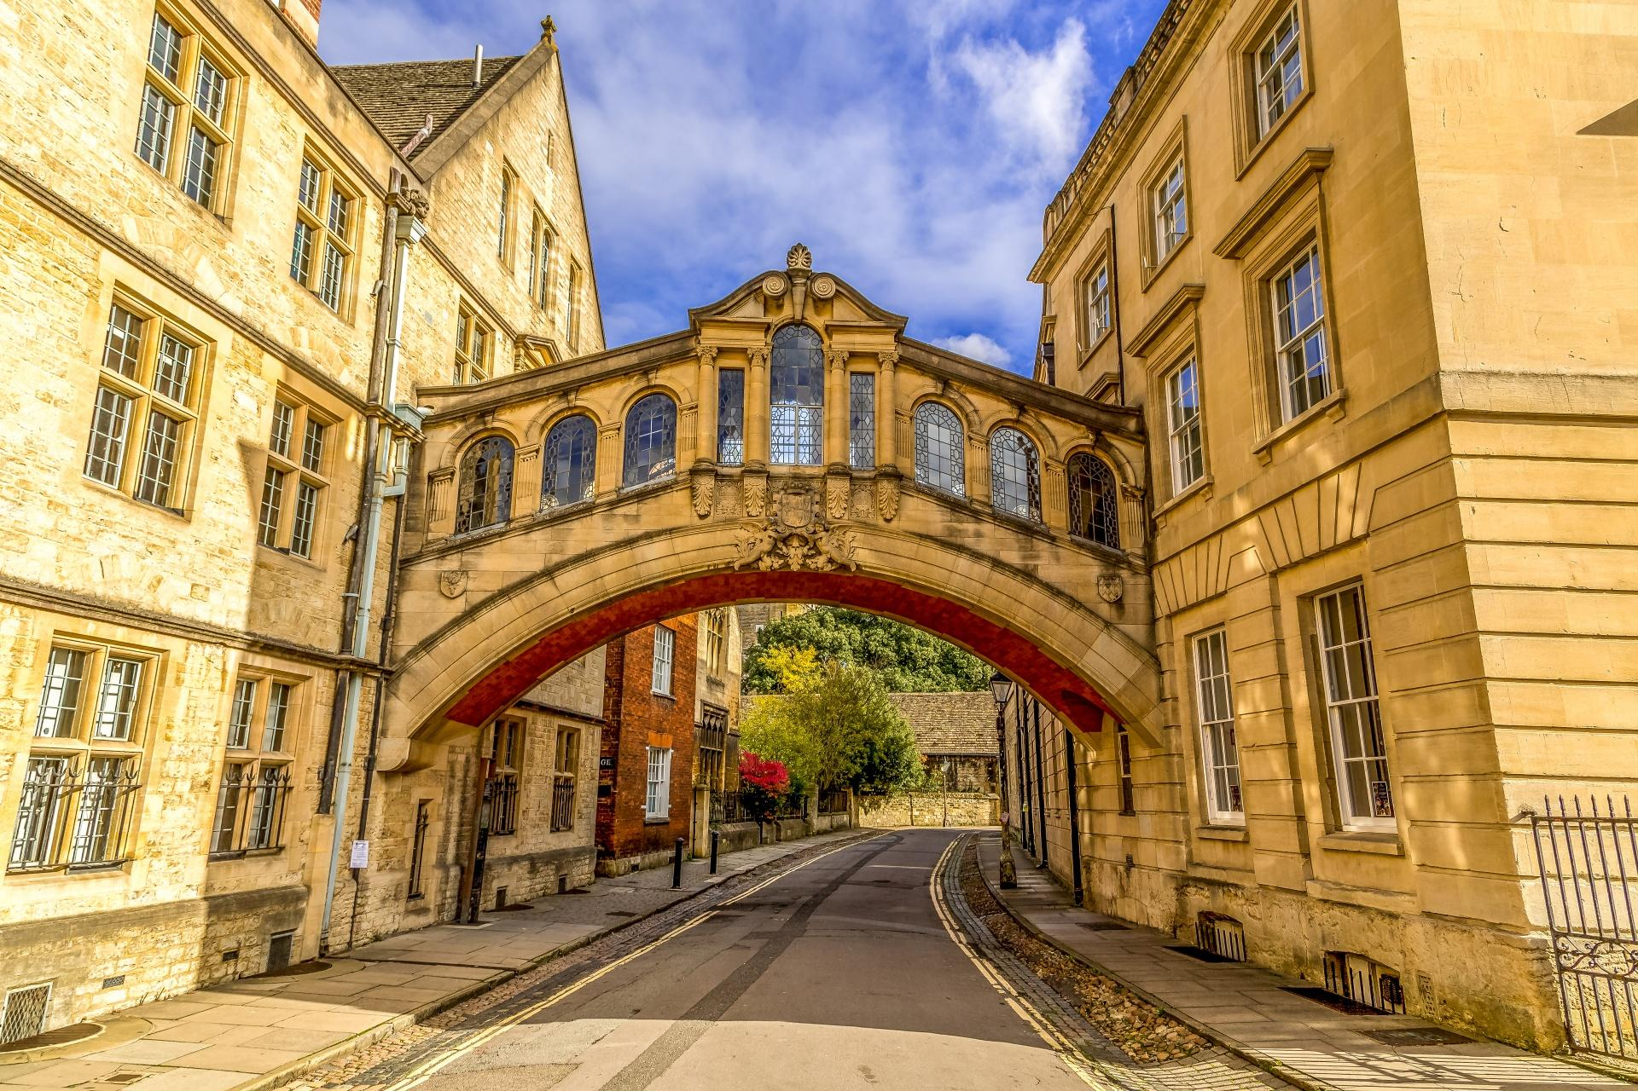

The number and choice of cask beer in Oxford city centre is holding firm, according to a survey of 24 pubs by members of the city’s CAMRA branch. The survey, done on Saturday 8 November, found beer prices are up but cask beer holds its own in the city centre as the price for a pint hits more than £7 for the first time. Oxford Drinker editor Dave Richardson said: “There is renewed concern over the steady increase in prices, with one pub, the Turf Tavern, breaking the £7 ceiling for a pint of real ale for the first time and an average price of £5.62 compared to £5.42 last year. “These price rises illustrate the difficulties facing all pubs as they grapple with extra staff costs caused by higher National Insurance and minimum wage rates, business rates and escalating costs passed on by brewers, food and energy suppliers, and others. Pubs are looking to the Budget on 26 November to provide some relief, with the pub industry warning that further closures are inevitable unless something is done.” While city-centre pubs are insulated to some degree by the large volume of well-off tourists, all locals are aware more people are drinking at home when supermarkets are selling 500ml (slightly less than a pint) cans of cheap lager for £1 or less, and bottles of good quality beer for around £2. With good quality keg beers typically costing around £1 a pint more in pubs than cask beers, the gulf between pub and supermarket prices is getting ever wider with the possible side effect of people staying at home drinking to excess. Oxford CAMRA secretary and survey organiser Steve Lawrence said: “The headline this year is that there has been very little change in terms of number and variety of real ales available but inevitably the average price has gone up, and the first sighting of a (fairly ordinary) pint at more than £7. “There are now 24 real ale pubs in the OX1 area bounded by Magdalen Bridge, Folly Bridge, the railway station and the junction of Banbury Road and Woodstock Road. “We found 114 beers on sale [113 in 2024] with some duplicated, so the number of different beers available was an impressive 86 [85]. The most frequently found beer was Oxford brewery Prospect (five), then Greene King (GK) Abbot with four, and GK IPA, Sharp’s Doom Bar, Fuller’s London Pride and Timothy Taylor Landlord with three each. Oxford brewery has come from nowhere last year to take the lead. “Unsurprisingly, the most common brewery was Greene King with 10 different beers although four were one-off specials for the Turf Tavern. Titanic supplied five, and four different beers could be found from Fuller’s, Marston’s under various guises, and Hook Norton.” Regarding prices, the figures exclude the Wetherspoon pubs (Four Candles and Swan and Castle) where cask beers all cost £2.59 except GK IPA at £1.89, a slight change from 2024 when cask beers all cost £2.49 with IPA at £1.99. Also the White Rabbit was selling a one per cent ABV beer from Twisted Tree for £1, so that is not included either. The average cost of a pint overall was £5.62, while the highest price was £7.05 for both Chadlington brewery beers at the Turf Tavern. Last year, the highest-priced cask beer was £6.55 at Fuller’s Head of the River. The lowest price was £3.90 at the White Rabbit (up from £3.80 last year) but the number of pubs where you could not get a pint under £5 has gone up from 12 to 15. In both Fuller’s pubs (the Bear and Head of the River) you couldn’t get a pint for under £6. Worthy of note is that an impressive 19 pubs had gluten-free beer available either from keg, can, or bottle, with three having gluten-free cask beers. Some local breweries, including Little Ox and Loddon, now produce all their beers gluten-free.

