Stag hunts for bright future
23/11/2025 by Timothy Hampson
Pub

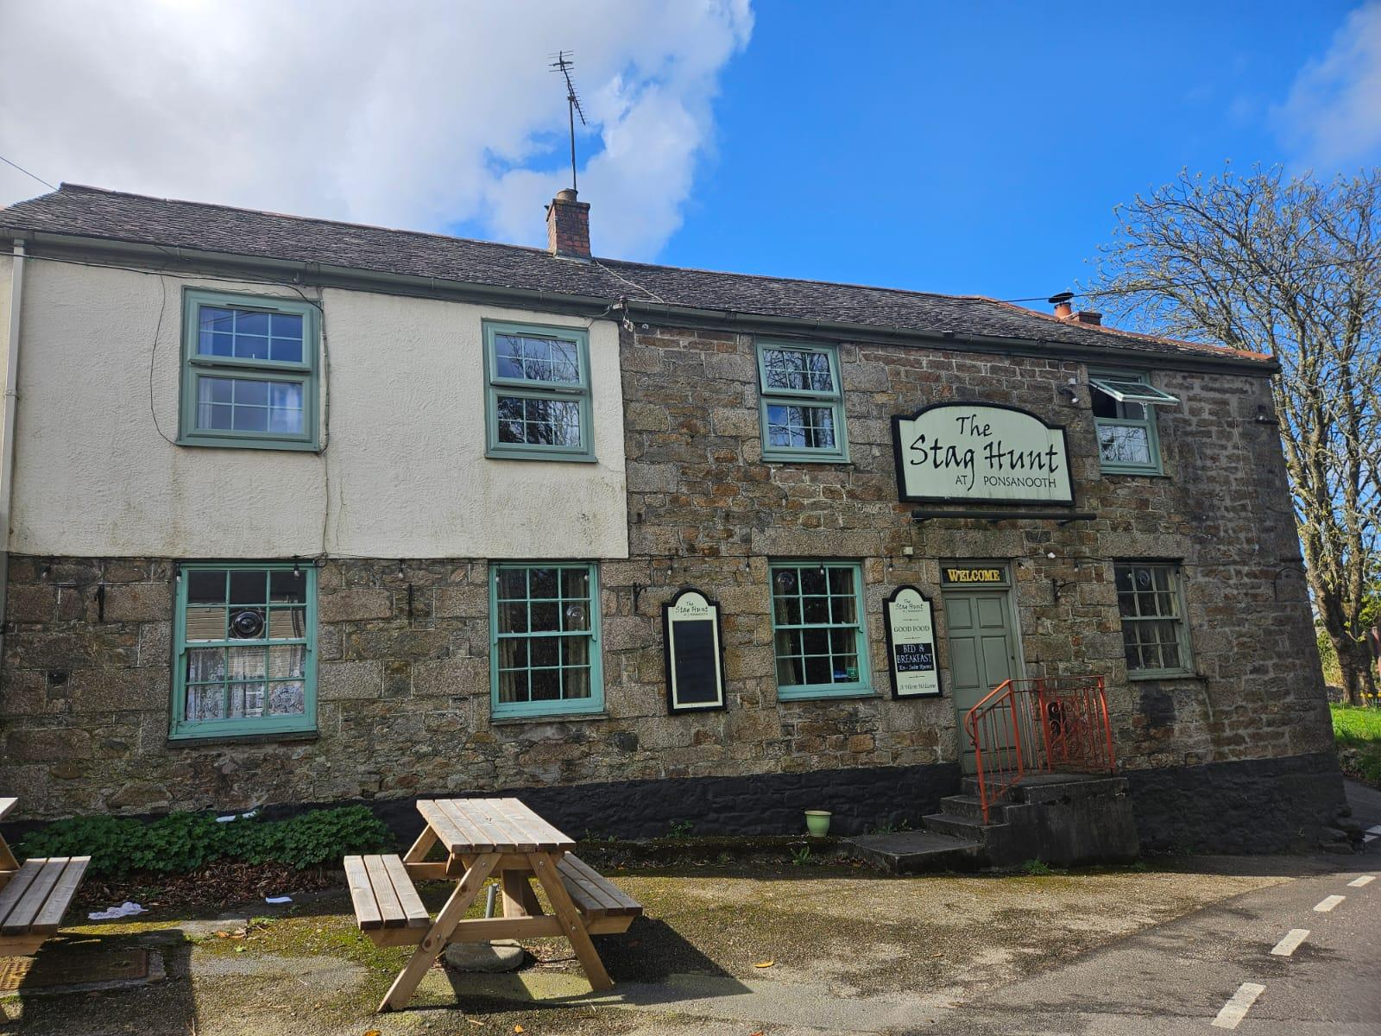

Ponsanooth Community Benefit Society (PCBS) has opened its long-awaited community share offer to secure the future of the Cornish village’s Stag Hunt Inn. The community-led initiative aims to raise a minimum of £300,000 to buy the village’s last remaining pub’s freehold and safeguard its future. A PCBS spokesman said: “The road to reach our goal is a long one, and is in no way guaranteed to succeed, but faced with the alternative of losing our village pub forever, we felt we had to step in and do everything we can.” The pub dates back to the early 1800s and sits at the heart of the Cornish Mining World Heritage Site, closely linked to the Kennall Vale gunpowder works. For decades, it has served as a vital meeting point for neighbours, families, and social groups. Its closure would leave Ponsanooth without a communal space where people can connect and support each other. PCBS chair Sam Fitch said: “The time to act is now. Without community support, we risk losing the Stag Hunt Inn forever. This is our opportunity to reclaim a cherished piece of village history and create a thriving, inclusive space that strengthens Ponsanooth for decades to come for both locals and visitors alike.” PCBS was formed by volunteers after overwhelming support from a community survey and public meetings. The society has already secured early grants, built a strong volunteer network, and commissioned an independent valuation confirming the pub is at risk and currently trading far below its potential. With the pub on the market for 18 months and the vendors becoming “increasingly motivated sellers”, the team believes demonstrating strong local backing will be key to negotiating a fair purchase price. The share offer opens the door for anyone to support the future of the pub and represents a critical step in ensuring the success of the project. To keep the offer accessible, the minimum investment has been set at £100, with every shareholder becoming a member of the society and gaining an equal vote in how the pub is run. Investments will receive a competitive rate of interest and may also qualify for substantial tax relief. If successful, the community plans to restore the Stag Hunt as a traditional country pub with low ceilings, warm interiors, and space for activities such as quizzes and games. PCBS aims to deliver “more than a pub”: a warm space for isolated residents, a social café area for families and young people, and a venue where community groups can run events, workshops and activities throughout the year. Plunkett UK’s David Miskin said: “Community ownership is becoming one of the few truly resilient models in today’s hospitality landscape. The Stag Hunt Inn is a perfect example of a once-thriving pub that has been forced to close. “By giving the community the chance to step in, we’re not just saving a pub - we’re demonstrating a viable, sustainable future for rural hospitality at a time when the sector needs success stories more than ever.” Investors can access the share offer and find more information at savethestag.co.uk

