Beer poached pears with beer caramel sauce
23/11/2025 by Christian Gott
Opinion

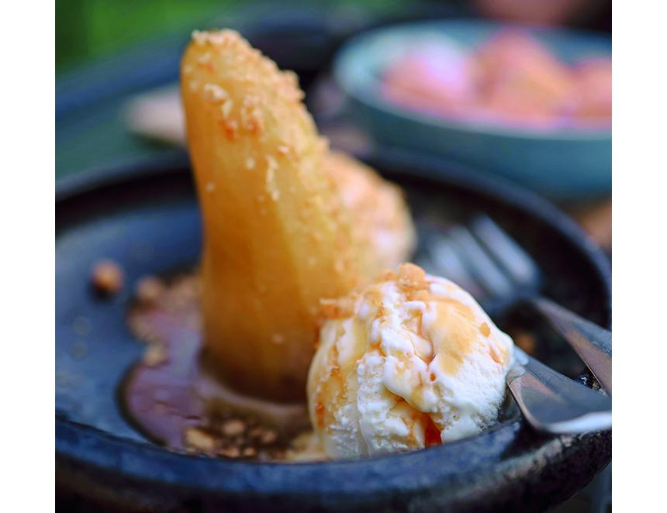

A couple of weeks ago I spent some time sampling cask beer along the south coast of England. I tried some delightful new beers as well as revisiting old favourites all in some truly wonderful pubs and had a very pleasant time. However, I don’t think you can really visit the south coast without imbibing a pint or two of Harvey’s Best Bitter (4 per cent ABV). While sat in the late autumn sunshine I got thinking how to make the best of the delicious flavours in a recipe. September to November is peak season for English pears. In my opinion a ripe pear is far superior to the majority of apples available. They are juicy, sweet and have a soft, almost creamy texture. As well as being exceptionally good to eat, pears are also used to make what is known as English Champagne or perry. The classic pear dessert is made by poaching them in a flavoured syrup or in sweet or red wine and as you may already know, I think cooking with beer is equal to any made with wine and so today’s recipe was born. Harvey’s Best Bitter is the flagship beer of the eighth generation, family-owned brewery founded during the rule of George III. Based in Lewes, Sussex, by the 1850s the brewery supplied 17 company-owned pubs. Today having survived fire and floods the company continues to operate out of the splendid Victorian gothic brewery on the side of the river Ouse, brewing a range of beers including a mild and lighter table beer, seasonal brews like Christmas Ale and limited-edition specials such as the strong, dark, Imperial Extra Double Stout. Harvey’s Best is made with water from the breweries own artesian well, drawn deep from the Sussex downs to supply a reservoir at the top of the Harvey’s brewery tower. Mashed with Maris Otter malts and four local hops, the finished bitter has won many awards including best bitter in CAMRA’s Champion Beer of Britain competition in 2005 and 2006. Full of caramel and biscuity malt flavours Harvey’s Best has a long peppery, hoppy finish. These flavours work wonderfully in both the pear poaching liquid and the finished caramel sauce. Beer poached pears with beer caramel sauce For the pears 6 large pears 200ml Harvey’s Sussex Best Bitter 120g golden caster sugar 1 vanilla pod 2 star anise pods 1 small sprig fresh thyme For the caramel 250g golden caster sugar 120g unsalted butter 240ml double cream 120ml Harvey’s Sussex Best Bitter 1tsp flaky salt Finely chopped nuts Vanilla ice cream For the sauce, place the sugar and beer into a large heavy-bottomed pan and onto a high heat. Stir with a wooden spoon until the sugar has melted, then remove the spoon or the sauce will start to crystalise. Boil the mix until it reaches a pale brown colour. Immediately add the butter and stir continuously until melted and remove from the heat. Stir in the cream and salt until thoroughly combined and return to a medium heat until the sauce starts to bubble. Remove from heat and allow to cool. Store in the fridge in a sterilised glass jar. Warm through when required. To prepare the pears first heat the beer, sugar, vanilla, star anise and thyme in a large pan until the sugar is dissolved. Peel and halve the pears and place in the pan, add sufficient water to ensure they are submerged, and cover with a piece of baking paper. Bring to a gentle simmer and poach the pear halves for about 15 minutes or until soft. Carefully remove from the syrup and allow to cool before scooping out the core. To serve, slice a little piece from the bottom of the pear halves to allow them to stand. Place in a bowl and sprinkle with nuts. Add a scoop of ice cream and sauce.

