One beer does not a good pub make
22/11/2025 by Matthew Curtis
Opinion

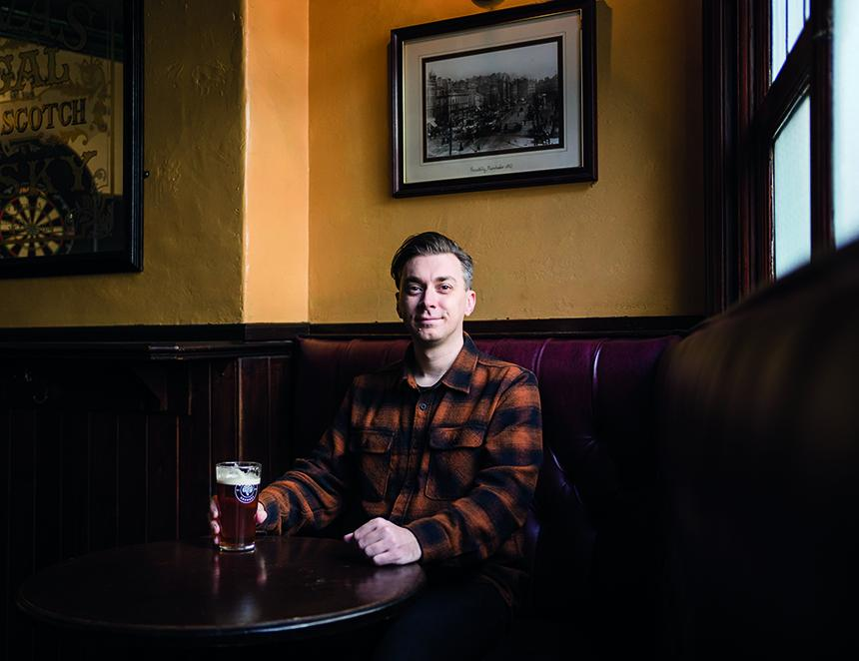

Last month Time Out published its annual 50 best pubs in London list. Compiled by a handful of writers, including editor Leonie Cooper and bona fide pub man Jimmy McIntosh of the highly amusing Instagram account London Dead Pubs, the publication describes it as an “indisputable, irrefutable and 100 per cent accurate list of London’s best pubs”. It covers decent ground, avoiding the pitfall of focusing too much on trendier central London locales such as Shoreditch and Soho, and moving out towards the suburbs where people actually live. It’s here, after all, where pubs exist to serve their communities and not just visiting tourists. There are some real gems on the list too, including Gospel Oak’s Southampton Arms and its recently opened sister pub the Pocket, which both feature. Peckham’s the Gowlett is truly – despite the term being woefully overused – a hidden gem, and coming back to Soho, it’s refreshing to see one of its best pubs, the Old Coffee House, proudly included. Although I do wish people would stop banging on about the French House – it’s fine, but it's not what I would consider to be a pub in the traditional sense. As a former Londoner, I was puzzled by the inclusion of a lot of the pubs on the list, the majority of which appeared to follow two particular trends – that they were proper, no frills, spit-and-sawdust boozers, or they were Irish pubs. Along with the remainder of the list there was a common thread running through the overall list – that their reputations are built on the quality of a specific beer, Guinness. To anyone paying attention, it should come as no surprise that this particular beer is driving the popularity of certain hostelries. According to data published in the Morning Advertiser stout is proving to be increasingly popular, with the category seeing 10.6 per cent growth year-on-year. Stout now accounts for 9.5 per cent of all beer volumes, among which Guinness – now the best-selling beer in the UK (by value) – is the most popular. Being honest for a moment, I don’t mind a pint of the black stuff on the odd occasion. After lockdown I briefly became quite enamoured with it, but I now understand this was centred on a longing for the pub and an experience that could never be replicated at home, not on one particular beer. Cask beer remains the biggest driver of what makes me want to visit a pub, at least in terms of what I want to drink. While this list does highlight a few great spots serving good cask beer, its tendency to veer towards the aforementioned particular kind of pub means that some of London’s actual best pubs are absent from the list. Where is the Sutton Arms, Robin, Harp, and Wenlock Arms? I could go on, but of course it's never going to be easy to whittle down 3,500 pubs to a list of just 50. Time Out isn’t the only outfit to have recently highlighted its preferred choice of pub, with the Good Food Guide having also recently named its top 100 pubs in the UK. I could level criticism here as well, as most of the pubs on this list are what you might refer to as gastropubs, although I prefer to call them what they actually are – restaurants. However, I will save my ire for another occasion, because I consider that its overall pick as “best pub in the UK” is a refreshingly inspired choice. Although it reopened under new management less than a year ago, the Highland Laddie in Leeds has rightfully been making waves. Yes, it does have a strong focus on food, with a high-end menu that draws as much inspiration from some of the UKs best restaurants as it does British Asian-owned Desi Pubs. And yet, at its core this is a proper pub – a really exceptional one at that – and thoroughly deserves its accolade. Having had the opportunity to visit both as a drinker and a diner, I admired the delicate balance between the two. It’s easy to pop into the pub, which sits just off the busy Kirkstall Road, and enjoy a pint or two. It just so happens that if you fancied enjoying half a dozen oysters or a devilled egg then this particular pub presents you with that opportunity. Crucially, booking yourself in for a meal doesn’t exclude you from the pub atmosphere, with the dining room directly adjacent from the bar area, avoiding any feeling of stuffiness that some higher-end pub dining rooms can possess. The blueprint here is so good, in fact, that I imagine it will inspire several copycats that will spawn around the rest of the UK over the next 12 months or so. Of course, being highly opinionated about pubs and holding my own favourites close to my chest means it's unlikely a list compiled by someone else is ever going to tick all of my boxes. In terms of the Time Out list, it feels like a missed opportunity, a box ticking exercise that is more focused on the current zeitgeist rather than what actually makes a pub really good. And while the Good Food Guide is always going to focus on a particular kind of “pub” it is refreshing to see it championing a venue that is doing something different and doing it very well indeed. Swings and roundabouts, I suppose.

