Community pub film series doubles up
21/11/2025 by WB Reporter
Campaign

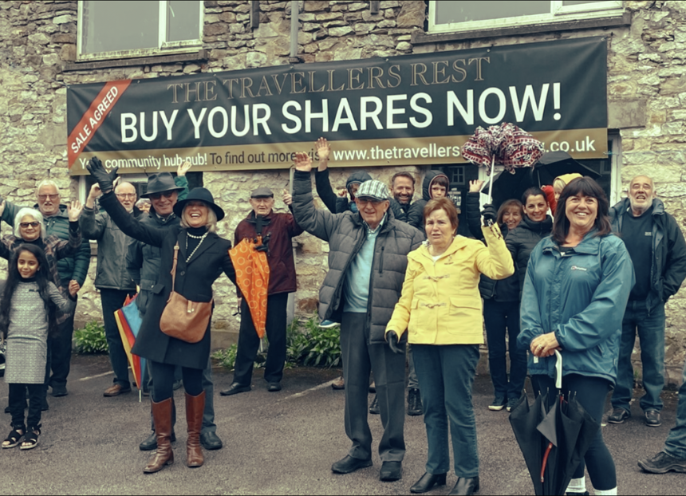

CAMRA has released the second film in its community-owned pub documentary series, this time focusing on the Travellers Rest in Skeeby, North Yorkshire. The Travellers Rest was bought by the Skeeby Community Pub Society in 2022, and after raising nearly £300,000, the pub opened its doors for the first time since 2008. The latest film shows what it is like to campaign and save a pub, plus how to open and maintain one under community ownership. It includes interviews from the pub’s key volunteers, staff and locals. Documenting the community's efforts to save the pub, the second episode highlights how it cultivated friendships, especially with its popular Leek Club vegetable competition. Director Katie Greenhalf and producer Rachel Auty, in collaboration with Plunkett UK, have made an emotional and humorous documentary on how important community-owned pubs are in tackling loneliness and isolation in UK communities. Watch the film here. The first film in this series, starring Tottenham's Antwerp Arms, is available to watch on the Learn and Discover platform, while the third in the series, featuring Yr Heliwr in Wales, will be released on Friday 5 December. CAMRA’s pub and club campaigns director Gary Timmins said: “This film series highlights how important pubs are to the well-being of our communities. If it wasn’t for the amazing volunteers who campaigned so hard to save the Traveller’s Rest, it may have been lost forever, robbing people of an important social hub. “Community-owned pubs show the difference we can all make when we come together. I hope audiences watching are inspired by the success of Travellers Rest and look into the option of community ownership to save their own local from demolition or conversion. “The government must reintroduce a dedicated funding pot, so community groups can get the help to save their beloved closed locals.” Rachel said: “I loved meeting the committees, teams and locals at each of the three community pubs. It's been a real honour. Hearing their stories and learning more about their communities has been brilliant. “I've always believed pubs are an essential part of society, and now more than ever we need these local places of togetherness and belonging. These films reflect that.”

