CAMRA celebrates top campaigners
21/11/2025 by WB Reporter
Campaign

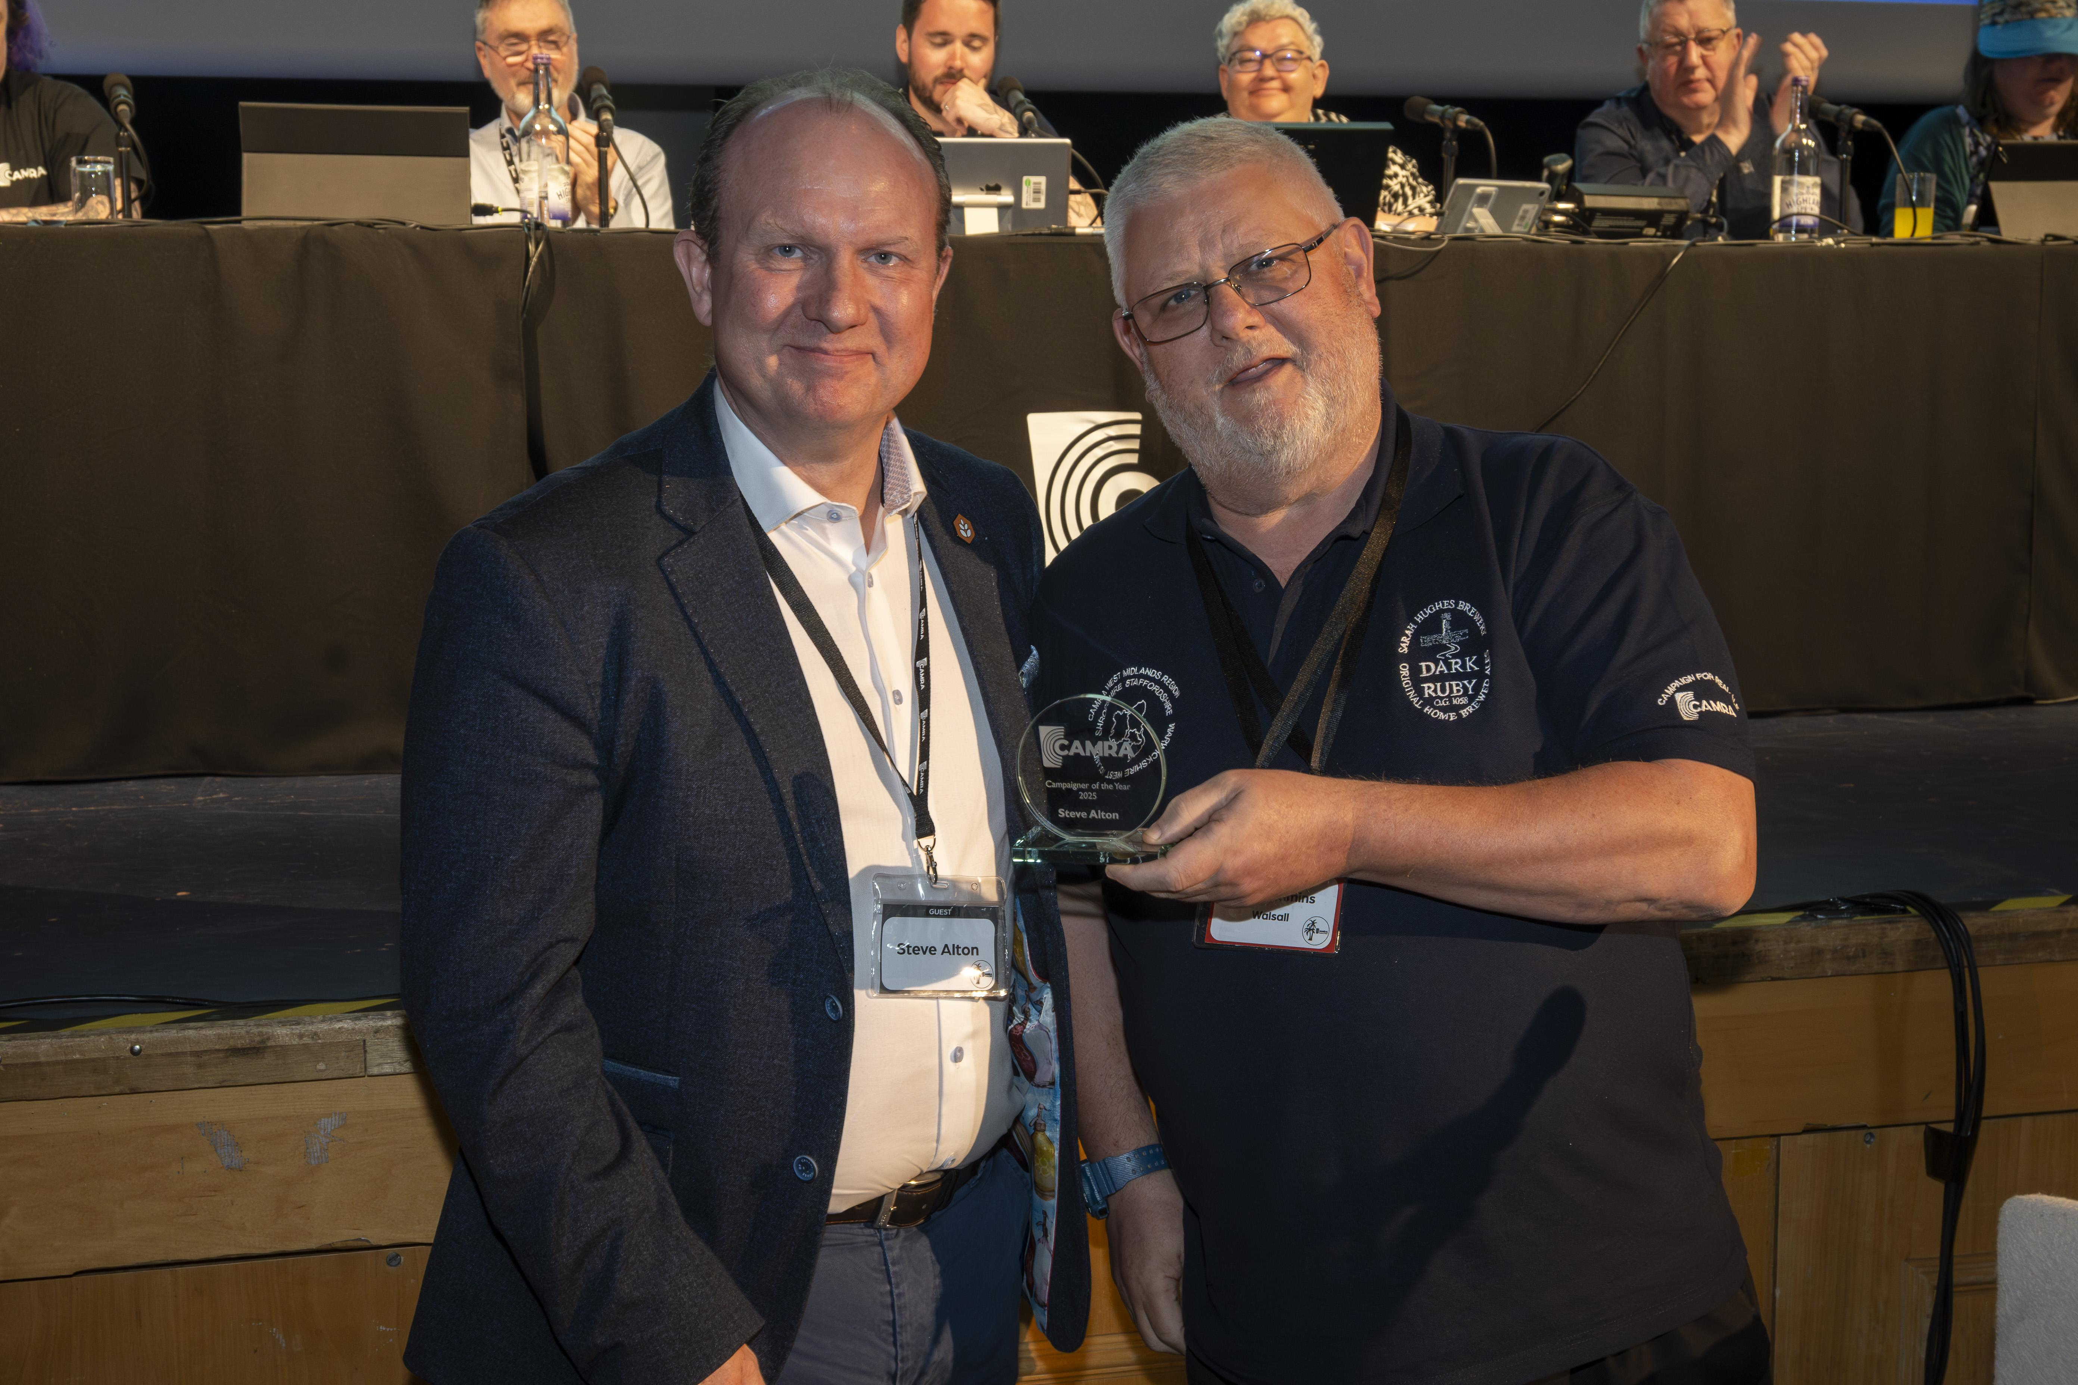

Nominations have opened for CAMRA’s Campaigner of the Year award, recognising those who have gone above and beyond for pubs, pints and people. The award celebrates a person or group whose campaigning efforts have created positive change for pubs, clubs, cask beer or real cider and perry over the past year. The award puts a face and personality to CAMRA’s aims and goals, with members recommending those who have fought effective campaigns locally or nationally and embody the heart of a community. Nominees are judged for their leadership, impact, innovation, commitment and inclusion. The winner will be announced next year at Members’ Weekend in St Albans, 17-19 April 2026. Previous winners include Steve Alton, chief executive of the British Institute of Innkeeping (BII), Laura Hadland, award-winning author and What’s Brewing columnist, and Helen Anne Smith, co-founder of Burum Collective and advocate for greater equality, diversity and inclusivity in the beer and cider world. CAMRA awards director Gary Timmins said: “With the beer and pub industry in economic turmoil, and the uncertainty of an upcoming Budget, our Campaigner of the Year award is more important than ever, putting a spotlight on those who work tirelessly to fight for cask beer, real cider or perry, and pubs, social clubs and taprooms. “The award recognises everyone, from selfless volunteers campaigning at a grassroots level to protect and promote the industry, those in the pub or brewing trades dedicated to educating consumers, to simply a venue that you think is a really special social hub. Even celebrities and politicians who actively support our campaign asks, the awards are open to all who strive to make a difference.” The Campaigner of the Year nomination form, plus eligibility and nomination criteria, are here. Nominations can also be sent by post c/o Campaigner of the Year, CAMRA, 230 Hatfield Road, St Albans, AL1 4LW. The nomination deadline is Friday 27 February 2026. Pictured: Steve Alton (left) collecting his award at Members’ Weekend 2025 in Torquay from Gary Timmins

