Your social club needs you
20/11/2025 by Phil Gregg
Industry

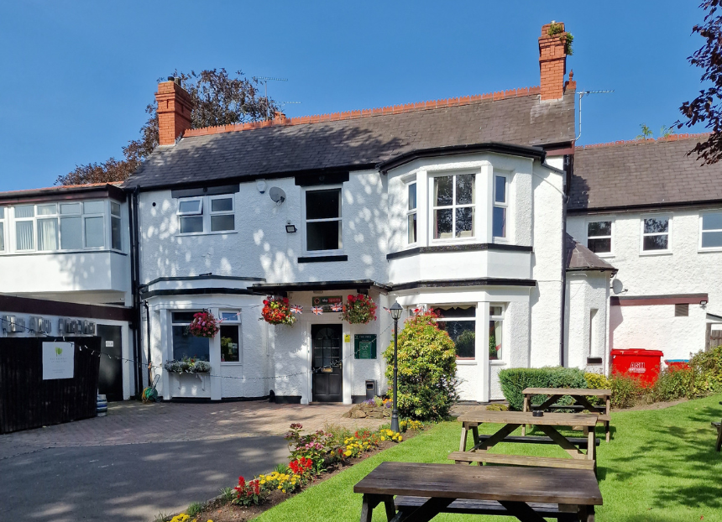

Social clubs have been a cornerstone of British working-class and community life for more than a century. These are not just places for a pint – they are member-led, democratic organisations that foster connection, civic engagement, culture, and solidarity. Yet, as the Centre for Democratic Business (CfDB) reports, nearly half of Britain’s social clubs have disappeared, and many of those remaining are struggling with rising costs, ageing buildings and lack of support. CAMRA values clubs, not only as drinking venues, but as vital community spaces. It also believes social clubs are more than just places to drink, they are cooperative, community-owned, and often deeply woven into local life. The 21st Century Social Clubs programme, led by the CfDB, is a national movement to revitalise and strengthen social clubs. With the current £25,000 crowdfunding campaign it plans to: – produce practical guides and training for clubs to improve governance, diversify membership, and plan for the future – host a national practitioner summit to bring club leaders together to learn, share, and build solidarity – facilitate study visits and peer exchanges between clubs, so they can learn from one another’s successes and challenges – provide urgent advice for clubs at risk, working with local advisors to offer guidance and support – advocate for a 21st-century social club charter to secure better policy, funding, and recognition for the sector. It is also working with key partners, including the Co-operative Party and several MPs, to push for this. CAMRA is backing the campaign as it has: – shared values: as a movement committed to cask beer, community pubs, and the preservation of gathering places, CAMRA naturally aligns with this effort – democratic ethos: many clubs operate on co-operative, democratic lines; supporting this campaign helps reinforce that model – cultural and social Infrastructure: revitalised social clubs can become hubs for music, civic engagement, learning, and inclusion. Indeed, the CfDB plans a national training programme to boost live music capacity in clubs – policy leverage: by backing this campaign, CAMRA can help amplify calls for a national social club charter – a formal recognition that could unlock policy and financial support. How you can help: – donate: make a gift to the crowdfunding campaign here. – spread the word: share the campaign link and its story with branch members, club contacts, and local stakeholders. Use the hashtag #BackOurSocialClubs to boost visibility – engage policymakers: encourage your MP, councillors, or community leaders to support the idea of a social club charter – feature the campaign: consider running a feature, interview, or call-out. This is a chance to put social clubs and their members back in the spotlight – get involved locally: if your club is interested, you could host or attend one of the CfDB’s webinars or training sessions here. In an era when many of our social institutions feel under threat, this campaign offers a real opportunity to reclaim and reinvest in the co-operative, member-led spirit that built so many of our clubs in the first place. By coming together – CAMRA, club members, community leaders and policymakers – we can help ensure that social clubs don’t just survive, but thrive as vibrant, democratic, meaningful places for the 21st century. Pictured: CAMRA Club of the Year 2024 Firs Club, Codsall, West Midlands. Phil Gregg is CAMRA’s national clubs co-ordinator.

