Fury as minister blocks Northern Ireland licensing reform
19/11/2025 by WB Reporter
Campaign

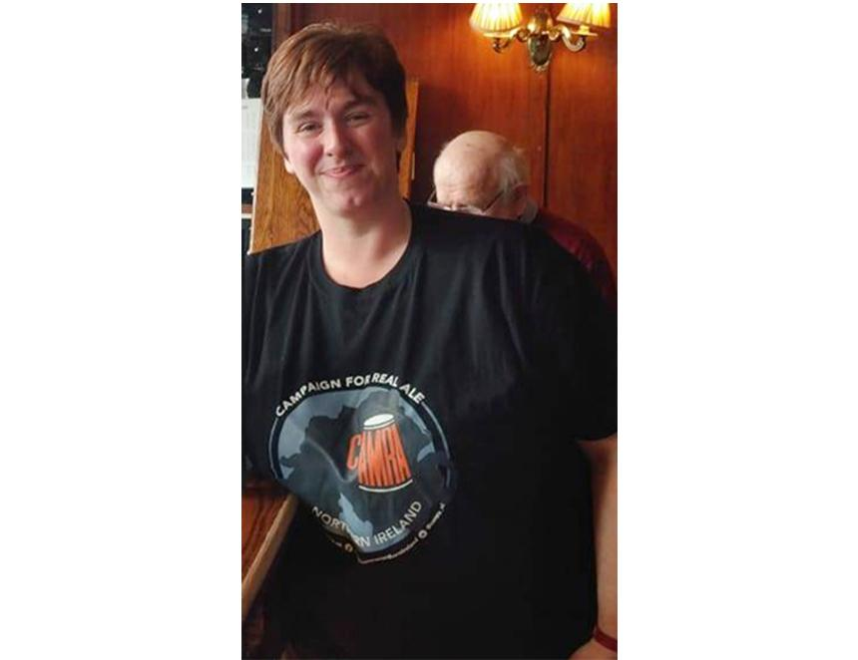

CAMRA NI has attacked the communities minister’s decision to block modernising the alcohol licensing system. Gordon Lyons MLA gave an oral statement to the assembly outlining his response to an independent review of Northern Ireland’s outdated alcohol licensing system and the surrender principle which means a licence has to be given up before a new pub or off-licence can open. Experts from the University of Stirling concluded: – the surrender principle has seen pubs closing and licences moving to supermarkets or off-licence – the current system “is doing little to protect or invigorate the pub sector as a whole” and means “the retail market for beer is dominated by a small number of non-NI based producers who often establish restrictive supply agreements” – the current licensing system “creates barriers to diversification and innovation” meaning we don’t see good choice of local, independent products on offer, or a good range of venues like micropubs, specialist outlets, brewery taprooms etc. which are thriving in the rest of Europe – the promotion of positive health and social outcomes would be better served by supporting a well-managed on-trade sector [pubs] over a continued increase in the number of off-licences – NI is losing pubs at a faster rate than elsewhere. Despite this, the minister is proposing not to accept any of the independent review’s substantive recommendations on modernising the alcohol licensing system. Director of CAMRA NI Ruth Sloan (pictured) said: “This is a huge, wasted opportunity from the communities minister and shows a total disregard for the consumers this administration represents. Instead of working to modernise the industry in Northern Ireland he has chosen to side with giant multinational businesses which dominate our pub market and mean there is rarely a choice of decent beer and cider at the bars. “With alcohol licences still having to be surrendered for up to £100,000 a time it makes it almost impossible to open a new independent pub, closes pubs in areas calling out for third spaces and community hubs as well as stifling innovation and growth by pricing out anything new or interesting. “This decision just adds another nail to the coffin of micropubs, brewery taprooms, wine bars and other specialist venues that are thriving across GB and the rest of Europe yet cannot exist here due to the nature of these outdated laws. “Instead we can only expand existing floorspaces and end up with huge pubs and groups of pubs, sharing their existing licences, that are often forced by restrictive agreements with big business so that they can only sell the same few drinks everywhere, with no options to provide the wonderful and innovative products being made by beer and cider producers here in Northern Ireland that locals want and tourists are actively travelling here to try. “I’m calling on MLAs from all parties to urge the communities minister to think again and commit to modernising our alcohol licensing system so that consumers can have a decent choice of beer and cider in every bar here and our economy can thrive in this new and upcoming market on our own doorstep.” The minister’s full response is here. The University of Stirling’s report and recommendations are here.

