Budget must ensure pubs survive
19/11/2025 by Timothy Hampson
Industry

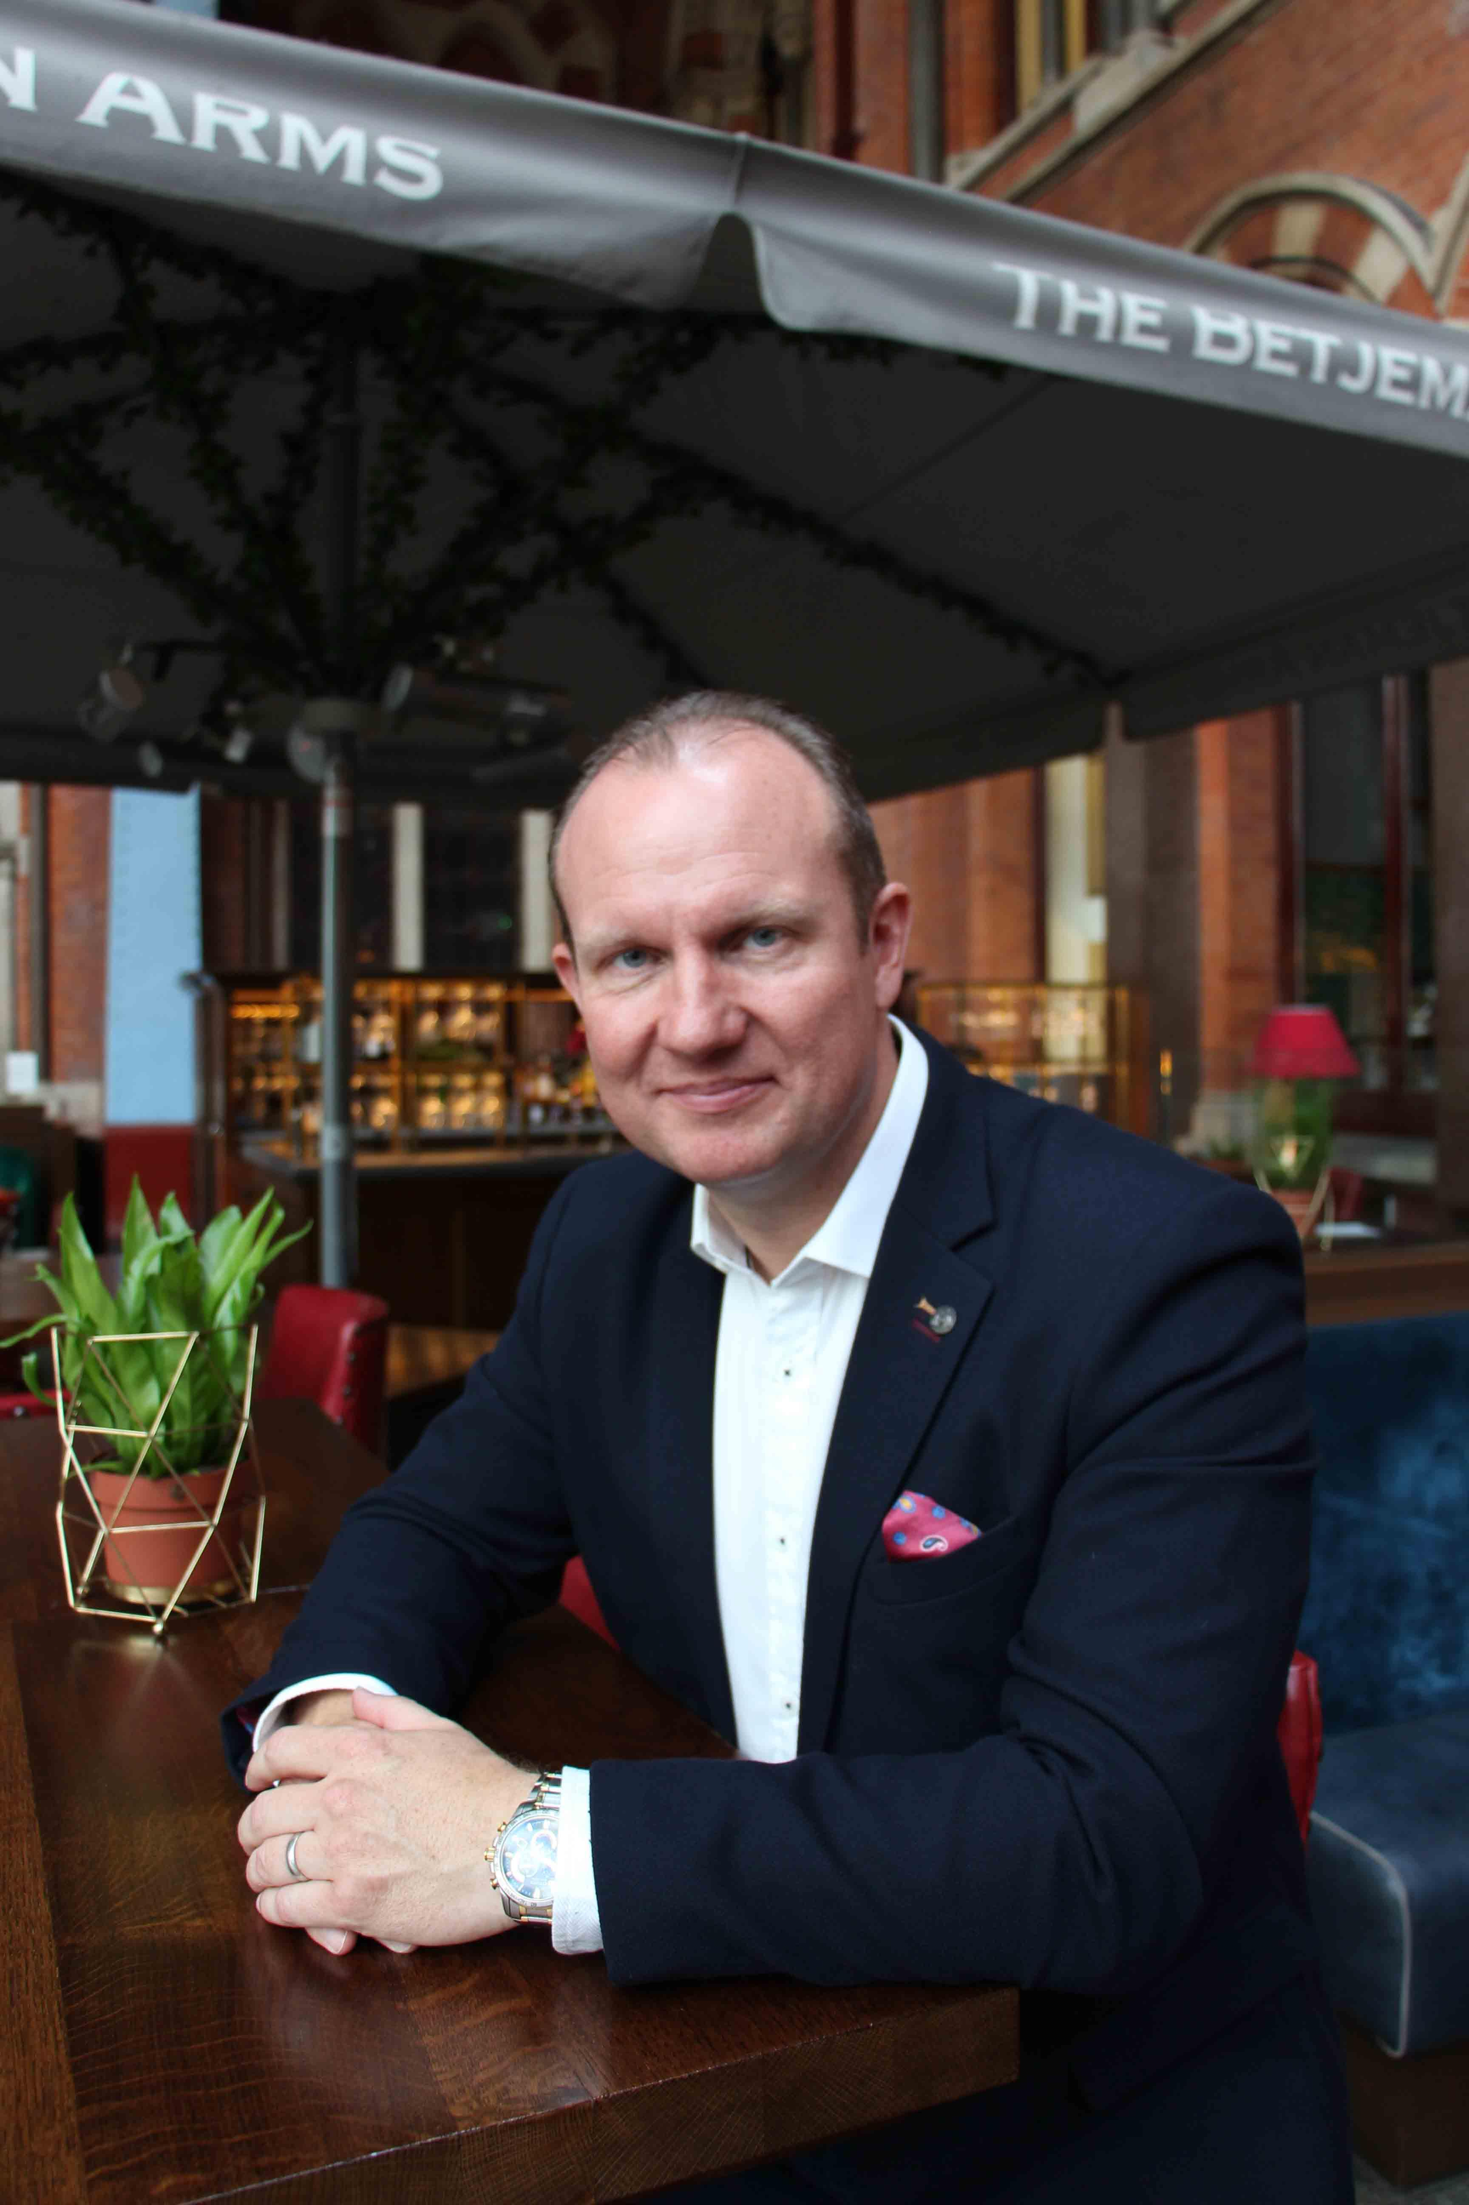

With the Budget due on 26 November, campaigners are continuing to call for a better deal for pubs. British Institute of Innkeeping (BII) CEO Steve Alton (above) has written to chancellor Rachel Reeves seeking urgent action to support UK pubs and the vital role they play in communities and the economy. Representing more than 13,500 members with the majority operating single, independent pubs, the BII has highlighted the stark reality facing the sector. Following substantial tax increases introduced in April and long-term inflationary pressures, only one in three pubs is now profitable. The BII is warning that 35 per cent of the nations’ pubs risk closure without immediate intervention. Despite stronger trading throughout this year, the financial pressures have forced operators to make difficult decisions. According to the BII 74 per cent of operators have significantly reduced staff hours, while 70 per cent have reduced the number of employees with licensees now covering the shortfall by working unsustainably long hours themselves. Alton said: “Since the Covid pandemic, government has recognised the huge value of our pubs with the prime minister recently stating ‘when our locals do well, our economy does too’. “This recognition must now be matched with urgent action at the Budget to drive local economic growth by reducing the unfair tax burden. This will create skilled jobs and allow pubs to continue to serve their communities. Without it, many simply will not survive.” The BII has urged the chancellor to seize the opportunity to support and invest in the pub, stating closures would result in lost jobs and tax revenue plus immeasurable damage to communities across the UK. The BII is calling for urgent action on: – VAT reform: permanently reduce VAT on pub sales to 10 per cent, boosting resilience, creating jobs, enabling investment and minimising price rises for consumers – business rates: deliver permanent, real-terms reductions in business rates bills from April 2026 – employment incentives: reverse recent NICs changes and introduce financial incentives for pubs hiring under-25s and those returning to work.

