Brewer taps up beer lovers for taproom
18/11/2025 by Timothy Hampson
Industry

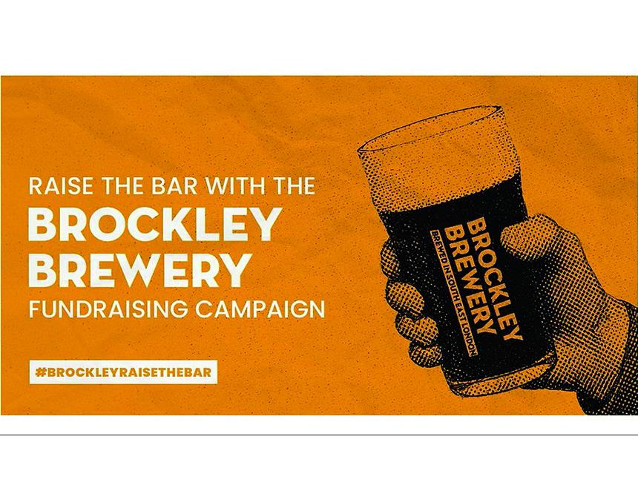

South East London brewer Brockley has launched its Raise the Bar community fundraiser inviting locals and beer lovers everywhere to help build a new taproom and outdoor space. The campaign celebrates more than a decade of community, creativity, and pride plus gives supporters the chance to play a part in the next chapter of Brockley’s story. At the top of the rewards list is the Brockley Brewery Black Card, which offers unlimited Brockley beer for 10 years across all taprooms, an exclusive thank you for those making the producer’s biggest dreams possible. But it’s not just about the big gestures. Brockley has also introduced a range of accessible rewards that give everyone a way to join in from £25 for £50 to £50 for £100 bar tabs with exclusive merch packs, and other limited-edition offers. “This isn’t just about raising money, it’s about growing together,” said Brockley co-owner Carl Lawrence. “For more than 10 years we’ve seen how powerful this community is, and this campaign is our way of giving towards creating a new taproom and outdoor space, expanding opportunities for local artists, musicians, and young creatives, and ensuring Brockley brewery remains independent and community-led for years to come.” The campaign runs until Christmas 2025, and you can get involved here.

