More life-saving Sheps pubs
13/11/2025 by Timothy Hampson
Pub

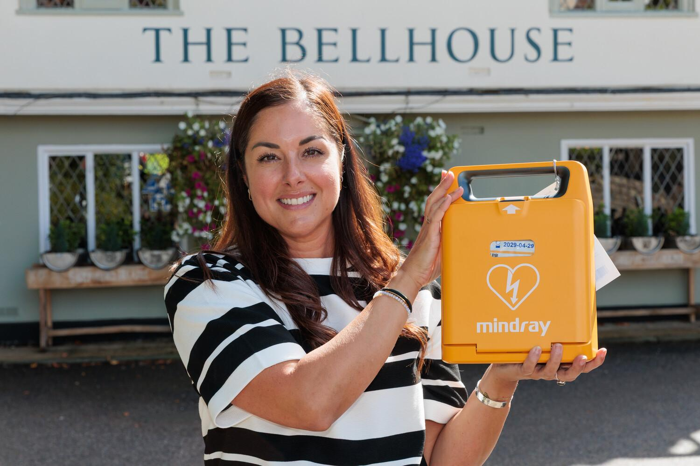

Brewer Shepherd Neame has installed defibrillators at six of its pubs across Kent and Essex. The Faversham-based brewer joined forces with charity London Hearts, which procures and distributes defibrillators across the UK, to source government match-funding for the equipment. Among the pubs to receive a defibrillator is the Bellhouse in Leigh-on-Sea. In December last year, when the pub officially reopened following a £300,000 transformation, Shepherd Neame chief executive Jonathan Neame presented £1,000 to the foundation, which promotes screening and awareness to help prevent Young Sudden Cardiac Deaths (SCDs) in memory of 19-year-old Jude, from Southend, who died after suffering a heart attack in 2023. The pub’s general manager Athena Sigsimondi (pictured) said: “The Bellhouse is here for its community, and we are delighted to welcome the installation of this defibrillator, though, naturally, we all hope it is never needed.” London Hearts chief operating officer Jo Lovell said: “The aim of London Hearts Charity is to increase the number of available AEDs (Automated External Defibrillators) throughout the UK. “We are extremely pleased to have worked together with Shepherd Neame in providing this life-saving equipment to more communities. “We feel it is vital that AEDs are readily available to everyone to protect them from cardiac arrest which tragically can happen to a person of any age at any time.”

