Pubs as community glue
12/11/2025 by Rachel Auty
Campaign

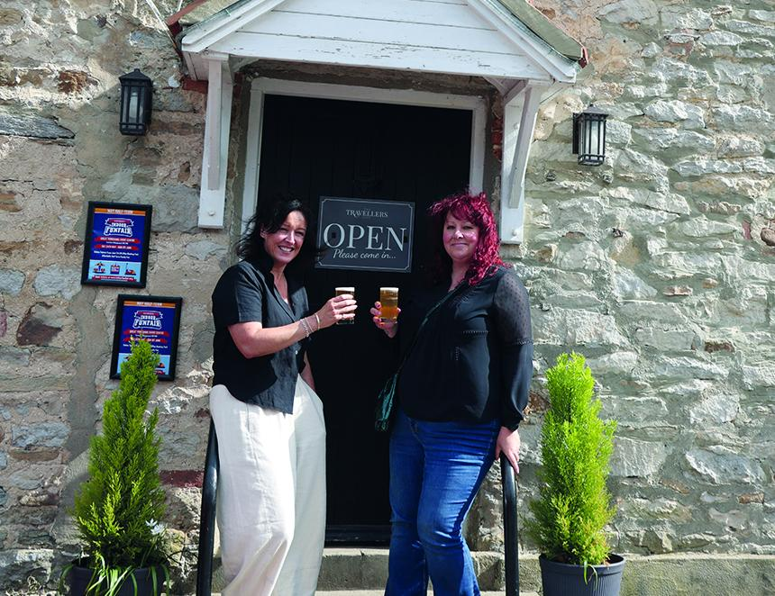

Rachel Auty has been working with filmmaker Katie Greenhalf to create three short films about community-owned pubs for CAMRA’s Learn and Discover education platform, but it’s not her first rodeo. Back in 2014, Rachel led a campaign to save the Yorkshire Lass in Knaresborough. Although the pub was ultimately lost to redevelopment, that experience sparked a deep interest in the role pubs play at the heart of their communities. Now, more than a decade later, she’s come full circle, capturing the inspiring stories of three pubs that were saved, owned, and loved by the very people who refused to let them go. In 2014, I tried to save a local pub. It didn’t end well. At the time, the idea of community ownership was gaining traction. The Asset of Community Value (ACV), introduced under the Localism Act 2011, gave communities the right to nominate land or property that mattered to them. Once listed, these assets were protected from immediate development if sold. A small but powerful safeguard for places that defined local life. It was all still quite new back then, and saving the Yorkshire Lass in Knaresborough was always going to be a challenge. The pub stood proudly within the Green Belt, the Knaresborough Conservation Area, and the Nidd Gorge Special Landscape Area, a landmark building on a landmark site, just before the town’s listed High Bridge. In its day the Lass was a hugely successful pub run by landlord Derek Spiers, and was well known for its live music, theme nights and its award-winning floral displays. The former pub had sat empty since 2007, its new owner pushing repeatedly – and unsuccessfully – for housing development. It was damaged by fire in 2010 and January 2013, with arson suspected on both occasions. The plans to demolish it and build flats were thrown out by Harrogate Borough Council several times. Even in January 2014 an application to build 14 flats was unanimously refused by Harrogate Borough Council. By the time I got involved, a new planning application for four flats had been submitted and once again the Yorkshire Lass was facing demolition. I believed it was time to see if the community could save it. A campaign began, including an online petition, a request for anecdotes from people who knew the pub, and a rallying cry for objections to the latest planning application. The response from the community was overwhelming, and soon I had a case to submit an application for the Yorkshire Lass to be listed as an Asset of Community Value. It was accepted. I couldn’t believe it. I teamed up with a local architect and contacted a venue in Wakefield that had relaunched under community-ownership to get advice. My Yorkshire Lass Limited was formed, and an expression of interest to purchase the pub was submitted. We then received the news that Harrogate Borough Council had decided to delist the Yorkshire Lass as an Asset of Community Value, following an appeal from the current property owner. Just a few months later, a new planning application was approved, and the pub was soon gone for good. What sits there today is an expensive-looking block of flats with a very soulless front facade. I have to say every time I pass by my heart sinks a little bit deeper for what could have been. Imagine my joy, then, to secure a commission from CAMRA, in partnership with Plunkett UK, in early 2025 to create three short documentary films about community-owned pubs. This is kid-in-a-sweet shop stuff for me. Better still, my talented filmmaker friend, Katie Greenhalf of This Film Production was more than just a little bit keen to work with me on it. In truth, we’ve talked about what the perfect project for the two of us might be. We had finally found it. Following further discussions with both CAMRA and Plunkett, we were presented with a shortlist of potential filming subjects, a range of community-owned pubs in different parts of the UK, each with their own story to tell. Katie and I chose our three, a mix of rural and urban; north and south; one community-owned for 10 years, the others much more recent ventures, each with their own story. Antwerp Arms, Tottenham, North London: More Than a Pub When speaking to the management committee at the Antwerp Arms in the early planning stages, there was one date for filming that was mentioned and immediately became non-negotiable: “We’re having our 10th birthday party in June – Beyonce-themed”. We arrived in Tottenham on a sunny Friday in June, walking through Bruce Castle Park towards the pub. I’d imagined a concrete-clad urban sprawl but instead found a leafy neighbourhood and a welcoming pub with picnic benches facing acres of green. Over the next few days, Katie and I held interviews with members of the management committee, people who had been a part of the initial campaign and fundraising, folk from the local community, and the regulars. Hearing their stories was incredibly humbling. This was previously a pub with a reputation – a bad one. For many years most of the local community had been actively excluded until the risk of losing the pub became a reality. A few passionate local representatives rallied the troops and quickly the community consolidated. I learned how the shares were priced at £50, and so many people bought more. Some of the most moving stories were about those who bought shares in memory of someone who had loved the pub – further evidence for my sentimental brain that these places are far more to many than just a place to go and drink. The bit that really got me was when I heard the story of the family members which had agreed that whatever happened, they would close the gap on the fundraising target in memory of their dad. I also had the pleasure of meeting Mahir, who had never worked in a kitchen in his life and is now the full-time volunteer chef, feeding folk and families who can’t otherwise afford a meal – the people they call their “guests”. The pub is a cooking food bank, taking supplies that would otherwise end up wasted and making meals for hundreds of local folk who would otherwise go without. Mahir told me he goes home “completely knackered” but the feeling he gets from what he does leaves him “on top of the world”. Standing in that packed pub during the 10th anniversary celebration, I was struck by the sheer love in the room — people of all ages, backgrounds, and stories. It was one of the most diverse, welcoming, and safe spaces I’ve ever been in. I was so impressed with how this community has taken ownership of this pub, literally, and turned it around from something that served only a few to a place that is for everyone. There is a significant population of families with young children in Tottenham – I saw many of them at the party – and how wonderful it is that this pub can be a part of their lives as they grow. These are our future pubgoers and pub owners and I can think of no better way to learn about the things that make a pub great than spending time at the Annie. Travellers Rest, Skeeby, North Yorkshire: Where Community Grows Skeeby is a village and civil parish about 18 miles north west of Northallerton. With one main road running straight through, it might be easy to miss. However, what we discovered is a passionate, committed community with traditions that matter to them. This is not a village to be underestimated. The back story of this pub reminded me in many ways of my experience with the Yorkshire Lass. The pub closed in 2008 and was bought by a property developer whose aim was to turn it into housing. So much so, he wasted no time ripping out the interior and starting work. However, the community stepped in, had the pub listed as an Asset of Community Value, and fought quite a battle to buy the pub back from the developer. Incredibly, it did it. Even more mind-blowing was how the village came together, bringing a range of trades and other skills together and calling on favours to fully rebuild the interior and make the pub a pub once more. Jeff, who was heavily involved in the team which rebuilt the pub, told me how his dad had loved it there. He wanted to give something back, for his dad, who he said he knew would be so proud of what is today. The pub has all the markers of a cosy country pub, complete with exposed stone walls, log burner, home-cooked food, and an extensive beer garden for warmer days. The volunteers who refitted it have done an incredible job, achieving a high-quality finish throughout. Tom and Rob, two longstanding pub regulars, friends and neighbours who live in the village, told me how they didn’t think the doors of the pub would ever open again. They are clearly delighted that they did. Some of the most notable parts of this story are how the pub has brought other forms of life back to the village. When the pub closed, the traditions went with it: quoits, darts and the Leek Club. What’s happened since is that it’s all back, and the locals love it. Leek Club returned in 2025, organised by the amazing Helen and Sarah. We followed them as they told us about the monthly club meetings and the annual Leek Show, which they’ve also brought back, including an independently judged competition with prize money. They told us it’s “just a bit of fun”, but speaking to the regulars who grow leeks and compete, I’m not so sure. There’s banter, sure, but I can’t help thinking there are some people with their eyes firmly on the top prize. I’m so happy for this community. They achieved the impossible in Skeeby, taking back the pub from the jaws of the developer who was already well on his way to making sure it would never be a pub again. Many of the locals live alone, and rural North Yorkshire is not the easiest place to navigate as an ageing population. This village needs this pub – it’s a lifeline for so many – and every pub needs its own Helen and Sarah. Yr Heliwr, Nefyn, North Wales: Raising the Bar Our final pub took us to Wales. Nefyn is a town and community on the north-west coast of the Llŷn Peninsula, Gwynedd, Wales. It’s a town that is popular in summer with tourists for its gorgeous sandy beach. For me, this trip required a long Sunday drive in the rain, but it was so worth it to get to amble along the sunny Wales Coast Path before breakfast on a Monday morning. Yr Heliwr is a pub that closed in 2008 and sat empty, until the local community responded to the threat of it being turned into housing by setting up a Community Benefit Society to buy the pub and bring it back to life. I loved my time at this pub and the warm Welsh hospitality. Our busy filming schedule included visiting the community garden and meeting the volunteers that look after it; meeting lots of locals; interviewing committee members, staff and regulars and learning about Welsh culture, Nefyn and the history of the pub itself. I learned so much here. The passion for the Welsh language was palpable. Despite being told that it’s a language that’s “not that hard to learn” I remain suspicious, but what a stunning language it is. As part of the efforts to keep Welsh alive, the pub hosts weekly learner sessions, which are well-attended. It’s clear, too, that music runs through the blood of every Welsh person, partly because of the way it is woven into the fabric of schooling from a very young age. The message that came across loud and clear from the various folk I interviewed was that the high street in Nefyn had been dying. When the pub had closed many shops were also gone and when the tourists left and the darker days came there wasn’t much left for the people who live there. It seems to me that bringing the pub back was an essential part of breathing life back into this town. Not only has it given people shared purpose and a place to connect and relax, but it’s also inspired other businesses to follow suit, with new shops opening nearby and even a chippy popping up across the road. I loved this community, and the way it has come together to create a much-needed beacon and hub for Nefyn. It’s a beautiful place that deserves a great pub and a thriving community, and I hope to return to experience it all again. Reflections Making these films was a humbling experience, much less about raising money and business models, and more about caring for the people around us. People want to be empowered to put the needs of others in their local communities first. I’m still sad about the loss of the Yorkshire Lass but knowing successful projects like these exist feels really good. I hope my story acts as a reminder of the fragility of the local assets that run through the veins of a place and its people. We take them for granted, and we should not. I believe that everyone can benefit from having a local pub where they can belong, be vulnerable, and feel connected and safe. I urge any community facing a risk of losing their pub to take action. I hope you enjoy and find inspiration in the films. More Than a Pub is available to watch now, Where Community Grows is released Friday 21 November and Raising the Bar is released Friday 5 December and are presented by CAMRA in partnership with Plunkett UK. View them at learn.camra.org.uk/home Pictures from left: Katie and Rachel at the Travellers Rest (Pic: Gary Lawson)

