Picture perfect pubs: CAMRA design awards open
06/11/2025 by WB Reporter
Campaign

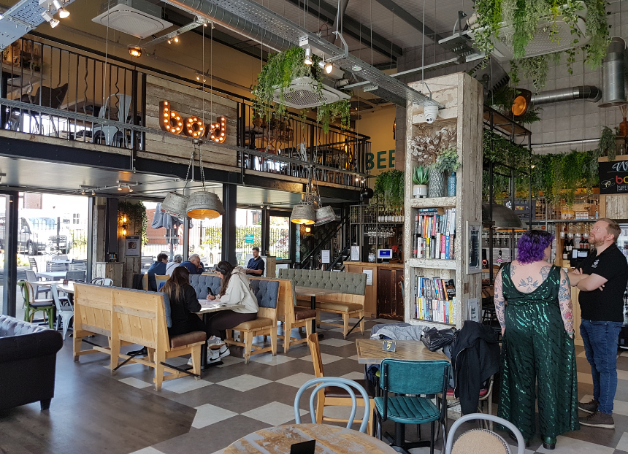

CAMRA is on the hunt for the UK’s best-looking pubs with the return of the Pub Design Awards. Collaborating with Historic England, CAMRA is celebrating stunning pub architecture across the UK by seeking nominations for the Pub Design Awards. Judged by a panel of experts in design and conservation, the awards recognise the highest standards of pub refurbishment and conservation, plus the construction of new outlets and spaces being converted to pub use. Pubs can be entered across five categories: Conversion to Pub Use, Historic England Conservation, New Build, Refurbishment and Community Local. The Pub Design Awards are open to all pubs in the UK, and anyone can nominate. Entrants may be asked to provide additional photographs and plans of the building; the licensee should be aware of and approve the entry. To enter work will need to have been completed between 1 July 2024 and 30 June 2025. The competition is free to enter and closes on 17 November. Once submissions have closed, judges will visit and assess the nominated pubs throughout the year, with judging set to be completed by mid-April 2026. Chair of CAMRA’s Pub Design Awards, Historic England’s Andrew Davison, said: “CAMRA’s Pub Design Awards are a fantastic opportunity for owners, publicans and communities to showcase the imagination, creative flair and inventive craftmanship dedicated to protecting, refurbishing and repairing their much-loved local. “It is always encouraging to see just how much people care about these spaces, willing to put blood, sweat and tears into fabulous design projects for future generations to enjoy. “From majestic Art Deco-era establishments, innovative creative projects to build or convert new pubs, and street-corner locals lovingly renovated by their community, the awards invite history buffs and pubgoers alike to explore and appreciate these inspirational buildings.” To enter and see previous winners visit: camra.org.uk/awards/pub-design Pictured: New Build 2025 winner bod Lichfield

