Pubs in frontline in fight against loneliness
04/11/2025 by Timothy Hampson
Industry

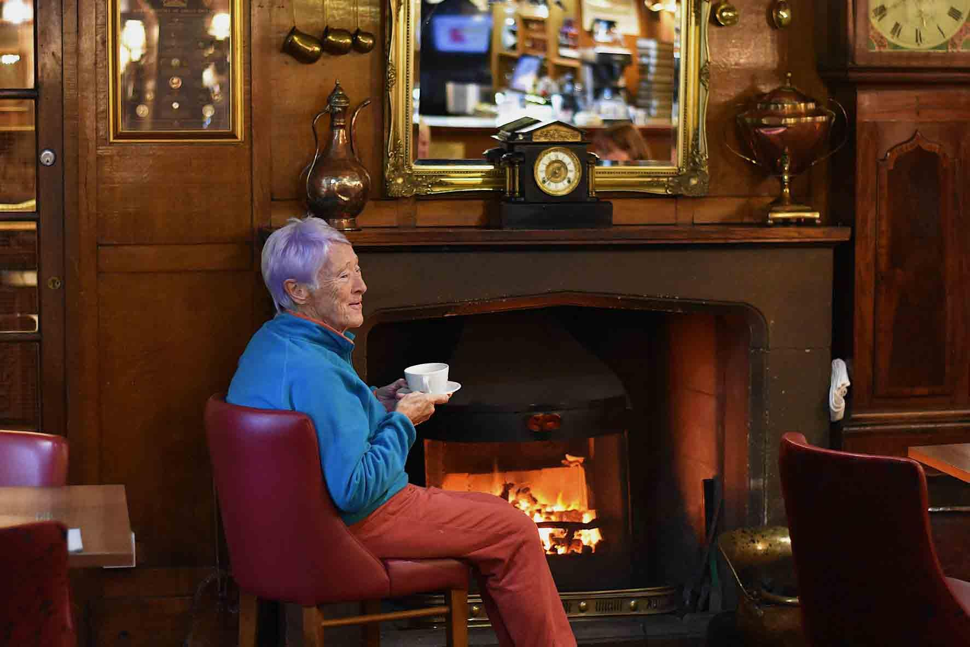

With worries about loneliness on a par with peak pandemic levels, new polling by the British Beer and Pubs Association (BBPA) shows two out of three see pubs as vital in the fight against isolation. However, two in five say they have seen pubs close in their area, prompting calls for urgent support for the “cherished institution” in the next Budget. With pubs struggling under a heavy tax and regulatory burden, more than 2,000 have closed since 2020, and one is predicted to close every day in 2025. The same poll found that, nationally, six in 10 are concerned about pub closures in their area, and seven out of 10 consider the pub important or very important for their area’s social life. The BBPA’s Long Live the Local campaign said this underlined the urgent need for the government to use the Budget to deliver fairer taxes and action on rising costs to save these beloved institutions. The survey shows a regional picture of where people view pubs as a solution to isolation and closely reflects where closures have hit hardest. In the North of England, 71 per cent of people agree pubs are vital in tackling loneliness and isolation, underlining the role pubs play as informal support networks and community hubs. In Wales, 64 per cent feel the same, while in Scotland, 63 per cent back the idea that pubs are part of the solution to the UK’s loneliness crisis. Since 2021, the BBPA has recorded a net closure of 291 pubs across the North West, North East and Yorkshire and the Humber, Wales has seen the net closure of 132 pubs and Scotland 206. According to Office of National Statistics figures from October 2025, 26 per cent of Britons report feeling lonely at least some of the time, a figure that has remained consistently high since records began in 2020, during the Covid pandemic. Similarly, 30 per cent of people surveyed for the BBPA’s Long Live the Local campaign say they or someone they know has felt isolated and lonely due to the loss of their local pub. BBPA chief executive Emma McClarkin said: “This polling confirms that for many, the local pub is a lifeline, not a luxury, and the loss of a pub can have a real and devastating impact. “It’s made all the more concerning given our prediction that one pub will close every day this year, with heavy tax and regulatory costs often at the heart of why they’ve been forced to shut. “The government must use this once-in-a-generation Budget to reset and reform the unfair tax burden and costs, which would help pubs keep their doors open and continue to fend off loneliness, which is affecting so many.” Professor of Historical and Cultural Geography at the University of Cambridge and author of the book Pub Philip Howell said: “When pubs are ripped out of communities and neighbourhoods, the damage to social cohesion is incalculable. “With rapidly rising levels of loneliness, we need pubs more than ever. As the survey suggests, the cost of standing by and watching pubs close will be measured in even greater isolation and the fracturing of our communities.” The BBPA is urging supporters to join Long Live the Local and email their MP before the Budget, calling for an overhaul of business rates, a duty cut in line with European averages and action on spiralling regulatory costs.

