Record charity donation from Steel City
02/11/2025 by Dave Pickersgill
Campaign

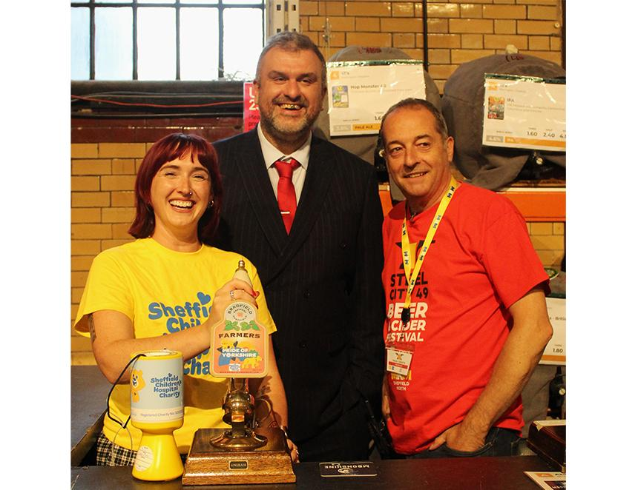

Sheffield Children’s Hospital Charity (SCHC) has been given a £3,500 boost thanks to a record donation from the recent Sheffield Steel City Beer Festival (SCBF49). The sum, which represents a donation rate of almost £100 an hour or £1.60 a minute, includes loose change, unused beer tokens, eBay sales of three sets of SCBF49 beer mats, net proceeds from the charity beer and a donation from Sheffield and District CAMRA. The branch thanks everyone who contributed and Bradfield brewery for providing the charity beer Pride of Yorkshire, a 4.3 per cent ABV, bittersweet, amber bitter. Festival organiser Paul Crofts said: “It’s a fantastic sum to raise for such a good charity. It was far more than we predicted and shows how much local people appreciate the work of the Children’s Hospital." SCHC’s Holly Newton-Steele said: “This is absolutely incredible, thank you so much. We are very grateful for your support and for making our team of volunteers and staff so welcome. I’ve had amazing feedback on just how brilliant it has all been – it really will make such a difference." The festival was formally opened by Reverend and the Makers front man John McClure. SCHC works with the hospital, to ensure children and young people can receive the best care, in the best possible environment. The money raised buys life-saving equipment, funds vital research and treatment for thousands of children from across the world and helps create a comfortable, engaging environment for patients at the hospital. Photo: Dave Pickersgill

