Women in Beer winners revealed
29/10/2025 by Timothy Hampson
Campaign

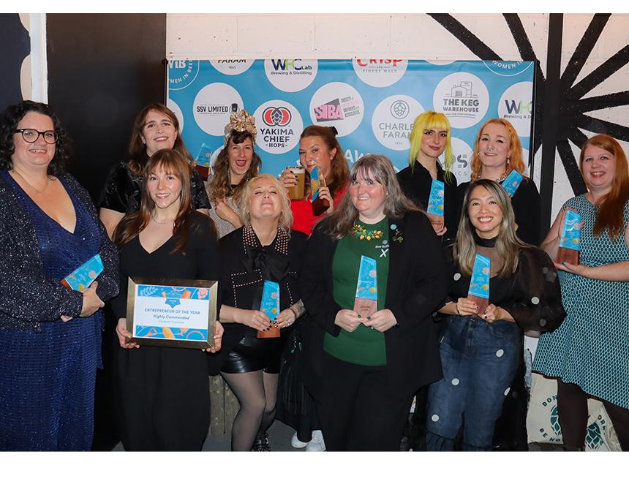

Beer writer Melissa Cole (pictured, centre back) was named an industry icon at the first Women in Beer Awards. More than 280 entries were judged by a panel of industry executives, brewers and journalists. The sold-out event took place at Eko Brewery and Taproom in London, celebrating the women shaping the beer industry. Women in Beer founder Amelie Tassin said: “It’s been amazing to see the support of the industry for these awards. It was very exciting to organise the awards, and to see the room filled with so many talented women last night was a real recompense for me. “We can all agree that Women in Beer Awards are needed, and I am looking forward to working on the second edition next year.” Who won what: Women in Beer 2025 Industry Icon sponsored by CAMRA: Melissa Cole Brewer of the Year sponsored by SIBA: Kate Hyde Hand Brew Co Rising Star Award sponsored by Simpsons Malt: Lucy Stevens Closet Brewing Communicator of the Year sponsored by Crisp Malt and The Malt Miller: Joanne Love Entrepreneur of the Year sponsored by Charles Faram: Lily Waite-Marsden Queer Brewing, Highly Commended: Elizabeth Townsend Kerroo Brewing Beer Expert of the Year sponsored by Yakima Chief Hops: Christina Wade Mentor of the Year sponsored by The Keg Warehouse: Dawn Maskell International Centre for Brewing and Distilling at Heriot-Watt University Industry Champion of the Year sponsored by SSV Limited: Lucy Do the Dodo Micropub Beer Creative of the Year sponsored by WHC Lab: Charlotte Waite-Marsden Queer Brewing Hospitality Leader of the Year sponsored by Hit Training: Joanna Whalley Wigan Central. Photo by Helen Smith, Burum Collective

