Women’s Brew Day theme revealed
28/10/2025 by WB Reporter
Industry

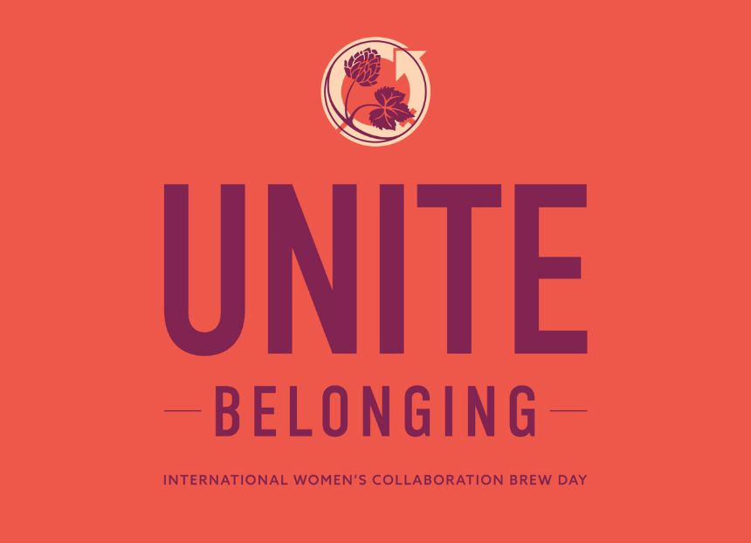

The International Women’s Collaboration Brew Day (IWCBD) campaign is back for 2026 and has revealed its theme. The theme, chosen by past IWCBD participants, Women On Tap Changemakers and the Women On Tap Advisory Board, is Unite Belonging. Unite Belonging is a global call to create a kinder, more inclusive world through the power of our beer communities. The brew days will celebrate the power of belonging, because no one should feel like an outsider in beer, in our communities, or in the world. This year also marks the launch of a new IWCBD poster for the event which is run in partnership with the Society of Independent Brewers and Associates (SIBA) and Women On Tap CIC. Printed copies will be sold as a fundraiser to help pay for the campaign. The plan is to make it a collectible annual release. Women On Tap invites breweries across the globe to rally the troops, get creative, and let everyone in their communities know they are welcome, be it through the brew day main event, launch, artwork, fundraising, or the beer recipe itself. Women On Tap CIC founder Rachel Auty said: “The need to open our doors and our hearts and cultivate a safe and welcoming space for all has never been more urgent. No one should feel like an outsider in beer, in our communities, or in the world. This year, we want the IWCBD campaign to reach out to those feeling disconnected, lost or isolated and let them know ‘you belong and are welcome here’. We can’t wait to see what the amazing people in this industry come up with!” The IWCBD sign-up form will launch on 31 October plus an online event will be held in November where anyone can find out more about IWCBD and how they can get involved. Details on how to pre-order a printed copy of the IWCBD 2026 poster will follow on the Women On Tap CIC website and social media.

