Push for better European beer labelling
28/10/2025 by WB Reporter
Campaign

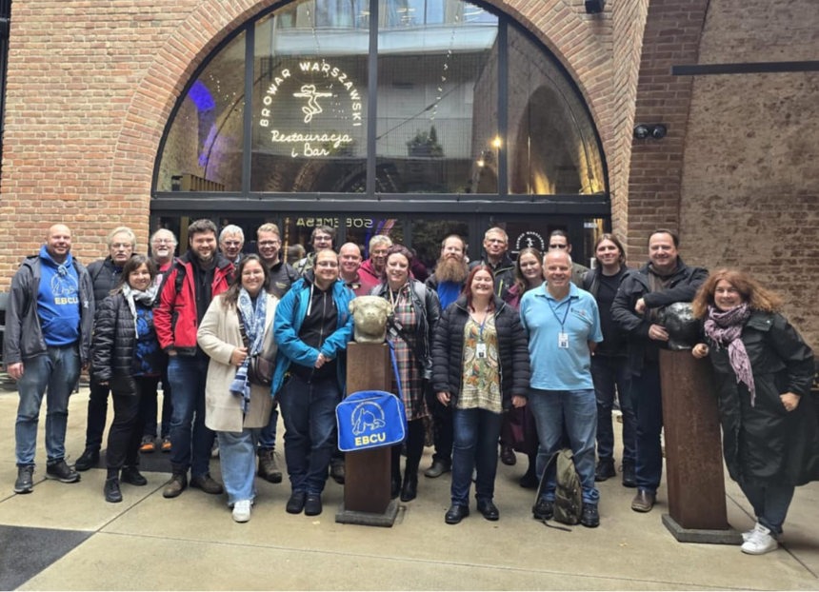

Support for small brewers and better beer labelling were the focus for delegates, including representatives from CAMRA, at the 72nd meeting of the European Beer Consumers’ Union (EBCU) in Warsaw, Poland. Hosted by the Polish Homebrewers’ Association, Polskie Stowarzyszenie Piwowarów Domowych, at the Browar Warszawski brewery and Warsaw craft beer bar the Taps, attendees took part in two days of discussions about preserving and promoting European beer cultures and campaigning for a fair deal for consumers. Delegates from 18 consumer organisations (pictured) discussed working together to: – campaign for transparency and better information on labels about where a beer is brewed and by whom. The Brewed Where? campaign will enable consumers to make informed choices about what they are drinking – respond to trends in European beer markets, including the rise of low-and-no alcohol brews – support and promote small and independent breweries in the face of rising costs, taxation and new regulations. Delegates also got the chance to experience Polish beer culture at the Warsaw Beer Festival. The festival had its first British beer stand, featuring brewers from Marble, Polly's Brew Co. and Pomona Island. CAMRA’s People director Laura Emson took part in a panel discussion at the event and talked about the role of cask beer and festivals plus interaction with the US craft scene.

