Steamed mussels with Burning Sky Petite Farmhouse Beer
26/10/2025 by Christian Gott
Opinion

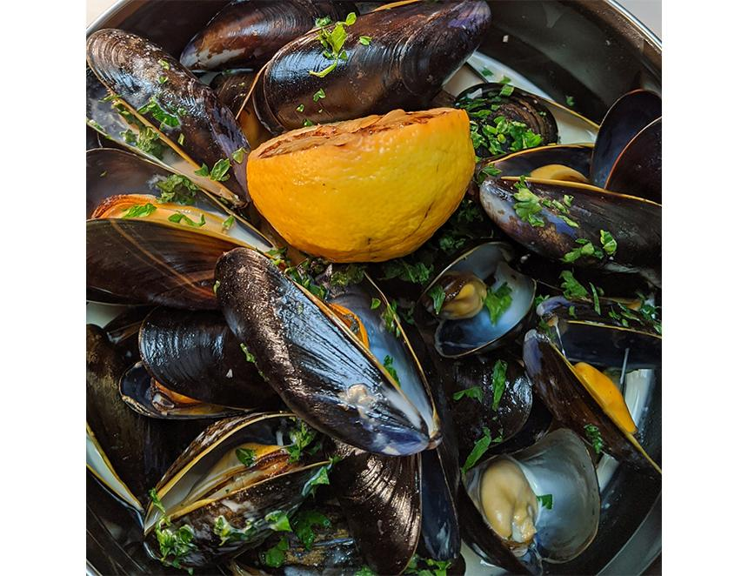

When I am researching for these recipes, I try to follow the basic rule to use a beer that is great as both an ingredient and when drunk alongside the dish. Sometimes the beer flavours are more forward in the food and in others it adds depth, complexity and it may help tenderise the ingredients when used as a marinade. I believe beer is far more versatile as an ingredient in cooking than wine. There is an Italian saying, “what grows together goes together” about matching food and wine. I think you can also use this maxim with regional beer styles. Take today’s recipe for mussels. Living close to France, mussels for me are only a short boat ride away served traditionally steamed with shallots and garlic, white wine and parsley. But there are lots of other variations like one of my earliest recipes for What’s Brewing when I used cider and bacon. However, if you really want to enjoy a bowl of mussels and beer then head to Belgium. Once a staple food of the poor, transported along the Belgian canal network from the North Sea, they are now referred to as black gold and Belgians consume more mussels per head than any other nation. And in this recipe the Burning Sky Petite Farmhouse Beer (3.4 per cent ABV) does all the hard work. It’s a beautiful beer brewed by a Belgian beer fanatic and it also pairs perfectly with the finished dish. It is a mixed fermentation beer using some wild-fermented ale, which is blended and aged in wine barrels, before being dry hopped. There really isn’t anything else quite like it. Burning Sky is nestled on the edge of the South Downs and was the first modern British brewery to invest in large oak vats for ageing beers and has its own koelschip, or coolship, a large, flat open vat used to produce lambic style beers with natural yeasts. Burning Sky also brews a range of hop-forward cask beers as well as traditional farmhouse-style beers. Steamed mussels with Burning Sky Petite Farmhouse Beer 2kg Jersey mussels 250ml of Burning Sky Petite Farmhouse Beer 150g salted butter 4 large banana shallots, peeled and finely diced 3 garlic cloves, peeled and crushed Handful of fresh parsley, thoroughly washed, dried and roughly chopped Freshly ground black pepper Garnish with lemon I allow 400-650g of mussels per person for a generous portion. First rinse them with plenty of cold running water. Throw away any with cracked or broken shells. Give any open mussels a quick squeeze if they do not close immediately throw them away as they are dead and not to be eaten. Then, using a small knife, scrape the shell to remove any barnacles or dirt. Pull out any beards by tugging towards the hinge of the mussel shell. If you intend to use the mussels later that day store in the bottom of your fridge covered with a damp cloth. In a very large heavy bottomed pan sauté the shallots and garlic for around 15 minutes to soften them without colouring. Turn up the heat and add the beer and a good few turns of the pepper mill. Tip in the mussels and cover with a tight-fitting lid. Steam for five minutes shaking the pan occasionally until the mussels are all open. Carefully take the mussels out of the pan and remove any that have not opened. Turn up the heat again to quickly reduce the cooking liquid by half and return the cooked mussels. Season with more pepper if required and add the parsley. Remove from the heat and spoon into bowls and serve with crusty bread and more beer.

