Music meets mash collab brew
24/10/2025 by Timothy Hampson
Industry

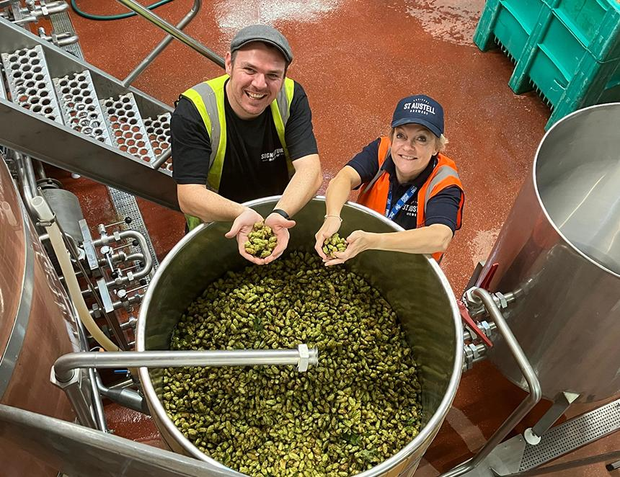

When brewing royalty calls, people answer. And that's just what the Signature Brew crew did when it was invited to St Austell brewery in Cornwall by brewing director Georgina Young to collaborate on a cask beer. The result was Never Mind The Dry Hops, a 3.4 per cent ABV, green-hop IPA. The beer was front and centre for Signature Brew’s Harvestfest as part of the Blackhorse Beer Mile and is now available pouring across St Austell’s Cask Club sites. The collaboration saw Signature Brew bringing its modern, music-forward approach together with St Austell’s history of brewing top beer. Founded in 2011, Signature Brew has built a reputation for its collaborations, including working with artists such as alt-J, the Libertines and IDLES. Its mission is to create beers that make music better. Meanwhile, St Austell brings 170 years of brewing history, a focus on innovative cask beers, and an unwavering commitment to quality. Signature co-founder Tom Bott said: “When Georgina Young calls and says, come to Cornwall and brew something special, you don’t hesitate. St Austell is one of the most respected names in British brewing, so getting to collaborate in that setting, surrounded by fresh hops, great people and a proper sense of tradition, was something really special. "Never Mind The Dry Hops captures that shared spirit perfectly: modern creativity built on classic brewing values. It’s a beer we’re really proud of, and one that shows just how exciting British cask beer can be when everyone brings their best to the table.” Never Mind The Dry Hops is a hop-forward cask beer with a zesty brightness balanced with an earthy freshness. Drinkers can expect waves of citrus, bold grapefruit, and a crisp malt backbone, finishing with a lively bitterness and lingering taste of freshly picked hops. Pictured: Tom Bott and Georgina Young

