New venue for Steel City cask fans

23/10/2025 by Timothy Hampson

Pub

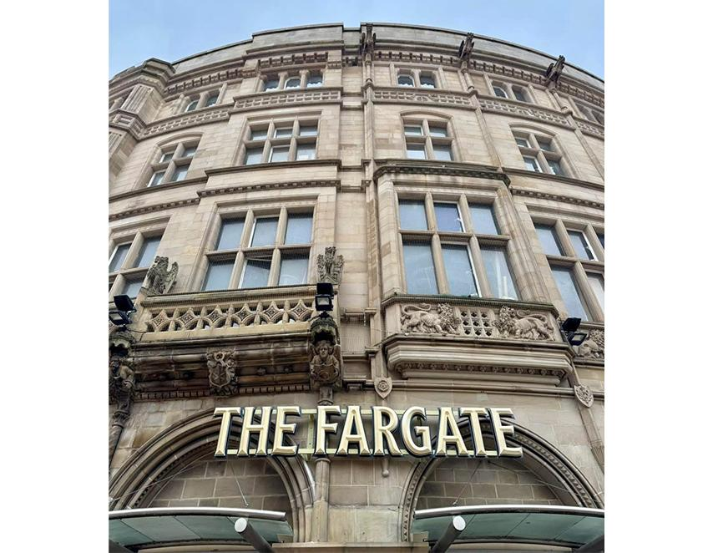

Sheffield has a new venue selling cask beer, the Fargate, which opened its doors today. The pub follows the success of Thornbridge’s other city-centre locations, the Market Cat in York, Bankers Cat in Leeds and Colmore in Birmingham. The venue brings together the storied elegance of the former Yorkshire Bank (previously the Yorkshire Penny Savings Bank) site with a pub interior created to feel timeless. Dark polished wood, elegant leather seating, herringbone floors, brass accents, chandeliers and curated artwork create the impression of a bar that could have stood here for over a century. At its heart is a striking horseshoe bar serving 10 cask beers, half of them from Thornbridge, as well as 16 draft beer lines. The ground floor also features screened booths, snug, banquette seating, and full height glazing to the front, offering a light and inviting space. Thornbridge director and Pivovar president Jamie Hawksworth said: “The Fargate is on track to become a defining feature of Sheffield’s pub scene, thanks to a large investment in its unique design. We’re delighted to help shape the vibrant new era of the city centre.” Thornbridge CEO Simon Webster: “We’re eager to open our doors to the people of Sheffield and contribute to the continued growth and character of the area.”