New cash for rural pubs

23/10/2025 by WB Reporter

Industry

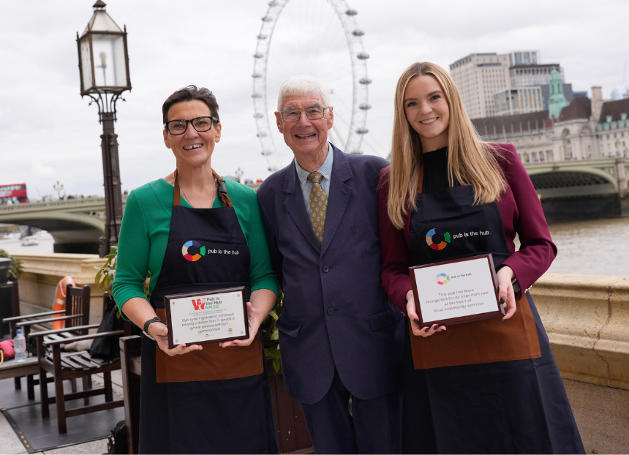

Rural pubs across the UK will benefit from new government cash to help them provide extra services for communities. Projects will include creating cafes, stores and play areas to help bring people together. The projects have been identified by Pub is The Hub in its Social Value Report which identified more than 40 currently stuck in limbo due to a lack of funding. In response, the Department for Business and Trade (DBT) has committed £440,000 to help Pub is The Hub deliver these projects. From North Yorkshire to Cornwall, funding will help support jobs and opportunities while increasing community cohesion as part of the Plan for Change. Minister for Employment Rights and Consumer Protection Kate Dearden said: “Rural pubs are hubs of their communities, and this government wants to support these vital community assets, creating jobs, supporting local economies, and providing residents with a place to socialise and come together. “That’s why, as part of the Plan for Change, we’re keen to help secure their future with this funding, alongside measures to slash red tape, modernise licensing and to create a fairer business rates system.” New research by Pub is The Hub shows that for every £1 invested in new services or activities, there is a social value of more than £8. So far, the organisation has supported hundreds of diversification projects and aims to help 1,000 more pubs over the next three years, creating 2,500 jobs and 1,600 services for more than one million residents. Pub is The Hub chief executive John Longden said: “We would like to thank the Department for Business and Trade for recognising the important role that pubs and publicans have in rural and deprived areas. “Publicans with their individual pub businesses have a vital social role in supporting communities and helping people to overcome social isolation and alleviate loneliness. They have a significant social value that is beyond economic impact. They are crucial in helping to bring people together and inspiring the provision of lost services and amenities.” To mark the announcement Kate Dearden met with John Longden, APPG Beer Group chair Tonia Antoniazzi MP and the British Institute of Innkeeping’s Molly Davis to discuss the new cash as well as the government’s wider support for the hospitality industry. Greene King CEO and co-chair of the Licensing Taskforce Nick Mackenzie said: “No one can underestimate the huge social and economic value of pubs. Our pubs are more than bricks and mortar where people eat and drink – they are places where people come together for all occasions and celebrations, they offer employment and careers for people of all ages and can help in tackling loneliness. “Additional access to funding and less red tape is some welcome news to help pubs continue to adapt to meet the needs of their local communities.” Pictured, from left, Tonia Antoniazza, John Longden and Kate Dearden