History under the hammer

22/10/2025 by WB Reporter

Campaign

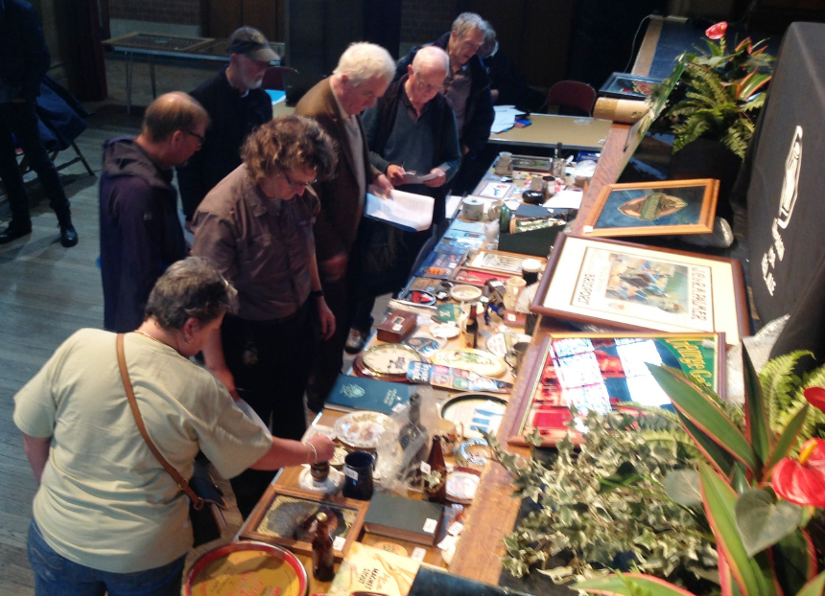

Ever fancied owning a slice of brewing history? CAMRA’s National Breweriana Auction returns to Burton-on-Trent Town Hall on Saturday (25 October) at 10.30am, with around 150 lots. The auction in the Victorian venue will have a range of unusual items from mirrors and trays to advertising signs, water jugs, flagons, bottles, books and pump clips plus much more. Additional stands will also be selling brewery memorabilia. Beer from local breweries will be on sale all day. The 39th National Breweriana Auction is a great event for both seasoned auctioneers and newcomers alike. Fun to take part in, or even just to watch, the auction is an opportunity to get some great bargains plus many of the items on sale can appreciate in value. The event opens at 10.30am with the opportunity to view lots and browse the stands before bidding starts at noon. The auction is normally finished by 3pm. Entrance is by catalogue (£3), available on the day, or in advance by post (£6.15, first class) from Bill Austin: 07831 688276 or baustin1951@btinternet.com If you can’t get to the event, postal bids are accepted by contacting Bill. Similarly, contact him if you have items you would like to enter into the auction. For more details see: gandc.camra.org.uk