Contact your MP now to help pubs and breweries

21/10/2025 by WB Reporter

Campaign

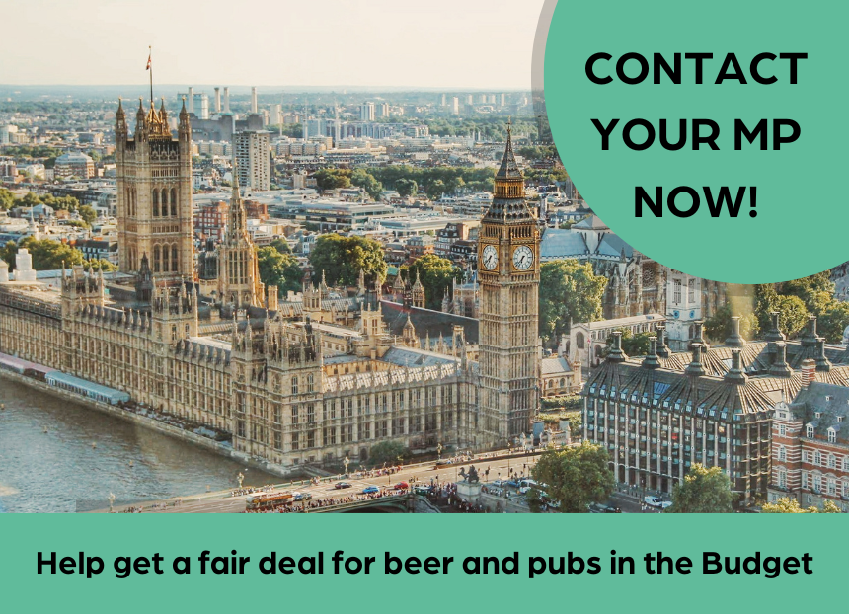

CAMRA is urging everyone to demand the chancellor announces support for pubs, social clubs, breweries and pubgoers ahead of the Autumn Budget on 26 November.   With more and more pubs and breweries struggling or being forced to close their doors for good, the UK government needs to put pubs at the heart of its priorities in this Budget.  CAMRA has set up a quick and easy-to-use template tool for consumers to email their MP asking them to support beer and pubs.  With the simple e-lobby tool, it only takes a minute to contact your MP. Every email an MP receives from CAMRA members and non-members helps to get the message across to government ministers, special advisors and civil servants in the Treasury as they prepare for the Budget.  CAMRA wants MPs to ask the chancellor to:  reduce VAT on food and drink served in pubs

keep her promise to introduce permanently lower business rates for pubs and hospitality businesses in England

provide help with sky-high energy bills for pubs and breweries

think again on increases to Employer National Insurance contributions which are hitting pubs hard

drastically cut duty charged on draught beer and cider served in pubs, social clubs and taprooms.   CAMRA chairman Ash Corbett-Collins said: “We all know that our pubs and independent breweries are struggling right now. This year, more than ever, we really need as many people as possible to use our tool to contact their MP and demand better support for consumers, pubs and breweries. “Emailing your MP really does make a difference. MPs tell me that people power is one of CAMRA’s greatest strengths when getting our voice heard in parliament and in government. Together we can convince the chancellor to deliver meaningful support for pubgoers and beer lovers.” Contact your MP here.