Cash for Belfast night buses just start of journey

21/10/2025 by WB Reporter

Campaign

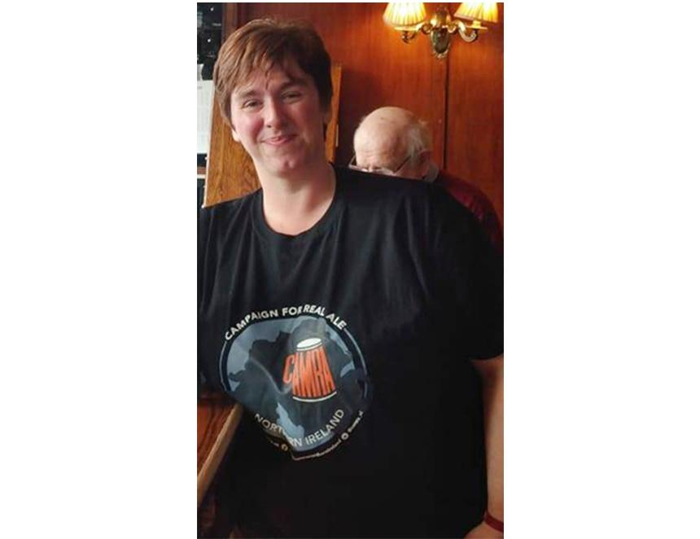

Responding to the executive confirming funding for late-night transport in Belfast, CAMRA NI director Ruth Sloan (pictured) said: “This is great news for pubs and consumers who have been crying out for night buses and late-night services for years and comes at a time when pubs need all the help they can get to survive and thrive in the face of rising costs and tax burdens. “But this should be just the start of more to come. We now desperately need the executive to modernise our alcohol licensing laws so that Belfast and the whole of Northern Ireland can see new pubs, micropubs, wine bars and brewery taprooms opening up and offering a diverse range of venues and better choice of local beer and cider from independent businesses instead of every bar being dominated by the likes of Guinness and Harp.”