Ouse Booze is back

20/10/2025 by Timothy Hampson

Industry

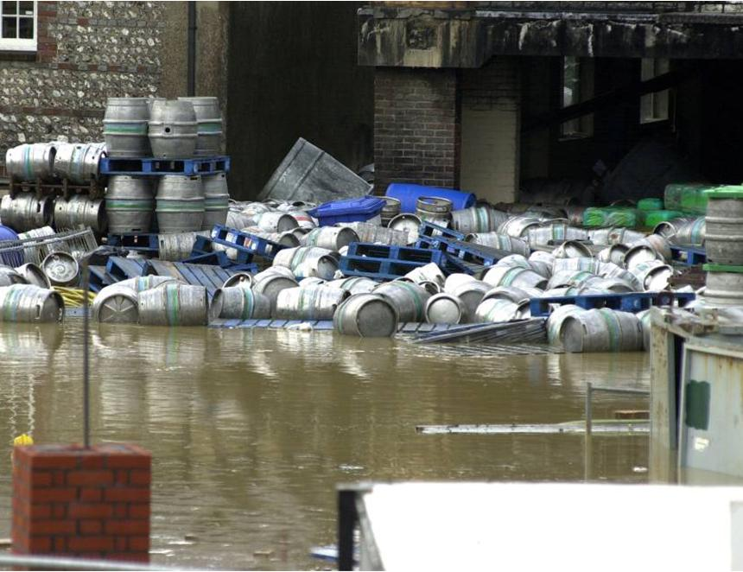

A beer born of disaster has been brewed again to mark 25 years since the River Ouse burst its banks and swept through Lewes and Harvey’s brewery. Brewing was abandoned on that day a quarter of a century ago, with two half-full fermenting vessels of strong malt sugars left standing as the river raged through the brewery (above). These were combined into a single vessel and left to ferment naturally while the floodwaters receded beneath them over the course of 36 hours. The beer that emerged was bottled and aptly named Ouse Booze, (6.5 per cent ABV) and was sold in aid of the Lewes Flood Appeal. It stood as a testament to the resilience of Lewes and Harvey’s shared spirit of perseverance. Now, Harvey’s has faithfully recreated Ouse Booze to mark the anniversary of the flood. Brewed using the same techniques, malt, and hops sourced from the original growers, the beer is smooth and full-bodied, with a gentle sweetness and abundant hop character. This special edition has been released in a limited run of 440ml cans. During the floods, many empty casks floated out to sea, later sighted by passengers aboard the Newhaven-to-Dieppe ferry. The flood caused damage totalling more than £2m. Harvey’s was told it would take nine months to get back on its feet but just nine days later it was brewing again. Harvey’s head brewer Miles Jenner said: “A calamity brew, Ouse Booze was born of disaster yet captured the resilience and creativity of our team and town in the face of crisis. “This anniversary edition has been brewed from the same hops, the same strength, the same maltsters, and as a single copper brew, just as it was that day. Hopefully, it will be as warmly received as the original.”