Eagle flies under Damm

16/10/2025 by Timothy Hampson

Industry

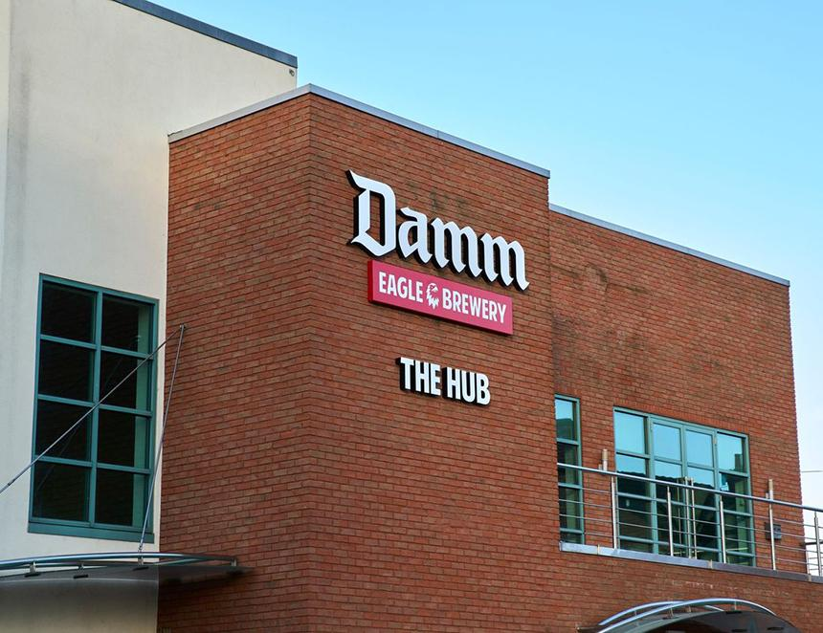

Damm, Spain’s largest brewing business, has officially opened its first brewery outside the Iberian Peninsula – the Eagle brewery in Bedford on the former Charles Wells production site. Founded in 1876, the brewery remained with the Wells family until 2017, when it and its brands were acquired by Marston's and renamed Eagle brewery. It brewed Young’s beers after the closure of the Ram brewery in 2007, and the popular Bedfordshire ale, Eagle IPA. In 2022 the brewery was sold to SA Damm and all production of cask beers transferred to what was the Carlsberg Marston’s Brewing Co. Now, Damm has transformed the Bedford brewery and has set itself the bold ambition of becoming the UK’s largest independent beer company and might even brew cask beer. Damm MD Jorge Villavecchia said: “Our commitment goes beyond capital investment. We are bringing skills, innovation and a vision of how industry must evolve to remain competitive: more digital, more sustainable, more resilient. “This country has shown, time and again, its ability to adapt and emerge stronger from adversity. That is why we believe that our decision to invest in Bedford will contribute not only to Damm’s growth, but also to the resilience of the UK’s wider economy.” Government minister Jason Stockwood said: “Damm’s investment is a vote of confidence in the UK and demonstrates our Plan for Change in action. “The UK is proud to be the location of Damm’s first brewery outside the Iberian Peninsula. Damm’s investment will support sustainability through a new canning line equipped with significant advances in technology and energy efficiency. And it will support innovation through a new incubator hub.” The modernised facility has doubled packaging capacity and diversified into new formats and beverages, including soft drinks. Thanks to advanced syrup handling and mixing technology, the site can now produce soft drinks and “beyond beer” beverages. The investment phase is expected to double the number of direct employees at the brewery. Over the past three years since acquiring the brewery, Damm has already tripled its number of direct employees in the UK from 56 to 180.