Two crowns for Five Kingdoms
15/10/2025 by WB Reporter
Campaign

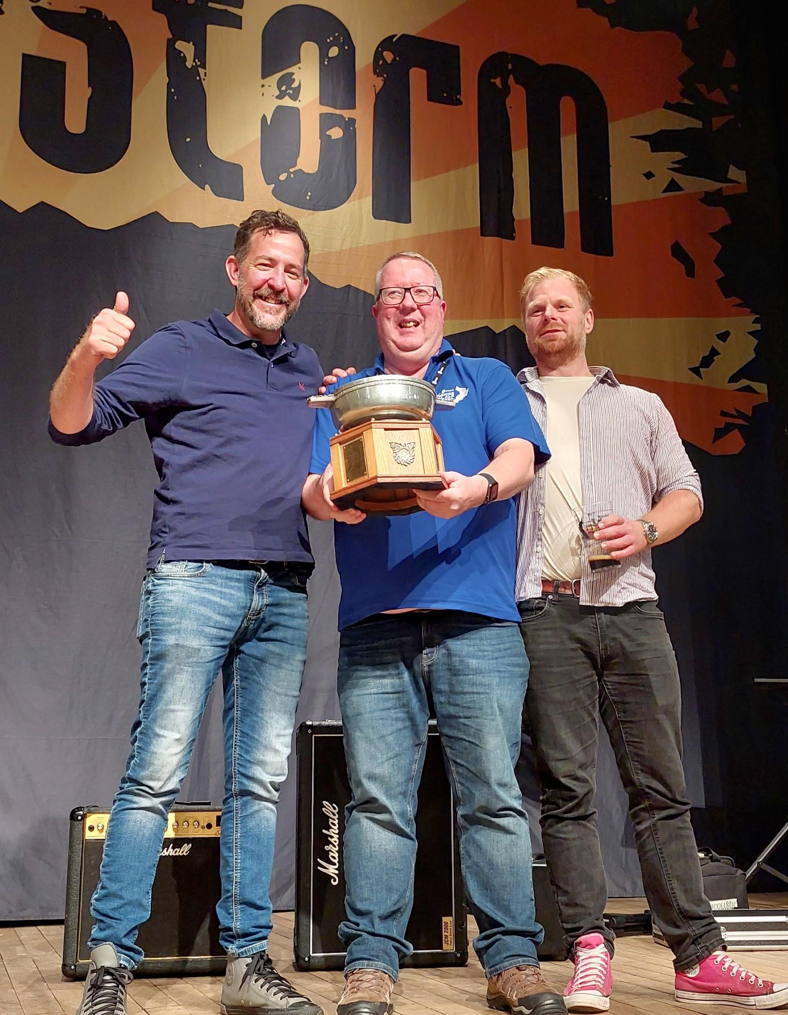

Five Kingdoms, Scotland’s most southerly brewery, won both Gold and Silver in CAMRA’s Champion Beer of Scotland competition at the Ayrshire Real Ale Festival in Troon. Gold winner Dark Storm (6.9 per cent ABV) was praised by judges as: “A smooth, rich and creamy stout with a long, dry finish.” The beer previously won Silver in last year’s competition and CAMRA’s overall Champion Bottled Beer of Britain in 2024. Silver was also claimed by the Isle of Whithorn brewer with its McGregor’s Mild (3.8 per cent). One of the few examples of mild in Scotland, it is proving to be popular thanks to its sessionable strength. No stranger to awards, the beer previously won Bronze in the mild category of the Champion Beer of Britain 2024. Judges commended the beer as a “traditional mild with low hop and loads of malt for easy drinking”. Bronze was won by Cairngorm brewery’s premium bitter, Wildcat (5.1 per cent). The beer was also awarded Gold in the Premium Bitter category in the overall Champion Beer of Britain 2025 competition at the Great British Beer Festival in August. Judges described the beer as: “a full-bodied, warming strong bitter with complex malt and fruit flavours with an underlying hop character.” The Dan Kane Memorial Quaich was presented to Five Kingdoms’ brewers Brendon Dennett and Nathan Wall by director of CAMRA Scotland Stuart McMahon during the festival earlier this month. Stuart said: “All the judges were in agreement that Dark Storm was a worthy winner. It is rapidly gaining cult classic status at the brewery with its name reflecting its colour and strength, but is super smooth, rich and creamy on the palate. “Scotland has some amazing beers of all styles being produced by independent brewers. It is worth seeking out our award-winning brews like Dark Storm, but with global brewers and pub companies having a stranglehold over the market, it is hard for Scottish pubgoers to access the fantastic beers on their doorstep. "The new guest beer right in the Scottish Pubs Code is a good start helping pub licensees to serve a beer of their choice from a local brewer, but we need the UK government’s ongoing Access to Market review to introduce significant changes to help provide true choice for beer and cider lovers by making sure local and independent breweries can get their beers on taps at the bar.” Pictured, from left, Brendon Dennett, Stuart McMahon and Nathan Wall. Photo by Ronnie Beveridge

