Fab Four revealed

13/10/2025 by WB Reporter

Campaign

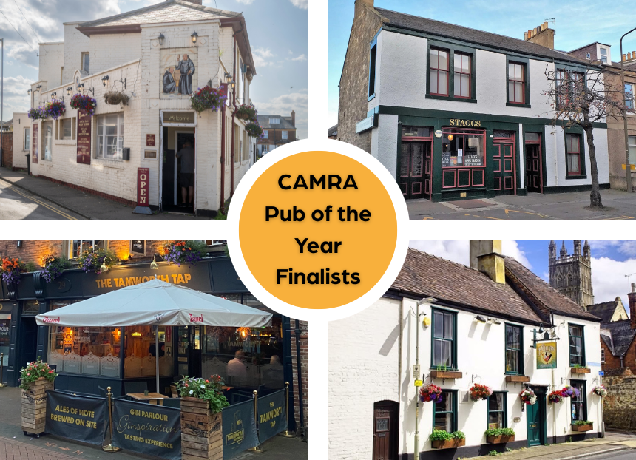

The fight to win CAMRA’s National Pub of the Year 2025 competition is hotting up with just four pubs remaining after months of rigorous judging.  The final round of assessments is underway with the result set to be revealed at the start of 2026. Two former CAMRA Pub of the Year winners are in the running, along with this year’s Cider and Perry Pub of the Year.  Beating thousands of entries and showcasing their commitment to quality and their communities, they have been judged on their atmosphere, décor, welcome, service, inclusivity, overall impression and, most importantly, quality cask beer, real cider and perry.    The Fab Four are:    Blackfriars Tavern, Great Yarmouth: Awarded CAMRA’s Cider and Perry Pub of the Year just weeks ago, this Victorian corner pub, next to the 13th-century town walls, has made its mark as a must-visit destination. Described as a real gem, the pub focusses on East Anglian-produced cask, plus real ciders and perries, with its bar regularly showcasing CAMRA award winning brews and even beers from the on-site brewery. Landlord and freeholder Pharez Smith said: “Built on quality, consistency and a calm, welcoming atmosphere, we’re thrilled – especially as a final four pub – to be part of CAMRA’s work championing cask ale and real cider.”  Pelican Inn, Gloucester: Dating back to 1679, this Grade II-listed, family run traditional ale house is popular with cyclists, cathedral visitors and Gloucester rugby fans. With up to 10 cask beers, 12 ciders and six craft kegs on at all times, plus a collection of rarer beer styles in can, there is something for everyone to enjoy. The multi-award-winning pub has been featured in the Good Beer Guide for more than a decade. Licensee Mike Hall said: “Never did I dare hope that the Pelican Inn would be recognised as one of the top four pubs in the country. It’s been a joyous journey for me and my family, building the pub up from a poor trading position. The plan from day one was to make it a relevant part of the community and a beacon for real ale fans to find. The fact that it’s evolved into something so far beyond our own ambitions is the warmest of feelings. Our greatest strength is the support offered to us by Wye Valley brewery, we showcase all of its beers but with a flexibility to offer a broader choice of beers than its portfolio alone. It’s a simple, traditional public house with a clear vision and fabulous, fabulous beer. This honour will stay with me always.”  Tamworth Tap, Tamworth: Twice winner of the National Pub of the Year (2022 and 2023), the Tudor building and historic courtyard beer terrace offers striking views of Tamworth’s Norman castle. Home to Tamworth Brewing Company and its tap, it features eight handpulls, with cask from near and far, along with a wide range of ciders, gins, wines and bottled beers. The ‘CAMRA corner” at the bottom of the stairs is always popular, along with its display of a complete set of Good Beer Guides. Owners George and Louise Greenaway said: “We’re over the moon to receive the news that the Tamworth Tap has been shortlisted as a finalist for CAMRA’s Pub of the Year. This recognition reflects the dedication of our team and the continued support of our wonderful customers who make the pub what it is. Huge thanks to everyone who makes the pub such a special place to enjoy company and great beer.”  Volunteer Arms (Staggs), Musselburgh: A superb pub run by the same family since 1858 with a traditional bar and snug, wooden floors, wood panelling and mirrors from now-closed local breweries. The pub’s interior is of historic interest with an attractive Victorian gantry topped with old spirit cask barrels. It has a range of regularly changing cask beers and has won many awards, including CAMRA’s National Pub of the Year in 1998 and reached the top four in 2018. Staggs co-owner Katie McKenzie said: “Nigel, Hayley and I are absolutely delighted to be in the final four of CAMRA’s Pub of the Year competition. It is a testament to our hard-working staff, the breweries which supply us with fantastic beer and the community which drinks and socialises with us. Staggs is a special place to many and we are grateful to everyone who plays a part in making us a community and more than just a pub.”  Award coordinator Andrea Briers said: “It is always a hard-fought and close competition with judges having an incredibly difficult job whittling them down to just four. They are shining examples of what makes our pubs so incredibly special, vital to our communities and providing a wonderful welcome to all.   “I am very excited to see the outcome of the final round of judging and crowning our winner. Every year we see pubs facing new pressures and to continue to thrive in the face of rising costs and other issues is humbling to see. We are calling on the chancellor to give pubs a fair deal in the Autumn Budget, so they can keep serving their communities for many years to come.”