Women In Beer unveils awards shortlist

13/10/2025 by Timothy Hampson

Industry

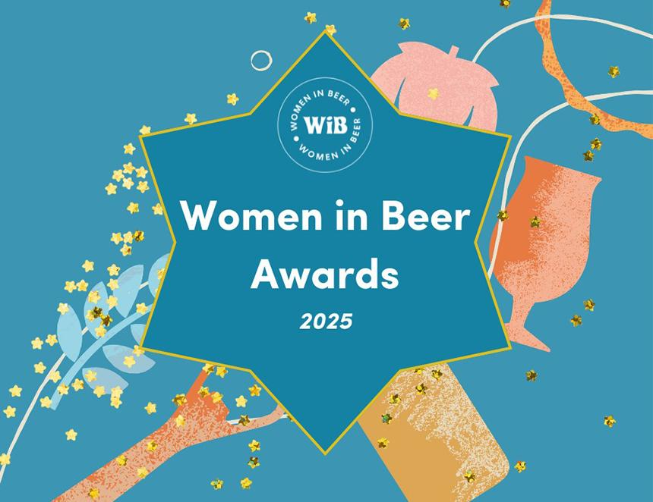

Women in Beer (WiB) has announced the finalists for its inaugural awards, which has seen 280 nominations in nine categories. WiB founder Amelie Tassin said: “I was not expecting to see so many nominations for our first awards, but it confirmed there’s a need to celebrate the women who work and shape the beer industry. “It’s been a real joy to get to know so many talented women through the nominations, and I am in awe of the judges who had a very tough job selecting the shortlisted and the winners.” The finalists in each category are: Brewer of the Year – sponsored by SIBA Kate Hyde – Hand Brew Co. Sophie Ashdown – Buxton brewery Lara Lopes – Round Corner Brewing Rising Star Award – sponsored by Simpsons Malt Katie Sanders-Pope – Old Cannon brewery Natalie Tunnacliffe – Tandle Hill Tavern Sophie Whitcher – Lost and Grounded Lucy Stevens – Closet Brewing Communicator of the Year – sponsored by Crisp Malt and the Malt Miller Joanne Love Tori Powell Kimberley Spivey Ruvani de Silva Katie Mathers Entrepreneur of the Year – sponsored by Charles Faram Jane Peyton Elizabeth Townsend – Keroo Brewing Lucy Do – Dodo Micropub Lily Waite–Marsden – Queer Brewing Beer Expert of the Year – sponsored by Yakima Chief Hops Alix Blease – Lallemand Brewing Joanne Love – BarthHaas X Christina Wade Natalya Watson – WSET Mentor of the Year – Sponsored by Keg Warehouse Dawn Maskell – International Centre for Brewing and Distilling at Heriot–Watt University Kate Hyde – Hand Brew Co. Kelly Johnson Industry Champion of the Year – sponsored by SSV Jane Peyton Sara Webber – SA Brain & Co. Lucy Do – Dodo Micropub Catherine Webber – Attic Brew Co. Beer Creative of the Year – Sponsored by WHC Lab Kimberley Spivey – freelance Charlotte Waite-Marsden – Queer Brewing Amy Haselden – Track Brewing Co. Vik Kastenbauer Stronge – Lost Cause Brewing Co. Hospitality Leader of the Year – sponsored by Hit Training Joanna Whalley – Wigan Central Margaret Elliott-Tredinnick – Dog and Duck Inn Lucy Do – Dodo Micropub Aimee Harbison-Roper – Barrel Drop Women in Beer 2025 – Industry Icon (judge’s choice) – sponsored by CAMRA Dawn Maskell Jane Peyton Lucy Do Melissa Cole Jaega Wise The winners will be announced on 28 October at Eko Brewery and Taproom in London.